**MINISTRY OF EDUCATION AND TRAINING**

**FPT UNIVERSITY**

Capstone Project Document

**Just Walk Out Library**

|  |  |
| --- | --- |
| **Group 1** | |
| **Group members** | Võ Hồng Hà – SE61394  Nguyễn Tuấn Anh – SE61476  Đặng Nhật Thiên – SE61357 |
| **Supervisor** | Kiều Trọng Khánh |
| **Ext. Supervisor** | N/A |
| **Capstone Project code** | JWL |

- Ho Chi Minh city, April 3rd 2017 -

*This page is intentionally left blank*

Table of Contents

[List of Tables 6](#_Toc479619390)

[List of Figures 7](#_Toc479619391)

[Definitions, Acronyms, and Abbreviations 8](#_Toc479619392)

[A. Report No. 1 Introduction 9](#_Toc479619393)

[1. Project Information 9](#_Toc479619394)

[2. Introduction 9](#_Toc479619395)

[3. Current Situation 9](#_Toc479619396)

[3.1 Ho Chi Minh City University of Social Sciences and Humanities library 9](#_Toc479619397)

[3.2 FPT University library 9](#_Toc479619398)

[4. Problem Definition 10](#_Toc479619399)

[5. Proposed Solution 10](#_Toc479619400)

[5.1 Technologies 10](#_Toc479619401)

[5.2 Feature Functions 11](#_Toc479619402)

[5.3 Advantages and Disadvantages 12](#_Toc479619403)

[6. Functional Requirements 12](#_Toc479619404)

[7. Role and Responsibility 13](#_Toc479619405)

[B. Report No.2 Software Project Management Plan 14](#_Toc479619406)

[1. Problem Definition 14](#_Toc479619407)

[1.1. Name of this Capstone Project 14](#_Toc479619408)

[1.2. Problem Abstract 14](#_Toc479619409)

[1.3. Project Overview 14](#_Toc479619410)

[2. Project organization 19](#_Toc479619411)

[2.1. Software Process Model 19](#_Toc479619414)

[2.2. Roles and responsibilities 19](#_Toc479619415)

[2.3. Tools and Techniques 20](#_Toc479619416)

[3. Project Management Plan 21](#_Toc479619417)

[3.1. Software development life cycle 21](#_Toc479619419)

[3.2. Phase Detail 23](#_Toc479619420)

[3.3. All Meeting Minutes 25](#_Toc479619421)

[4. Coding Convention 27](#_Toc479619422)

[E. Report No. 3 Software Requirement Specification 28](#_Toc479619425)

[1. User Requirement Specification 28](#_Toc479619426)

[1.1 Unauthorized User Requirement 28](#_Toc479619427)

[1.2 Authorized User Requirement 28](#_Toc479619428)

[1.3 Passenger Requirement 28](#_Toc479619429)

[1.4 Staff Requirement 28](#_Toc479619430)

[1.5 Manager Requirement 28](#_Toc479619431)

[1.6 Admin Requirement 28](#_Toc479619432)

[1.7 Emulator Requirement 28](#_Toc479619433)

[1.8 Auto Handler Requirement 29](#_Toc479619434)

[2. System Requirement Specification 29](#_Toc479619435)

[2.1 External Interface Requirement 29](#_Toc479619437)

[2.2 System Overview Use Case 30](#_Toc479619438)

[2.3. List of Use Case 31](#_Toc479619445)

[3. Software System Attribute 94](#_Toc479619446)

[3.1 Usability 94](#_Toc479619448)

[3.2 Reliability 94](#_Toc479619449)

[3.3 Availability 94](#_Toc479619450)

[3.4 Security 94](#_Toc479619451)

[3.5 Maintenanability 94](#_Toc479619452)

[3.6 Portability 94](#_Toc479619453)

[3.7 Performance 94](#_Toc479619454)

[4. Conceptual Diagram 95](#_Toc479619455)

[**2.** 95](#_Toc479619456)

[F. Report No. 4 Software Design Description 96](#_Toc479619457)

[1. Design Overview 96](#_Toc479619458)

[2. System Architecture Design 96](#_Toc479619459)

[1.2 Web Application Architecture Description 98](#_Toc479619460)

[1.3 Android Application Architecture Description 98](#_Toc479619461)

[3. Component Diagram 98](#_Toc479619462)

[4. Detailed Description 100](#_Toc479619463)

[4.1 Class Diagram 100](#_Toc479619466)

[4.2 Class diagram explanation 101](#_Toc479619467)

[4.3 Interactive Diagram 106](#_Toc479619468)

[5. User Interface 114](#_Toc479619469)

[5.1 Component Interface 114](#_Toc479619470)

[5.2 Web Application Design 117](#_Toc479619471)

[5.2 Mobile Application Design 149](#_Toc479619472)

[6. Database design 155](#_Toc479619473)

[6.1 Entity Relationship Diagram 155](#_Toc479619474)

[6.2 Entity Dictionary 155](#_Toc479619475)

[7. Algorithms 156](#_Toc479619476)

[7.1 AES Encryption 156](#_Toc479619477)

[7.2 Token Authentication 157](#_Toc479619478)

[G. Report No. 5 System Implementation & Test 161](#_Toc479619479)

[1. Introduction 161](#_Toc479619480)

[1.1 Overview 161](#_Toc479619481)

[1.2 Test Approach 161](#_Toc479619482)

[2. Database Relationship Diagram 161](#_Toc479619483)

[2.1 Physical Diagram 162](#_Toc479619484)

[2.2 Data Dictionary 163](#_Toc479619485)

[3. Performance Measures 167](#_Toc479619486)

[3.1 Web Application Loading Speed 167](#_Toc479619487)

[3.2 Mobile API Speed 167](#_Toc479619488)

[4. Test Plans 168](#_Toc479619489)

[4.1 Features to be tested 168](#_Toc479619490)

[4.2 Features not to be tested 169](#_Toc479619491)

[5. System Testing Test Case 169](#_Toc479619492)

[5.1 Communication Diagram 169](#_Toc479619493)

[5.2. System Test Cases 171](#_Toc479619500)

[H. Software User’s Manual 178](#_Toc479619501)

[1. Installation Guide 178](#_Toc479619502)

[1.1. Setting up environment at server side 178](#_Toc479619503)

[1.2. Deployment at server side 178](#_Toc479619504)

[1.3. Deployment at Client Side 182](#_Toc479619505)

[2. User Guide 182](#_Toc479619506)

[2.1. Web application 182](#_Toc479619507)

[2.2. Mobile application 205](#_Toc479619508)

[2.3. Emulator application 214](#_Toc479619509)

[I. Appendix 219](#_Toc479619510)

## List of Tables

[Table 1 : Roles and Responsibilities 13](#_Toc479619511)

[Table 2 : Hardware Requirement for Server 17](#_Toc479619512)

[Table 3 : Hardware Requirement for Mobile 17](#_Toc479619513)

[Table 4 : Hardware Requirement for Mobile 18](#_Toc479619514)

[Table 5 : Software requirements 18](#_Toc479619515)

[Table 6 : Roles and responsibilities 20](#_Toc479619516)

[Table 7: Tools List 20](#_Toc479619517)

[Table 8: Technique List 20](#_Toc479619518)

[Table 9: Software Development Life Cycle Detail 22](#_Toc479619519)

[Table 10: Phase 1 - Infrastructure 23](#_Toc479619520)

[Table 11: Phase 2 - System & Web Application 24](#_Toc479619521)

[Table 12: Phase 3: Web service 24](#_Toc479619522)

[Table 13: Phase 4 - Mobile Application 25](#_Toc479619523)

[Table 18: <Unauthorized User> Login 32](#_Toc479619524)

[Table 19: <Unauthorized User> Activate account 34](#_Toc479619525)

[Table 20: < Authorized User> Overview use case 36](#_Toc479619526)

[Table 21: < Authorized User> Log out 37](#_Toc479619527)

[Table 22: < Passenger> Get NFC card 40](#_Toc479619528)

[Table 23: < Passenger> Add credit 42](#_Toc479619529)

[Table 24: < Passenger> Edit card name 43](#_Toc479619530)

[Table 25: < Passenger> Get outcome report 46](#_Toc479619531)

[Table 26: < Passenger> Find bus 47](#_Toc479619532)

[Table 27: < Passenger> Get route 49](#_Toc479619533)

[Table 28: < Passenger> Get route 50](#_Toc479619534)

[Table 29: < Passenger> Get route 52](#_Toc479619535)

[Table 30: < Passenger> Get route 53](#_Toc479619536)

[Table 31: < Staff > Add card 56](#_Toc479619537)

[Table 32: < Staff > Activate/Deactivate card 58](#_Toc479619538)

[Table 33: < Staff > Search passenger 59](#_Toc479619539)

[Table 34: < Staff > Edit passenger 62](#_Toc479619540)

[Table 35: < Staff > Edit passenger 63](#_Toc479619541)

[Table 36: < Manager > Add ticket type 66](#_Toc479619542)

[Table 37: < Manager > Edit ticket type 68](#_Toc479619543)

[Table 38: < Manager > Delete ticket type 70](#_Toc479619544)

[Table 39: < Manager > Add credit plan 72](#_Toc479619545)

[Table 40: < Manager > Edit credit plan 74](#_Toc479619546)

[Table 41: < Manager > Delete credit plan 76](#_Toc479619547)

[Table 42: < Manager > Get income report 78](#_Toc479619548)

[Table 43: < Manager > Create promotion 80](#_Toc479619549)

[Table 44: < Admin> Search account 81](#_Toc479619550)

[Table 45: < Admin> Add account 84](#_Toc479619551)

[Table 46: < Admin> Edit account 85](#_Toc479619552)

[Table 47: < Auto Handler > Parse bus route 87](#_Toc479619553)

[Table 48: < Auto Handler > Suggest promotion 89](#_Toc479619554)

[Table 49: < Auto Handler > Send notification 90](#_Toc479619555)

[Table 50: < Emulator > Write card 92](#_Toc479619556)

[Table 51: < Emulator > Verify ticket 94](#_Toc479619557)

[Table 52: Conceptual Diagram Data Dictionary 96](#_Toc479619558)

[Table 53: Component Dictionary 99](#_Toc479619559)

## List of Figures

[Figure 1 : Scrum model 19](#_Toc479619560)

[Figure 2 : <Use case> Web application overview 30](#_Toc479619561)

[Figure 3 : <Use case> Mobile application overview 30](#_Toc479619562)

[Figure 4: <Unauthorized User> Overview use case 31](#_Toc479619563)

[Figure 5: <Unauthorized User> Login 31](#_Toc479619564)

[Figure 6: <Unauthorized User> Activate account 33](#_Toc479619565)

[Figure 7: < Authorized User> Overview use case 34](#_Toc479619566)

[Figure 8: < Authorized User> Overview use case 34](#_Toc479619567)

[Figure 9: < Authorized User> Log out 36](#_Toc479619568)

[Figure 10: < Passenger> Overview use case 38](#_Toc479619569)

[Figure 11: < Passenger> Get NFC card 38](#_Toc479619570)

[Figure 12: < Passenger> Add credit 40](#_Toc479619571)

[Figure 13: < Passenger> Edit card name 42](#_Toc479619572)

[Figure 14: < Passenger> Get outcome report 44](#_Toc479619573)

[Figure 15: < Passenger> Find bus 46](#_Toc479619574)

[Figure 16: < Passenger> Get route 48](#_Toc479619575)

[Figure 16: < Passenger> Get route 49](#_Toc479619576)

[Figure 16: < Passenger> Get route 50](#_Toc479619577)

[Figure 16: < Passenger> Get route 52](#_Toc479619578)

[Figure 17: < Staff > Overview use case 54](#_Toc479619579)

[Figure 18: < Staff > Add card 54](#_Toc479619580)

[Figure 19: < Staff > Activate/Deactivate card 56](#_Toc479619581)

[Figure 20: < Staff > Search passenger 58](#_Toc479619582)

[Figure 21: < Staff > Edit passenger 60](#_Toc479619583)

[Figure 21: < Staff > Edit passenger 62](#_Toc479619584)

[Figure 22: < Manager > Overview use case 64](#_Toc479619585)

[Figure 23: < Manager > Add ticket type 64](#_Toc479619586)

[Figure 24: < Manager > Edit ticket type 66](#_Toc479619587)

[Figure 25: < Manager > Delete ticket type 69](#_Toc479619588)

[Figure 26: < Manager > Add credit plan 70](#_Toc479619589)

[Figure 27: < Manager > Edit credit plan 72](#_Toc479619590)

[Figure 28: < Manager > Delete credit plan 74](#_Toc479619591)

[Figure 29: < Manager > Get income report 76](#_Toc479619592)

[Figure 30: < Manager > Create promotion 78](#_Toc479619593)

[Figure 31: < Admin> Overview use case 80](#_Toc479619594)

[Figure 32: < Admin> Search account 80](#_Toc479619595)

[Figure 33: < Admin> Add account 82](#_Toc479619596)

[Figure 34: < Admin> Edit account 84](#_Toc479619597)

[Figure 36: < Auto Handler > Overview use case 85](#_Toc479619598)

[Figure 37: < Auto Handler > Parse bus route 85](#_Toc479619599)

[Figure 38: < Auto Handler > Suggest promotion 87](#_Toc479619600)

[Figure 39: < Auto Handler > Send notification 89](#_Toc479619601)

[Figure 40: < Emulator > Overview use case 91](#_Toc479619602)

[Figure 41: < Emulator > Write card 91](#_Toc479619603)

[Figure 42: < Emulator > Verify ticket 92](#_Toc479619604)

[Figure 43: Conceptual Diagram 95](#_Toc479619605)

[Figure 44: Web Application Architecture 97](#_Toc479619606)

[Figure 44: Mobile Application Architecture 97](#_Toc479619607)

[Figure 45: Component Diagram 98](#_Toc479619608)

[Figure 46: Class Diagram 100](#_Toc479619609)

[Figure 47: <Sequence Diagram> Add Credit 107](#_Toc479619610)

[Figure 48: <Sequence Diagram> Get Cards 107](#_Toc479619611)

# Definitions, Acronyms, and Abbreviations

|  |  |
| --- | --- |
| **Name** | **Definition** |
| JWL | Just Walk Out Library |
| NFC | Near Field Communication |
| RFID | Radio-Frequency IDentification |

# Report No. 1 Introduction

## Project Information

* Project name: **Just Walk Out Library**
* Abbreviation: **JWL**
* Product Type: **Web Admin & Mobile App**
* Start Date: **January 5th, 2017**
* End Date: **April, 2017**

## Introduction

For a long time, library has been a reliable place for people to study and borrow books. However, almost every library system nowadays still uses a traditional way for their borrowers to obtain books: a borrower has to carry all the books that he/she wants to the librarian, so that the librarian can record which books that the borrower will borrow; after that, the borrower signs in each form to commit that he/she is borrowing those books. Only after these steps, the borrower can take back his/her library card and bring the books home. Because one librarian can only manage one borrower at a time, these traditional steps can be very painful if the library is currently crowded with borrowers.

Therefore, we build a system to help libraries and their borrowers to solve those problems. Applying this system, they will not only save a huge amount of time in book-borrowing process, but they will also have a better way to manage books.

## Current Situation

In order to have a more thorough view on our current situation, we will look into the book-borrowing procedure in the libraries of Ho Chi Minh City University of Social Sciences and Humanities, and FPT University.

### Ho Chi Minh City University of Social Sciences and Humanities library

1. The borrower gives the library’s card/student’s card to the librarian.
2. The borrower receives the locker’s key to put the bag in.
3. The borrower walks into the room.
4. The borrower finds wanted books.
5. The borrower takes wanted books.
6. The borrower fills in the book-borrowing form.
7. The borrower brings the books and the form to the librarian’s desk.
8. The librarian checks the form and records the books.
9. The librarian gives the books to the borrower.
10. The borrower re-checks the books, takes back the bag, returns the locker’s key, and brings the books home.
11. The librarian arranges the book-borrowing forms in a specific order.

Reference: <http://hcmussh.edu.vn/Resources/Docs/SubDomain/lib/TV.QT10.01%20-%20Quy%20trinh%20phuc%20vu%20muon%20tai%20lieu%20ve%20nha.pdf>

### FPT University library

1. The borrower gives the student card to the librarian.
2. The borrower receives the locker key to put the bag in.
3. The borrower walks into the reading room.
4. The borrower finds and takes wanted books.
5. The borrower goes to the librarian to check out.
6. With each book, the student has to fill in a form with the book’s code, and his/her signature.
7. The librarian checks the forms and books.
8. The librarian scans each book’s barcode to record the student’s borrow list. The alarm is turned off for each scanned book.
9. The librarian returns the student’s card to the student.
10. The process finishes. The student can take the books home.

## Problem Definition

Because of current situation, we found that the traditional process has many advantages and disadvantages below:

* Advantages:
* No technical skills needed.
* Disadvantages:
* Borrowing books need to go through complicated steps, thus durring the rush hour, it might take too much time to wait for checking out for both borrowers and librarians.
* The librarian should work very hard when having many borrowers.
* Paper records are hard to manage and easy to be damaged.
* Librarians may forget to remind borrowers about their deadline.
* Borrowers have to memorize the deadline of their borrowing books.
* It is hard for borrowers to know when a wanted book is available.

## Proposed Solution

Our proposed solution is to build a system named Just Walk out Library (JWL), which uses NFC, QR Code, RFID technologies to create a more easily and efficiently book - borrowing process: Borrowers only need to use smartphones to check in the library and borrow books, the system will automatically match and save the right books to the right borrower. Therefore, our solution helps to reduce librarian’s work in book – borrowing process, let them have more time for other tasks. Furthermore, librarians and borrowers can manage the borrowing books better.

### Technologies

* + **NFC (abbreviated from Near Field Communication):** is a form of contactless communication between devices like smartphones or tablets. Contactless communication allows a user to wave the smartphone over an NFC compatible device to send information without needing to touch the devices together or go through multiple steps to set up a connection. NFC utilizes electromagnetic radio fields while technologies such as Bluetooth and Wi-Fi focus on radio transmissions instead. NFC is supported in card or the smartphone (<http://nearfieldcommunication.org/>).
  + **QR code (abbreviated from Quick Response Code):** is the trademark for a type of [matrix barcode](https://en.wikipedia.org/wiki/Matrix_barcode) (or two-dimensional [barcode](https://en.wikipedia.org/wiki/Barcode)) first designed for the [automotive industry in Japan](https://en.wikipedia.org/wiki/Automotive_industry_in_Japan). A barcode is a machine-readable optical label that contains information about the item to which it is attached. A QR code uses four standardized encoding modes (numeric, alphanumeric, byte/binary, and [kanji](https://en.wikipedia.org/wiki/Kanji)) to efficiently store data; extensions may also be used.
  + **RFID (abbreviated from Radio-Frequency Identification):** The acronym refers to small electronic devices that consist of a small chip and an antenna. The chip typically is capable of carrying 2,000 bytes of data or less. The RFID device serves the same purpose as a bar code or a magnetic strip on the back of a credit card or ATM card; it provides a unique identifier for that object. And, just as a bar code or magnetic strip must be scanned to get the information, the RFID device must be scanned to retrieve the identifying information (<http://www.technovelgy.com/ct/technology-article.asp)>.
  + **iBeacon:** They are essentially tiny, low power computers attached to walls or objects in the physical world. Using proximity technologies, they detect human presence and behavior and trigger pre-programmed actions delivering contextual and personalized experiences (<http://estimote.com>).

### Feature Functions

* **Check in:** JWL application supports both NFC and QR Code. To gain permission to the library, a borrower only needs to open the application on his/her phone, and scan it on our check - in device. He/she will be checked in automatically.
* **Borrow books and check out:** the borrower finds all the books he/she needs on the shelves, and carries them out. The RFID Reader Device and the iBeacons at the gate will automatically recognize that borrower and record the list of books he/she borrows.
* **Ring the alarm:** the alarm will go off if someone
  + - * + Takes the books out without having JWL’s mobile application turned on and a logged in, valid account
        + Exceeds the book limit that they can borrow
        + Does not have enough money to borrow more books
        + Checks in, or borrows books with invalid account
* **Search:** a borrower can search for the books they want by title. The search result will show the book (if it is stored in the library) and its availability (if it is still available to be borrowed).
* **Make wish list:** a borrower can mark a book to his/her wish list so as to receive notification when the book is available again.
  + - **Manage borrowing books:** 
      * A librarian can manage borrowing books: get information of the books, their borrowers, and the borrow status (late or not), and confirm returned books from borrowers. A librarian can also help borrowers to borrow books.
      * A borrower can get information of his/her borrowing books, receive notification when a book is near its deadline, and renew a book’s borrow time.

### Advantages and Disadvantages

* + - **Advantages:**
      * Make the book-borrowing process faster and easier.
      * Reduce the management time.
      * Store the borrower’s record at ease and safely.
      * Quickly search for wanted books.
      * Notify borrower when a wanted book is available.
    - **Disadvantages:**
      * + Scanning issues: there maybe cases that make the RFID reader to scan books incorrectly.

## Functional Requirements

Borrower component:

* Get borrowing/borrowed books.
* Borrow books.
* Get notifications when borrowing books are about to be returned.
* Search for books by name.
* Make wish list about an unavailable book, so that borrower can receive notification when the wanted book is back on shelf.

Librarian component:

* Manage borrowing books: borrow, return books.
* Manage borrowers: insert, update, activate, deactivate accounts.
* Tracking which books a borrower are borrowing.
* Search for books by name.

## Role and Responsibility

|  |  |  |  |  |
| --- | --- | --- | --- | --- |
| **No** | **Full Name** | **Role** | **Position** | **Contact** |
| 1 | Kiều Trọng Khánh | Project Librarian | Supervisor | [Khanhkt@fpt.edu.vn](mailto:khanhkt@fpt.edu.vn) |
| 2 | Võ Hồng Hà | Developer | Leader | [Havhse61394@fpt.edu.vn](mailto:Havhse61394@fpt.edu.vn) |
| 3 | Nguyễn Tuấn Anh | Developer | Member | [Anhntse61476@fpt.edu.vn](mailto:Anhntse61476@fpt.edu.vn) |
| 4 | Đặng Nhật Thiên | Developer | Member | [Thiendnse61357@fpt.edu.vn](mailto:Thiendnse61357@fpt.edu.vn) |

Table : Roles and Responsibilities

# Report No.2 Software Project Management Plan

## Problem Definition

### Name of this Capstone Project

* **Official name**: Just Walk Out Library
* **Vietnamese name**: Thư viện mượn sách tự động
* **Abbreviation**: JWL

### Problem Abstract

We develop JWL system in order to help librarians reduce work overload and give borrowers a much more comfortable experience in acquiring books. The role of this system is to automate the book-borrowing process with the help of RFID, NFC, QR Code, and iBeacon. However, those great technologies could come with below difficulty:

* Those are complicated software and hardware which our team does not have any background knowledge. During the process of doing this research, we spend a good amount of time to study not only the operational principles but also detailed features and requirements. This is our main challenge.

### Project Overview

#### Current Situation

Below are the problems encountered in this project:

* **New technologies:** Our team has no experience in embedded system. Therefore, we need time to do research about each technology, which devices to choose, and how to use them.
* **Traditional habit:** Borrowers have been using traditional way to obtain books for a long time, so libraries should provide proper introduction and assistance for their users to get used to JWL.
* **Devices problem:** RFID/NFC devices may be crashed or damaged after long time using, so backup solution should be prepared and periodically maintenance should be carried out.

#### The Proposed System

* After doing many researches on technology for saving information, we choose RFID, NFC and QR code technologies as these technologies is very capable of resolving the current situations in borrowing book. The basic idea is to use a RFID tag that each tag contains a unique book ID.
* Our system includes two subsystems:
* Mobile Application:
  + - For borrower: to borrow book automatically when he/she steps out of the library.
    - For emulator: to read NFC/QR Code from the borrower’s mobile application.
  + Web Application:
* For Admin: to manage system accounts.
* For librarian: to manage borrowers and their borrowing books.
  + Emulator Application:
* For RFID reader gate:
  + To deliver the data scanned froms borrower’s borrowing books to server
  + To raise alarm.
* For RFID reader of librarian:
  + Provide GUI control for librarian to borrow books for borrowers and return books from borrowers to the library.

##### ***Web Application***

For admins:

* + - * Manage accounts (CRUD).

For librarians:

* Manage borrowers (CRUD).
* Deactivate/activate borrowers.

##### ***Mobile Application***

For borrower:

* Check in user through NFC (uses QR if NFC is not available)
* Get borrower’s information.
* Search books.
* Add books to wish list.
* Track list of borrowing books.
* View history about borrowed books.
* Notify user about:
  + Borrowing books.
  + Book’s deadline.
  + Available books in user’s wish list.

For emulator:

* Scan NFC/QR Code for validation.

##### ***Emulator Application***

For RFID Reader Gate:

* Send data from scanned books to the JWL server.
* Raise alarm when errors occur: robbery, borrowers do not meet requirement to borrow books, or system error.
* Stop alarm manually.

For RFID Reader for Librarian:

* Send data from scanned books to the JWL server.
* Provide GUI control for librarian to help borrower borrow and return books.

#### Boundaries of the System

* The system provides an outstanding solution to support the process of borrowing books in the library. This facilitates an automated book - borrowing process, as a result, implicit and explicit benefit would be brought to both librarians and borrowers:
  + Allow borrower to check in the library by scanning their phone to the RFID reader of the library.
  + Allow borrower to check out with their borrowed books by just walking out of the library.
  + Allow borrower to search for wanted books by title.
  + Allow borrower to add a book to a wish list.
  + Allow librarian to manage borrowers and their borrowed book list.
  + Allow librarian to help borrowers borrow and return books.
  + Allow admin to manage all accounts.
* Any libraries which deployed this system must set up their devices as required below:
  + One RFID tag on each book.
  + RFID reader gate to scan books with RFID tags.
  + Two iBeacons for each RFID reader gate to control borrower’s check out process.
  + Check in device capable of reading NFC and QR Code.
  + Computer system with internet connection.
* Borrowers that use JWL have to make sure that:
  + They open the application when checking in and out of the library.
  + Their phones have Internet and Bluetooth connection turned on.
* The completed system includes:
  + Android mobile application.
  + Website application.
  + RFID reader gate.
  + Two ibeacons.
  + Check in device capable of reading NFC and QR Code.

#### Future Plans

With further research and development, the system can apply the following features:

* The system provides more thorough library management.
* The system provides more ways to search books: by category, book type, position, author, and publisher.
* The system separates RFID robbery scanner gate and RFID book scanner gate to provide a more comfortable experience for borrowers.
* The system provides better description when a borrower checks in so that librarian can identify a borrower better.

#### Development Environment

##### ***Hardware requirements***

* **For web application server**

|  |  |  |
| --- | --- | --- |
| Windows | Minimum Requirements | Recommended |
| Internet Connection | Cable, Wi-Fi (4 Mbps) | Cable, Wi-Fi (8 Mbps) |
| Operating System | Window Server 2008 R2 | Window Server 2012 R2 |
| Computer Processor | Intel® Xeon ® 1.4GHz | Intel® Xeon ® Quad Core |
| Computer Memory | 2GB of RAM | 4GB of RAM or more |

Table : Hardware Requirement for Server

* **For Mobile**

|  |  |  |
| --- | --- | --- |
| Android | Minimum | Recommended |
| Internet Connection | Wi-Fi or 3G (1 Mbps) | Wi-Fi or 3G (8 Mbps) |
| Operating System | Android 4.4.2 | Android 5.0.0 |
| Mobile Processor | Cortex-A7 Dual-Core 1.3GHz | Cortex-A7 Dual-Core 1.3GHz |
| Mobile Memory | 1GB of RAM | 2GB of RAM or more |
| Mobile Feature | NFC, Camera supporting, Google play service version more than 7.0 | NFC, Camera supporting, Google play service version more than 7.0 |

Table : Hardware Requirement for Mobile

* **RFID EMULATOR**

|  |  |  |
| --- | --- | --- |
| Android | Minimum | Recommended |
| Internet Connection | Wi-Fi or 3G (1 Mbps) | Wi-Fi or 3G (8 Mbps) |
| Operating System | Android 4.4.2 | Android 5.0.0 |
| Mobile Processor | Cortex-A7 Dual-Core 1.3GHz | Cortex-A7 Dual-Core 1.3GHz |
| Mobile Memory | 1GB of RAM | 2GB of RAM or more |
| Mobile Feature | NFC, Camera supporting, Google play service version more than 7.0 | NFC, Camera supporting, Google play service version more than 7.0 |

Table : Hardware Requirement for Mobile

##### ***Software requirements***

|  |  |  |
| --- | --- | --- |
| Software | Name / Version | Description |
| Operating system | Window 7 Professional SP1 | Operating system and platform for development |
| Environment | JDK version 1.8.0 update 101 | Specification for developing web application |
| IDE | IntelliJ IDE 2016.3.2, Android Studio v2.2.3, XCode | Use to implement website and Android Mobile App. |
| Design Model tool | StartUML v2.5.1 | Use to create modal and diagrams. |
| DBMS | PostgreSQL 9.4 | Use to create & manage the database for system |
| Document storage | Github | Use to store document |
| Store and manage source code | Github & SourceTree | Use to store all source code |
| Web browser | Chrome 42 or above | Testing browser |

Table : Software requirements

## Project organization



### Software Process Model

This project is developed using Scrum Model. This model is appropriate under consideration of 3 following reasons:

* Those technologies used in this project (RFID, NFC, iBeacon, and QR Code) require much attention in studying. This takes time to concentrate on technologies understanding, we plan to apply them gradually to the system.
* Prototypes are delivered frequently for evaluation.
* Team members can involve more in the development process.



Figure : Scrum model

Reference: <http://skytechnovation.com/scrum-development-model/>

### Roles and responsibilities

|  |  |  |  |
| --- | --- | --- | --- |
| No | Full name | Role in Group | Responsibilities |
| 1 | Kiều Trọng Khánh | Product owner, Project Manager | * Specify user requirements * Control the development process   Provide technical and business analysis support |
| 2 | Võ Hồng Hà | Scrum leader, B.A, Developer, Tester | * Manage process * Design database * Clarify requirements * GUI design * Create test plan * Code   Test |
| 3 | Nguyễn Tuấn Anh | Team member,  B.A, Developer,  Tester | * Design database * Clarify requirements * Prepare and combine documents * Prepare documents * GUI design * Create test plan * Code   Test |
| 4 | Đặng Nhật Thiên | Team member,  B.A, Developer,  Tester | * Design database * Clarify requirements * Prepare documents * GUI design * Create test plan * Code   Test |

Table : Roles and responsibilities

### Tools and Techniques

|  |  |
| --- | --- |
| Tool | Name / version |
| Web server | Tomcat |
| Development tool | IntelliJ IDEA 2016.3.2, Android Studio, Webstorm |
| DBMS | PG Admin 4 |
| Source control | Github & SourceTree |
| Modeling tool | StarUML v5.0.1 |
| Document tool | Microsoft Word 2010 |

Table : Tools List

|  |  |
| --- | --- |
| Technique | Name / version |
| Frontend | HTML5, CSS, ReactJS |
| Backend | Spring Boot |
| Mobile | Android, NFC, RFID, QR Code |

Table : Technique List

## Project Management Plan



### Software development life cycle

|  |  |  |  |  |  |
| --- | --- | --- | --- | --- | --- |
| Phase | Description | Deliverables | Resource needed | Dependencies and Constrains | Risks |
| Infrastructure | - Identify and clarify overall requirements.  - Determine the system architecture.  - Build infrastructure for the project. | - Database xwdesign.  - System main structure. | 20 man-days |  | - Unclear project scope.  - Lack of member share of understand. |
| System  &  Web admin | - Identify software and hardware requirements.  - Implements all web admin modules.  - Design the web UI  - Build the web admin | - Complete web admin for all roles of the system. | 60 man-days | - Depends on “Infrastructure” | - Unclear project scope.  - Lack of experience. |
| Web services | - Identify requirements for mobile app.  - Build required API for mobile app. | - API for mobile app. | 20 man-days | - Depends on “Web admin & System” | - Lack of experience. |
| Mobile apps | - Design the mobile UI  - Build mobile apps for end users and emulator. | - Complete Android Apps | 20 man-days | - Depends on “Web services” | - Lack of experience.  - Lack of RFID, NFC knowledge |

Table : Software Development Life Cycle Detail

### Phase Detail

#### Phase 1: Infrastructure

|  |  |  |
| --- | --- | --- |
| Task | Description | Author |
| 1. Assessment | - Determine requirements.  - Create product backlog. | * HaVH * AnhNT * ThienDN |
| 2. Selection | - Determine system architecture: Spring Boot.  - Determine software design pattern: Repository & Service.  - Determine all core functions. | * HaVH * AnhNT * ThienDN |
| 3. Development | - Create the main structure of project. | * HaVH * AnhNT * ThienDN |
| 4. Review | - Review all completed works and presentation.  - Create sprint backlog. | * HaVH * AnhNT * ThienDN |

Table : Phase 1 - Infrastructure

#### Phase 2: System & Web app

|  |  |  |
| --- | --- | --- |
| Task | Description | Author |
| 1. Assessment | - Determine requirements for System and Web app.  - Update product backlog. | * HaVH * AnhNT * ThienDN |
| 2. Selection | - Determine all functions according to requirements of System and Web app. | * HaVH * AnhNT * ThienDN |
| 3. Development | - Design and build prototype for web UI  - Create conceptual diagram  - Design class diagram  - Design database  - Implement the entire web UI: layouts, detail pages, etc.  - Implement all the functions in controllers.  - Build needed utility classes | * HaVH * AnhNT * ThienDN |
| 4. Review | - Review all completed works and presentation.  - Create sprint backlog. | * HaVH * AnhNT * ThienDN |

Table : Phase 2 - System & Web Application

#### Phase 3: Web service

|  |  |  |
| --- | --- | --- |
| Task | Description | Author |
| 1. Assessment | - Determine requirements for Web service.  - Update product backlog. | * HaVH * AnhNT * ThienDN |
| 2. Selection | - Determine all functions according to requirements of Web service. | * HaVH * AnhNT * ThienDN |
| 3. Development | - Create API for mobile app based on functions on the web app. | * HaVH * AnhNT * ThienDN |
| 4. Review | - Review all completed works and presentation.  - Create sprint backlog. | * HaVH * AnhNT * ThienDN |

Table : Phase 3: Web service

#### Phase 4: Mobile app

|  |  |  |
| --- | --- | --- |
| Task | Description | Author |
| 1. Assessment | - Determine requirements for System and Mobile app.  - Update product backlog. | * HaVH * AnhNT * ThienDN |
| 2. Selection | - Determine all functions according to requirements of Mobile app. | * HaVH * AnhNT * ThienDN |
| 3. Development | - Implement all the functions based on the designed UI and the provided API. | * HaVH * AnhNT * ThienDN |
| 4. Review | - Review all completed works and presentation.  - Create sprint backlog. | * HaVH * AnhNT * ThienDN |

Table : Phase 4 - Mobile Application

### All Meeting Minutes

Meeting minutes are contained in folder “Meeting minutes” in the attached file.

## 

## Coding Convention

**Java:** Using to develop website and web service.

Summary:

* + Naming Convention:
* For variable and function name, use camel case. Eg: minValue, maxValue…
* For class name, use Pascal case. Eg: Book, UserRole…
  + Layout Convention:
* Indent contrinuation one tab stop (four spaces).
* Add at least one blank line between method definitions and property definitions.
  + - Use parentheses to make clauses in an expression apparent.
* Using Java Code Convention from: <http://www.oracle.com/technetwork/java/codeconvtoc-136057.html>

**Android:** Using to develop mobile application

Summary:

* Naming Convention:
  + For variable’s name, use camel case. Eg: minValue, maxValue…
  + For function name, class name, use Pascal case. Eg: AddIncome, AddExpense…
  + For resource file names are written in lowercase\_underscore. Eg: my\_name
  + Declarations Convention:
    - One declaration per line is recommended.
  + Using Android Code Convention from
    - <https://source.android.com/source/code-style.html>



# Report No. 3 Software Requirement Specification

## User Requirement Specification

### Unauthorized User Requirement

Unauthorized User is the user who has not logged into this system. Unauthorized User only has one functions.

* Login.

### Authorized User Requirement

Authorized User is the user who has logged into system. Authorized User has two common functions.

* Get profile detail.
* Logout.

### Borrower Requirement

Borrower is the user who goes to the library to search for books. They can either read books at the library or borrow them home. Therefore, their main functions in the system are:

* + Check in.
  + Check out.
  + Borrow books.
* Add books to wish list.
* Search books.
* Get borrowing list.
* Extend borrowing books deadline.

### Librarian Requirement

Librarian is the user who manages the library. They have the following functions:

* Manage borrowers:
  + - * Add borrowers.
      * Update borrowers.
      * Activate/Deactivate borrowers.
* Manage books:
  + - * Add new books.
      * Update books.
      * Delete books.
* Check out borrowers.
* View borrowing book list.
* Search books.

### Admin Requirement

Admin is the user who is responsible for managing accounts for the whole system, has the following function:

* Manage accounts:
  + - * Create account.
      * Update account.
      * Delete account.

### Auto Handler Requirement

Auto Handler is an intermediate entity which facilitates the flow of the whole system by automating the following functions:

* + Check in borrower by QR Code.
  + Check in borrower by NFC.
  + Record borrowers and their borrowed books.
  + Check out borrower.
  + Push notification to borrowers.

## System Requirement Specification



### External Interface Requirement

#### User Interface

* The user interface uses Vietnamese/English language for mobile application and English language mobile application.
* The user interface displays best on 1280x768 resolutions on desktop, and 1080x1920 on mobile.

#### Hardware Interface

* Smartphone with:
  + - * BLE support (Bluetooth 4.0).
      * NFC support.
* RFID Reader and tags use 125 kHz.
* Estimate Beacon.

#### Software Interface

* + Mobile application : Android OS version 4.4 (or 5.0).
  + Estimate cloud for manage beacons.
  + Estimate SDK for connect between mobile application and beacons.

#### Communication Protocol

* + Use HTTP 1.1 to communicate between the web browser and the web server.
  + Use HTTP 1.1 to communicate between the mobile application and the web service.
  + Use BLE protocol for communication between the mobile application and the Estimate beacons.
  + Use NFC protocol for communication between the mobile application and the emulator for check in.
  + Use RFID protocol for communication between tags and reader.

### System Overview Use Case

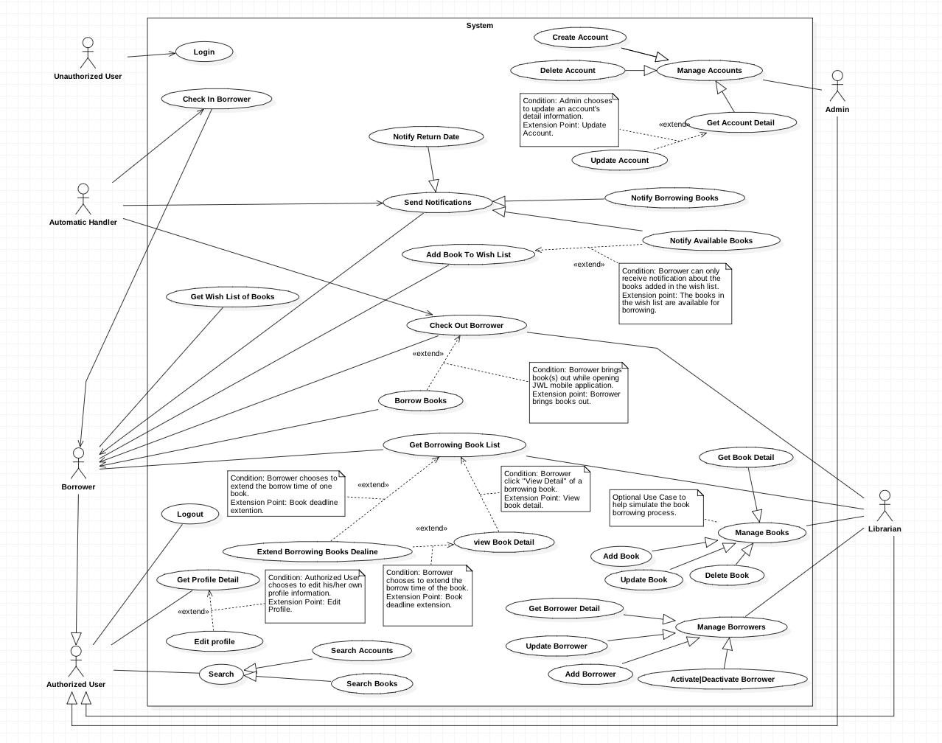

Figure <Use Case> System overview



#### Web Application

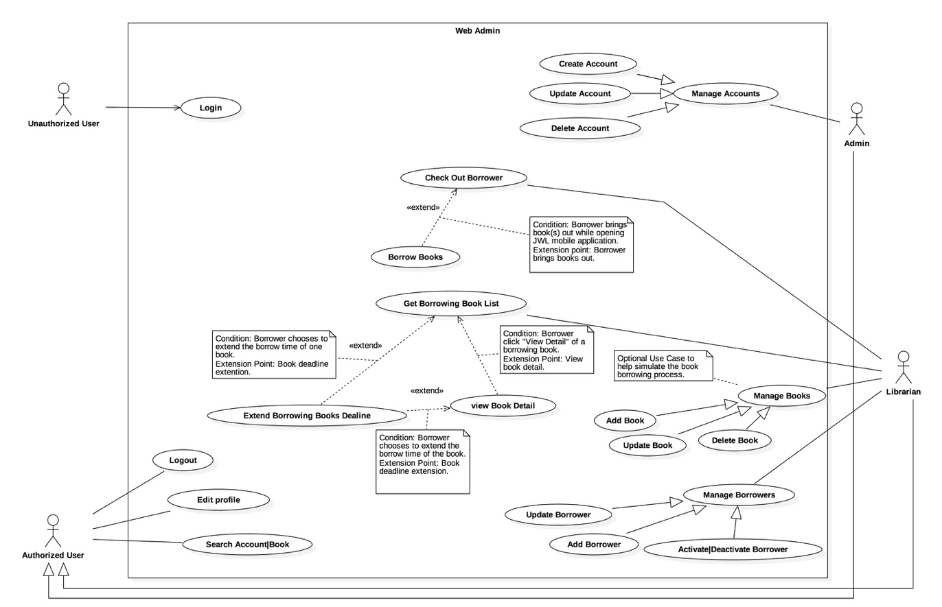

Figure : <Use case> Web overview

#### Mobile Application

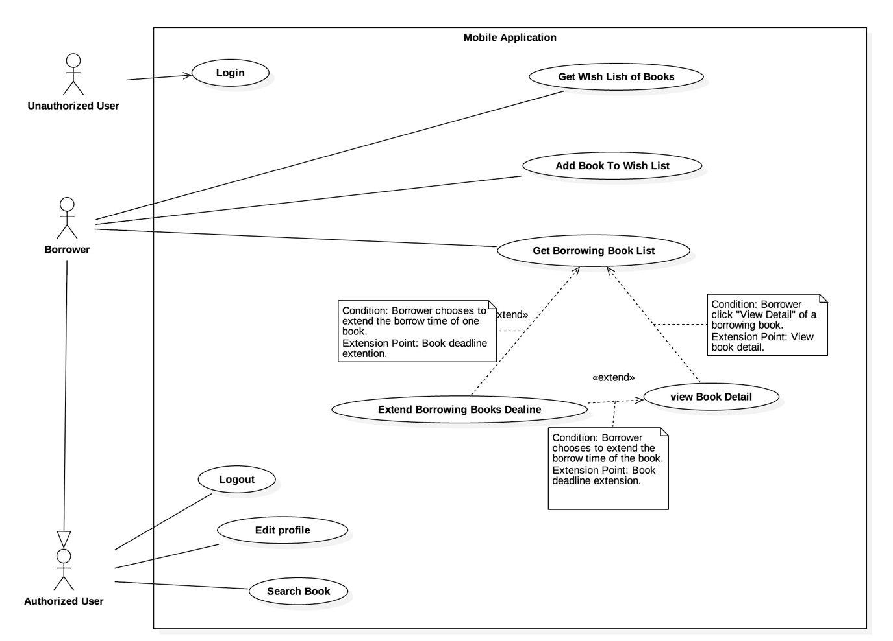

Figure : <Use case> Mobile application overview



### List of Use Case

#### Common Use Case

##### Unauthorized User

###### <Unauthorized User> Overview use case



Figure : <Unauthorized User> Overview Use Case

###### <Unauthorized User> Login



Figure : <Unauthorized User> Login

|  |  |  |  |
| --- | --- | --- | --- |
| **USE CASE – JWL01** | | | |
| **Use Case No.** | JWL01 | **Use Case Version** | 1.0 |
| **Use Case Name** | Login | | |
| **Author** | Nguyen Tuan Anh | | |
| **Date** | February 15, 2017 | **Priority** | Normal |
| **Actor:**   * Unauthorized User.   **Summary:**   * This use case allows Unauthorized User to log into the system with a specific role.   **Goal:**   * Authenticate user, redirect user to a specific view based on the user’s role.   **Triggers:**   * Unauthorized User sends Login command.   **Preconditions:** N/A  **Post Conditions:**   * **Success:** Unauthorized User is logged into the system as Authorized User. * **Fail:** N/A   **Main Success Scenario:**   |  |  |  | | --- | --- | --- | | Step | Actor Action | System Response | | 1 | Unauthorized User inputs user ID and password.  [Alternative 1] |  | | 2 | Unauthorized User sends Login command. | Unauthorized User will be logged into System with their specific role.  The system redirects to the role’s view. |   **Alternative Scenario:**   |  |  |  | | --- | --- | --- | | No. | Actor Action | System Response | | 1 | | Unauthorized user   * Leaves the user ID and password field empty, or * Inputs wrong user ID or password | System displays the error message: “Your user ID or password is invalid.” |   **Exception:** N/A  **Relationships:** This use case will be extended by all other use cases, depending on the Actor’s role in the system.  **Business Rules:**   * System authenticates Actor by checking the user ID and password. * Actor enters password in a free text field which hides the password. * Actor’s password must be encrypted before sending to server. * After logged in to the system, the Actor will be redirected to a specific view:   For web view:   * If the role is “Admin”, the system will display Admin view. * If the role is “Librarian”, the system will display Librarian view.   For mobile application view:  + If the role is “Borrower”, the system will display the mobile application’s view. | | | |

Table : <Unauthorized User> Login

##### Authorized User

###### <Authorized User> Overview Use Case

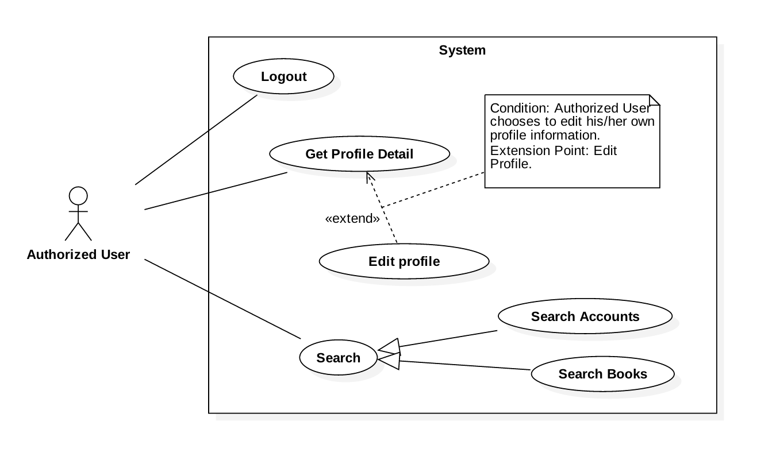

Figure : <Authorized User> Overview Use Case

###### <Authorized User> Get Profile Detail



Figure : <Authorized User> Get Profile Detail

|  |  |  |  |
| --- | --- | --- | --- |
| **USE CASE – JWL02** | | | |
| **Use Case No.** | JWL02 | **Use Case Version** | 1.0 |
| **Use Case Name** | Get Profile Detail | | |
| **Author** | Nguyen Tuan Anh | | |
| **Date** | February 20, 2017 | **Priority** | Normal |
| **Actor:**   * Authorized User.   **Summary:**  This use case allows an Actor to view his/her profile detail information, including:   * + - * User image       * User ID       * Full name       * Date of Birth       * Email       * Address       * Phone number       * Place of Work       * User Role   **Goal:**   * The System shows the Actor his/her profile detail information.   **Triggers:**   * The Actor sends Get Profile Detail command.   **Preconditions:**   * The Actor logged into the system.   **Post Conditions:**   * **Success:** The System shows the Actor his/her profile detail information. * **Fail:** N/A.   **Main Success Scenario:**   |  |  |  | | --- | --- | --- | | Step | Actor Action | System Response | | 1 | Actor sends Get Profile Detail. | System shows the Actor his/her profile detail information:   * “User image”: image * “User ID”: label * “Full name”: label * “Date of Birth”: label * “Email”: label * “Address”: label * “Phone number”: label * “Place of Work”: label * “User Role”: label |   **Alternative Scenario:** N/A  **Exceptions:** N/A  **Relationships:** From this use case, an Actor can [Edit Profile](#_<Authorized_User>_Edit).  **Business Rules:**   * This use case only allows an Actor to get his/her own detail information. | | | |

Table : <Authorized User> Get Profile Detail

###### <Authorized User> Logout



Figure : <Authorized User> Logout

|  |  |  |  |
| --- | --- | --- | --- |
| **USE CASE – JWL03** | | | |
| **Use Case No.** | JWL03 | **Use Case Version** | 1.0 |
| **Use Case Name** | Logout | | |
| **Author** | Nguyen Tuan Anh | | |
| **Date** | February 15, 2017 | **Priority** | Normal |
| **Actor:**   * Authorized User.   **Summary:**   * This use case allows Authorized User to log out off the system and become an Unauthorized User.   **Goal:**   * Invalidate the Authorized User, redirect the User to login view.   **Triggers:**   * Authorized User sends Logout command.   **Preconditions:**   * Actor logged in the system as an Authorized User.   **Post Conditions:**   * **Success:** Authorized User is logged out off the system and becomes Unauthorized User. * **Fail:** N/A   **Main Success Scenario:**   |  |  |  | | --- | --- | --- | | Step | Actor Action | System Response | | 1 | Authorized User sends Logout command.  [ Alternative 1] | System redirects the User to login view. |   **Alternative Scenario:**   |  |  |  | | --- | --- | --- | | No. | Cause | System Response | | 1 | | After at least one month not using the System, User sends any authorized commands. | System automatically redirects the User to login view. |   **Exceptions:** N/A  **Relationships:** N/A  **Business Rules:**   * Authorized User’s session ends after one month of inactivity. | | | |

Table : <Authorized User> Logout

###### <Authorized User> Edit Profile



Figure : <Authorized User> Edit Profile

|  |  |  |  |
| --- | --- | --- | --- |
| **USE CASE – JWL04** | | | |
| **Use Case No.** | JWL04 | **Use Case Version** | 1.0 |
| **Use Case Name** | Edit Profile | | |
| **Author** | Nguyen Tuan Anh | | |
| **Date** | February 16, 2017 | **Priority** | Normal |
| **Actor:**   * Authorized User.   **Summary:**  This use case allows an Actor to edit his/her personal information, including:   * + - * Full name       * Password       * Email       * Address       * Date of birth       * Phone number       * Place of work   **Goal:**   * Update the Actor’s personal information according to the Actor’s input.   **Triggers:**   * The Actor sends Edit Profile command.   **Preconditions:**   * The Actor must be logged into the System.   **Post Conditions:**   * **Success:** The Actor’s personal information is updated in the database. * **Fail:** System displays error messages according to fail reasons (see table **Exception**).   **Main Success Scenario:**   |  |  |  | | --- | --- | --- | | Step | Actor Action | System Response | | 1 | Actor sends Edit Profile command. | System lists out the information of the account:   * “Full name”: free text input * “Password”: free text input that hides user’s password * “Confirm Password”: free text input that hides users’ confirm password * “Date of Birth”: free text input that allows Actor to input day - month - year * “Email”: free text input * “Address”: free text input * “Phone number”: free text input * “Place of Work”: free text input | | 2 | Actor updates information. |  | | 3 | Actor sends Submit command. | * System validates the inputs then updates the account’s profile. * System redirect the Actor to the Get Profile Detail’s view. * System displays a successful message: “Update Successfully.”   [Exception 1, 2, 3, 4, 5, 6, 7] |   **Alternative Scenario:** N/A  **Exception:**   |  |  |  | | --- | --- | --- | | No | Cause | System Response | | 1 | Actor inputs Full Name field with the following wrong format:   * Blank, or all space characters * Longer than 100 characters. | System displays error messages:   * “Full name is required.” * “Full name must not be longer than 100 characters.” | | 2 | Actor inputs Password field with the following wrong format:   * Blank, or all space characters * Shorter than 6 characters * Longer than 50 characters | System displays error messages:   * “Password is required.” * “Password’s length is 6-50 characters.” | | 3 | Actor inputs Confirm Password field that does not match Password field. | System displays error message: “Confirm Password must match Password.” | | 4 | Actor inputs Email field with the following wrong format:   * Blank, or all space characters * Wrong email format (email format: [user.name]@[email.name]). | System displays error messages:   * “Email is required.” * “Wrong Email format. Please input something like your.name@mail.com” | | 5 | Actor inputs Address field with the following wrong format:   * Blank or all space characters * Longer than 250 characters | System displays error messages:   * “Address is required.” * “Address must not be longer than 250 characters.” | | 6 | Actor inputs Phone Number field with the following wrong format:   * Blank or all space characters * Wrong phone number format | System display error messages:   * “Phone Number is required.” * “Phone Number should be like +841692536224 or 01692536224.” | | 7 | Actor inputs Place of Work field with the following wrong format:   * Blank or all space characters * Longer than 100 characters | System displays error message:   * “Place of Work is required.” * “Place of Work must not be longer than 100 characters.” |   **Relationships:** Actor can only Edit Profile from [Get Profile Detail](#_<Authorized_User>_Get).  **Business Rules:**   * Actor’s information must not be blank. * Full name’s and place of work’s length must not be longer than 100 characters. * Password’s length is 6-50 characters. * Confirm password must match input password. * Email must be in format: [user.name]@[email.name]. * Phone number must be in format: +[phone no.] or [phone no.] * Address’s length must not be longer than 250 characters. * Password and Confirm Password must be encrypted before saving to the system. * Actor cannot update username, or user role. * This use case only allows an Actor to update his/her own profile information. | | | |

Table : <Authorized User> Edit Profile

#### Web Application

##### Librarian

###### <Librarian> Overview Use Case

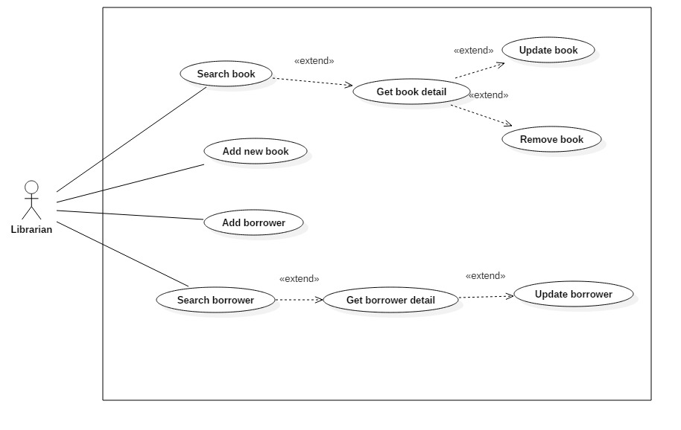

Figure : <Librarian> Overview Use Case

###### <Librarian> Search Book



Figure : <Librarian> Search Book

|  |  |  |  |
| --- | --- | --- | --- |
| **USE CASE – JWL09** | | | |
| **Use Case No.** | JWL09 | **Use Case Version** | 1.0 |
| **Use Case Name** | Search Book | | |
| **Author** | Dang Nhat Thien | | |
| **Date** | February 12, 2017 | **Priority** | Normal |
| **Actor:**   * Librarian   **Summary:**   * This use case allows Librarian to search book in library to view book detail.   **Goal:**   * Librarian can get a list book that match input book’s title.   **Triggers:**   * Librarian send Search command.   **Preconditions:**   * Actor logged in system with role Librarian.   **Post Conditions:**   * **Success:** List of matching books based on search term is showed. * **Fail:** N/A   **Main Success Scenario:**   |  |  |  | | --- | --- | --- | | Step | Actor Action | System Response | | 1.  2. | Librarian inputs wanted book’s title.  Librarian sends Search command. | System loads the result. Information for each book:   * No. * Title * Authors * Publisher * Publish year * Number of copies   [Alternative 1] |   **Alternative Scenario:**   |  |  |  | | --- | --- | --- | | Step | Cause | System Response | | 1 | There is no book that matches the search term. | System shows message: “No book found.” |   **Exceptions:** N/A  **Relationships:** Search book successfully, so librarian should Get book detail. Get book detail is extended from Search book.  **Business Rules:**   * Number of copies will show with format: [Remain] copies / [Total] copies. * Add action button to the last columns, so Librarian can Get book detail. * No: free text input * Book Title: free text input * Publisher: free text input * Description: free text input * Publish year: free text input * Number of pages: free text input * Number of copies: free text input * Book type: free text input, get book type name from book\_tye table. * Position: free text input, get floor, shelf from position table. * ISBN: free text input * Category: free text input, get category name from category table. * Author: free text input, get author name from author table. | | | |

Table : <Librarian> Search Book

###### <Librarian> Add Book

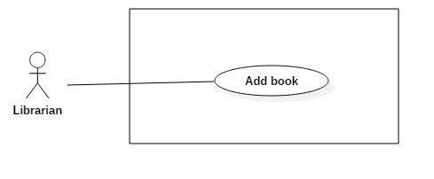

Figure : <Librarian> Add Book

|  |  |  |  |
| --- | --- | --- | --- |
| **USE CASE – JWL10** | | | |
| **Use Case No.** | JWL10 | **Use Case Version** | 1.1 |
| **Use Case Name** | Add Book | | |
| **Author** | Dang Nhat Thien | | |
| **Date** | March 15, 2017 | **Priority** | Normal |
| **Actor:**   * Librarian   **Summary:**   * Librarian adds new book information to the system database when the library obtains new books.   **Goal:**   * New books are available in the library system.   **Triggers:**   * Librarian sends “Add New Book” command.   **Preconditions:**   * Actor logged in system with role Librarian.   **Post Conditions:**   * **Success:** System show message: “Add successfully!” * **Fail:** N/A   **Main Success Scenario:**   |  |  |  | | --- | --- | --- | | Step | Actor Action | System Response | | 1  2  3 | Librarian send Add New Book  command.  Librarian input information.  [Alternative 1,2]  Librarian send “Save” command.  [Alternative 3] | System lists out the information of new Book:   * “Thumbnail”: the image Librarian can click to upload. Only JPG, PNG, JPEG format are accepted. Maximum file size is 3 MB, required. * “Book title”: free text input, required, length 1-50 * “Publisher”: free text input, required, length 1-100 * “Publish year”: free number input, required, max length 4 * “Page number”: free number input, required, length 1-4 * “Description”: free number input, required, length 1-500 * “Floor”: free number input, required, length 2 * “Shelf”: free text input, required, length 2. * “Author: free text input, required, length 1 – 50 * “Book type”: list of book type, required. * “Book category”: list of checkbox, required. * “RFID”: free text input, max length 10, required. * “Add new copy” command. * “Delete copy” command. * “Save” command. * “Cancel” command.   When text change, system verifies input information.  [Exception 1,2,3,4,5,6,7,8,9,10,11,12]  System verifies input information. New Book with all copies of it are saved to database. The system show message “Book [title] has been added!”  [Exception 1,2,3,4,5,6,7, 8, 9, 10, 11,12] |   **Alternative Scenario:**   |  |  |  | | --- | --- | --- | | No | Cause | System Response | | 1 | Librarian send “Add New Copy” command. | This corresponding RFID is display in a list below Book information. [Exception 6]  “RFID” will be clear. | | 2 | Librarian send “Delete Copy” command. | This corresponding RFID is deleted from list. | | 3 | Librarian send “Cancel” command. | System return to main view. |   **Exceptions:**   |  |  |  | | --- | --- | --- | | No | Cause | System Response | | 1 | Librarian inputs Book title field with wrong format. | System displays error message: “Book title’s length must be 1 - 50 characters.” | | 2 | Librarian inputs Publisher field with wrong format. | System displays error message: “Publisher’s length must be 1-100 characters.” | | 3 | Librarian inputs Publish year field with wrong format. | System displays error message: “Publish year must be a positive integer number and max length is 4” | | 4 | Librarian inputs Page number field with wrong format. | System displays error message: “Page must be a positive integer number and max length is 4” | | 5 | Librarian inputs Description field with wrong format. | System displays error message: “Description’s length is 1 - 500 characters” | | 6 | Librarian inputs RFID field with wrong format. | System displays error message: “RFID’s length is 10 characters.” | | 7 | Librarian send Save command with no RFID is added. | System display error message: “Please input at least one RFID.” | | 8 | Librarian inputs Floor field with wrong format. | System displays error message: “Floor must be a positive integer number and max length is 2” | | 9 | Librarian inputs Shelf field with wrong format. | System display error message: “Shelf length is 2 characters” | | 10 | Librarian inputs Author field with wrong format. | System display error message: “Author length is 1 – 50 characters”. | | 11 | Librarian pick up wrong format file. | System display error message: “Image extension are JPG, JPEG, PNG only and maximum size 3MB” | | 12 | Librarian does not pick up an image. | System display error message: “Please choose a thumbnail for book.” |   **Relationships:** Add successfully a new book so librarian can search, update, remove this.  **Business Rules:**   * “Book title”: free text input, length 1-50. * “Publisher”: free text input, length 1-100. * “Publish year”: free text input, length 4. * “Page Number”: free text input, length 1-4. * “Description”: free text input, length 1-500. * “RFID”: free text input, length 10. * “Floor”: free text input, length 2. * “Shelf”: free text input, length 2. * “Author”: free text input, length 1-50. * RFID must be added whenever Add New Book. * Floor and Shelf are two attributes of Position. | | | |

Table : <Librarian> Add Book

###### <Librarian> Get Book Detail

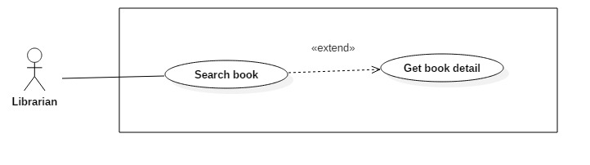

Figure : <Librarian> Get Book Detail

|  |  |  |  |
| --- | --- | --- | --- |
| **USE CASE – JWL11** | | | |
| **Use Case No.** | JWL11 | **Use Case Version** | 1.0 |
| **Use Case Name** | Get Book Detail | | |
| **Author** | Dang Nhat Thien | | |
| **Date** | March 16, 2017 | **Priority** | Low |
| **Actor:**   * Librarian   **Summary:**   * This use case allows Librarian to view book detail, so Librarian can Update/Delete book.   **Goal:**   * Full information of book is displayed.   **Triggers:**   * Librarian sends View Book Detail command.   **Preconditions:**   * Actor logged in system with role Librarian. * Librarian find out the Book want to view detail via Search Book.   **Post Conditions:**   * **Success:** System show all information of a specific Borrower. * **Fail:** N/A.   **Main Success Scenario:**   |  |  |  | | --- | --- | --- | | Step | Actor Action | System Response | | 1 | Librarian sends View Book Detail. | System lists out the information of the book:   * Thumbnail * Title * Publisher * Publish year * Page number * Description * Position * Author * Book type * Book category * Caution money * Max number of late days * List of copies that are being borrowed |   **Alternative Scenario:** N/A  **Exception:** N/A  **Relationships:** Librarian must find out the Book want to view detail via Search Book  **Business Rules:** N/A | | | |

Table : <Librarian> Get Book Detail

###### <Librarian> Update Book

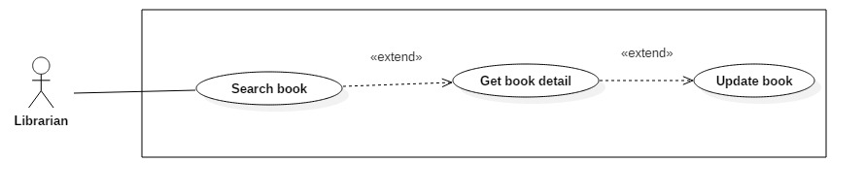Figure : <Librarian> Update Book

|  |  |  |  |
| --- | --- | --- | --- |
| **USE CASE – JWL12** | | | |
| **Use Case No.** | JWL12 | **Use Case Version** | 1.1 |
| **Use Case Name** | Update Book | | |
| **Author** | Dang Nhat Thien | | |
| **Date** | March 15, 2017 | **Priority** | Normal |
| **Actor:**   * Librarian   **Summary:**   * This use case allows Librarian to update information of books.   **Goal:**   * Book’s information will be updated.   **Triggers:**   * Librarian send Update Book command.   **Preconditions:**   * Actor logged in system with role Librarian. * Librarian find out the Book want to update.   **Post Conditions:**   * **Success: S**ystem show message: “Update successfully!” * **Fail:** N/A   **Main Success Scenario:**   |  |  |  | | --- | --- | --- | | Step | Actor Action | System Response | | 1  2  3 | Librarian sends Update Book  command from a Book Detail.  Librarian input information.  [Alternative 1,2]  Librarian send “Save” command.  [Alternative 3] | System lists out the information of new Book:   * “Thumbnail”: Image Librarian can click on to upload. Only JPG, PNG, JPEG format are accepted. Maximum file size is 3 MB, required. * “Book title”: free text input, required, length 1-50 * “Publisher”: free text input, required, length 1-100 * “Publish year”: free number input, required, max length 4 * “Page number”: free number input, required, length 1-4 * “Description”: free number input, required, length 1-500 * “Floor”: free number input, required, length 2 * “Shelf”: free text input, required, length 2. * “Author: free text input, required, length 1 – 50 * “Book type”: list of book type, required. * “Book category”: list of checkbox, required. * “RFID”: free text input, max length 10, required. * “Add new copy” command. * “Delete copy” command. * “Save” command. * “Cancel” command.   When text change, system verifies input information.  [Exception 1,2,3,4,5,6,7,8,9,10,11,12]  System verifies input information. New Book with all copies of it are saved to database. The system show message “Book [title] has been added!”  [Exception 1,2,3,4,5,6,7, 8, 9, 10, 11,12] |   **Alternative Scenario:**   |  |  |  | | --- | --- | --- | | No | Cause | System Response | | 1 | Librarian send “Add New Copy” command. | This corresponding RFID is display in a list below Book information. [Exception 6]  “RFID” will be clear. | | 2 | Librarian send “Delete Copy” command. | This corresponding RFID is deleted from list. | | 3 | Librarian send “Cancel” command. | System return to main view. |   **Exceptions:**   |  |  |  | | --- | --- | --- | | No | Cause | System Response | | 1 | Librarian inputs Book title field with wrong format. | System displays error message: “Book title’s length must be 1 - 50 characters.” | | 2 | Librarian inputs Publisher field with wrong format. | System displays error message: “Publisher’s length must be 1-100 characters.” | | 3 | Librarian inputs Publish year field with wrong format. | System displays error message: “Publish year must be a positive integer number and max length is 4” | | 4 | Librarian inputs Page number field with wrong format. | System displays error message: “Page must be a positive integer number and max length is 4” | | 5 | Librarian inputs Description field with wrong format. | System displays error message: “Description’s length is 1 - 500 characters” | | 6 | Librarian inputs RFID field with wrong format. | System displays error message: “RFID’s length is 10 characters.” | | 7 | Librarian send Save command with no RFID is added. | System display error message: “Please input at least one RFID.” | | 8 | Librarian inputs Floor field with wrong format. | System displays error message: “Floor must be a positive integer number and max length is 2” | | 9 | Librarian inputs Shelf field with wrong format. | System display error message: “Shelf length is 2 characters” | | 10 | Librarian inputs Author field with wrong format. | System display error message: “Author length is 1 – 50 characters”. | | 11 | Librarian pick up wrong format file. | System display error message: “Image extension are JPG, JPEG, PNG only and maximum size 3MB” | | 12 | Librarian does not pick up an image. | System display error message: “Please choose a thumbnail for book.” |   **Relationships:** Librarian must find out a book then get book detail.  **Business Rules:**   * “Book title”: free text input, length 1-50. * “Publisher”: free text input, length 1-100. * “Publish year”: free text input, length 4. * “Page Number”: free text input, length 1-4. * “Description”: free text input, length 1-500. * “RFID”: free text input, length 10. * “Floor”: free text input, length 2. * “Shelf”: free text input, length 2. * “Author”: free text input, length 1-50. * RFID must be added whenever Add New Book. * Floor and Shelf are two attributes of Position. | | | |

Table : <Librarian> Update Book

###### <Librarian> Remove Book

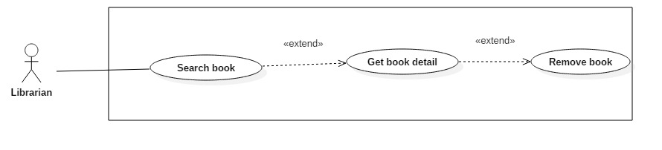

Figure : <Librarian> Remove Book

|  |  |  |  |
| --- | --- | --- | --- |
| **USE CASE – JWL13** | | | |
| **Use Case No.** | JWL13 | **Use Case Version** | 1.1 |
| **Use Case Name** | Remove Book | | |
| **Author** | Dang Nhat Thien | | |
| **Date** | March 15, 2017 | **Priority** | Normal |
| **Actor:**   * Librarian   **Summary:**   * This use case allows Librarian to remove books when all copies of books are unusable or the Library does not provide books anymore.   **Goal:**   * Librarian remove book and all of copies. The books and copies are not available in the library system. Borrowers can’t search and borrow.   **Triggers:**   * Librarian send Remove Book command.   **Preconditions:**   * Actor logged in system with role Librarian. * Librarian find out the Book want to remove via [<Librarian> Search Book](#_<Librarian>_Search_Book) * The book must be available in the library system.   **Post Conditions:**   * **Success:** System show message: “Removed successfully!” * **Fail:** N/A   **Main Success Scenario:**   |  |  |  | | --- | --- | --- | | Step | Actor Action | System Response | | 1  2 | Librarian send “Remove” Book  Command on a specific book.  Librarian send “Yes” command.  [Alternative 1] | System displays confirmation message: “Are you sure to remove this book?”.  System removes the book and show message: “Removed successfully!”  [Exception 1] |   **Alternative Scenario:**   |  |  |  | | --- | --- | --- | | No | Cause | System Response | | 1 | Librarian send “Cancel” command. | System return to main view. |   **Exceptions:**   |  |  |  | | --- | --- | --- | | No | Cause | System Response | | 1 | The book is being borrowed. | System displays error message: “Book is being borrowed. Can’t be removed!” |   **Relationships:** Librarian must find out a book via[<Librarian> Search Book](#_<Librarian>_Search_Book) to remove.  **Business Rules:**   * Book have copy is borrowing can’t be removed. * If book has been borrowed, change status to “false”. | | | |

Table : <Librarian> Remove Book

###### <Librarian> Add Borrower



Figure : <Librarian> Add Borrower

|  |  |  |  |
| --- | --- | --- | --- |
| **USE CASE – JWL14** | | | |
| **Use Case No.** | JWL14 | **Use Case Version** | 1.0 |
| **Use Case Name** | Add Borrower | | |
| **Author** | Dang Nhat Thien | | |
| **Date** | February 13, 2017 | **Priority** | Normal |
| **Actor:**   * Librarian   **Summary:**   * This use case allows Librarian to create an account for Borrower when someone ask to subscribe the library.   **Goal:**   * New account for borrower is created with status: “Activate”.   **Triggers:**   * Librarian sends Create Borrower command.   **Preconditions:**   * Actor logged in system with role Librarian.   **Post Conditions:**   * **Success:** Show success message: “Added successfully!”. * **Fail:** N/A   **Main Success Scenario:**   |  |  |  | | --- | --- | --- | | Step | Actor Action | System Response | | 1 | Librarian sends Create Borrower  command. | System lists out the information of the new account:   * “User Image”: Image Librarian can click on to upload. Only JPG, PNG, JPEG format are accepted. Maximum file size is 3 MB, required. * “User ID”: free text input, length 6-15 * “Full Name”: free text input, length 1-100 * “Email”: free text input * “Address”: free text input, length 1-250 * “Date of Birth”: view that allows Librarian to pick day – month - year * “Phone number”: free text input, length 8-12 * “Place of Work”: free text input: length 6-50 | | 2 | Librarian input the information. | System validate the corresponding field whenever text changed.  [Exception 1, 2, 3, 4, 5, 6, 7, 8, 9] | | 3 | Librarian sends “Save” command. | System validates the input then create a new borrower.  System displays a successful message: “New Borrower: [User Id] is added.”  [Exception 1, 2, 3, 4, 5, 6, 7, 8, 9] |   **Alternative Scenario:** N/A  **Exceptions:**   |  |  |  | | --- | --- | --- | | No | Cause | System Response | | 1 | Librarian pick up wrong format file. | System display error message: “Image extension are JPG, JPEG, PNG only and maximum size 3MB” | | 2 | Librarian does not pick up an image. | System display error message: “Please choose a picture for Borrower.” | | 3 | Librarian inputs User Id field with wrong format. | System displays error message: “User Id length is 6-15 characters.” | | 4 | Librarian inputs Full Name field with wrong format. | System displays error message: “Full name length is 1-100 characters.” | | 5 | Librarian inputs Email field with wrong format. | System displays error message: “Wrong Email format. Please input something like abc@somemail.com” | | 6 | Librarian inputs Address field with wrong format. | System displays error message: “Address length is 1-125 characters.” | | 7 | Librarian don’t pick up a Date of Birth. | System displays error message: “Have to pick up a Date of Birth for borrower.” | | 8 | Librarian inputs Phone Number field with wrong format. | System displays error message: “Phone Number should be all numbers at 8-12 length.” | | 9 | Librarian inputs Place of Work field with wrong format. | System displays error message: “Place of Work length is 6-50 characters.” |   **Relationships:** Librarian create success a borrower account, so borrower should login to the system with borrower role.  **Business Rules:**   * Password is a random string has length is 4. User can change password from phone when login first time. * Email format: abc@somemail.com | | | |

Table : <Librarian> Add Borrower

###### <Librarian> Search Borrower



Figure : <Librarian> Search Borrower

|  |  |  |  |
| --- | --- | --- | --- |
| **USE CASE – JWL15** | | | |
| **Use Case No.** | JWL15 | **Use Case Version** | 1.0 |
| **Use Case Name** | Search Borrower | | |
| **Author** | Dang Nhat Thien | | |
| **Date** | February 13, 2017 | **Priority** | Normal |
| **Actor:**   * Librarian   **Summary:**   * This use case allows Librarian to search for a borrower to view his/her detail information, including his/her borrowing books.   **Goal:**   * Librarian can get a list of borrowers that match input userID.   **Triggers:**   * Librarian send Search Borrower command.   **Preconditions:**   * Actor logged in system with role Librarian.   **Post Conditions:**   * **Success:** List of matching borrowers based on search term is showed. * **Fail:** N/A   **Main Success Scenario:**   |  |  |  | | --- | --- | --- | | Step | Actor Action | System Response | | 1  2 | Librarian inputs wanted userID.  Librarian send Search command. | System loads the result. Information for each Borrower:   * No. * UserID * Full name * Email * Is in Library * Is activated   [Alternative 1] |   **Alternative Scenario:**   |  |  |  | | --- | --- | --- | | Step | Cause | System Response | | 1 | There is no borrower that matches the search term. | System shows message: “We could not find any borrowers with userID like [search term]” |   **Exceptions:** N/A  **Relationships:** Search book successfully, so librarian can Get book detail. Get book detail is extended from Search book.  **Business Rules:**   * UserId: free text input, get from account table. * Email: text, get from profile table. * Is in Library: text (True/False), get from account table. * Is activate: text (True/False), get from account table. * View detail command. | | | |

Table : <Librarian> Search Borrower

###### <Librarian> Get Borrower Detail

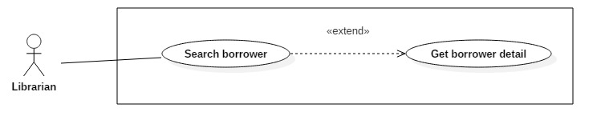

Figure : <Librarian> Get borrower detail.

|  |  |  |  |
| --- | --- | --- | --- |
| **USE CASE – JWL16** | | | |
| **Use Case No.** | JWL16 | **Use Case Version** | 1.0 |
| **Use Case Name** | Get Borrower Detail | | |
| **Author** | Dang Nhat Thien | | |
| **Date** | March 16, 2017 | **Priority** | Low |
| **Actor:**   * Librarian   **Summary:**   * This use case allows Librarian to view borrower’s detail. So Librarian can Update borrower’s profile.   **Goal:**   * Full information of borrower is displayed.   **Triggers:**   * Librarian sends View Profile Detail command.   **Preconditions:**   * Actor logged in system with role Librarian. * Librarian find out the Borrower want to view detail via [<Librarian> Search Borrower](#_<Librarian>_Search_Borrower)   **Post Conditions:**   * **Success:** System show all information of a specific Borrower. * **Fail:** N/A.   **Main Success Scenario:**   |  |  |  | | --- | --- | --- | | Step | Actor Action | System Response | | 1 | Librarian sends View Borrower Detail. | System lists out the information of the account:   * User Id * Full name * Date of birth * Email * Address * Phone number * Place of work * Status |   **Alternative Scenario:** N/A  **Exception:** N/A  **Relationships:** Librarian must find out the Borrower want to view detail via [<Librarian> Search Borrower](#_<Librarian>_Search_Borrower). After get borrower detail, Librarian can Update borrower.   * Get borrower detail is extended from Search book. * Update borrower is extended from Get borrower detail.   **Business Rules:**   * User Id: free text, get from user-id - account table. * Full name: free text, get from fullname - account table. * Date of birth: free text, get from date\_of\_birth - profile table. * Email: free text, get from email - profile table. * Address: free text, get from address - profile table. * Phone number: free text, get from phone\_no - profile table. * Place of work: free text, get from place\_of\_word – profile table. * Status: free text, get from is\_activated – account table. | | | |

Table : <Librarian> Get borrower detail.

###### <Librarian> Update Borrower

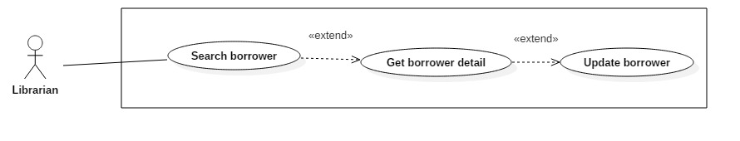

Figure : <Librarian> Update Borrower

|  |  |  |  |
| --- | --- | --- | --- |
| **USE CASE – JWL17** | | | |
| **Use Case No.** | JWL17 | **Use Case Version** | 1.1 |
| **Use Case Name** | Update Borrower Information | | |
| **Author** | Dang Nhat Thien | | |
| **Date** | March 16, 2017 | **Priority** | Low |
| **Actor:**   * Librarian   **Summary:**   * This use case allows Librarian to update borrower’s information.   **Goal:**   * Borrower’s information is changed.   **Triggers:**   * Librarian sends Update command.   **Preconditions:**   * Actor logged in system with role Librarian.   **Post Conditions:**   * **Success:** A message is displayed: “Update successfully!”. * **Fail:** N/A.   **Main Success Scenario:**   |  |  |  | | --- | --- | --- | | Step | Actor Action | System Response | | 1 | Librarian sends Update Account command on a specific account. | System lists out the information of the new account:   * “User Image”: Image Librarian can click on to upload. Only JPG, PNG, JPEG format are accepted. Maximum file size is 3 MB, required. * “User ID”: free text input, length 6-15 * “Full Name”: free text input, length 1-100 * “Password”: free text input that hides the input text, length 6-50 * “Confirm Password”: free text input that hides the input text, length 6-50 * “Email”: free text input * “Address”: free text input, length 1-250 * “Date of Birth”: view that allows Librarian to pick day – month - year * “Phone number”: free text input, length 8-12   “Place of Work”: free text input: length 6-50 | | 2 | Librarian updates information. | System validate the corresponding field whenever text changed.  [Exception 1, 2, 3, 4, 5, 6, 7, 8, 9, 10, 11] | | 3 | Librarian sends Submit command. | System validates the input then update borrower.  System displays a successful message: “Update successfully!”  [Exception 1, 2, 3, 4, 5, 6, 7, 8, 9, 10, 11] |   **Alternative Scenario:** N/A  **Exception:**   |  |  |  | | --- | --- | --- | | No | Cause | System Response | | 1 | Librarian pick up wrong format file. | System display error message: “Image extension are JPG, JPEG, PNG only and maximum size 3MB” | | 2 | Librarian does not pick up an image. | System display error message: “Please choose a picture for Borrower.” | | 3 | Librarian inputs User Id field with wrong format. | System displays error message: “User Id length is 6-15 characters.” | | 4 | Librarian inputs Full Name field with wrong format. | System displays error message: “Full name length is 1-100 characters.” | | 5 | Librarian inputs Password field with wrong format. | System displays error message: “Password length is 6-50 characters.” | | 6 | Librarian inputs Confirm Password field which does not match the Password. | System displays error message: “Confirm Password must match Password.” | | 7 | Librarian inputs Email field with wrong format. | System displays error message: “Wrong Email format. Please input something like abc@somemail.com” | | 8 | Librarian inputs Address field with wrong format. | System displays error message: “Address length is 1-125 characters.” | | 9 | Librarian don’t pick up a Date of Birth. | System displays error message: “Have to pick up a Date of Birth for borrower.” | | 10 | Librarian inputs Phone Number field with wrong format. | System displays error message: “Phone Number should be all numbers at 8-12 length.” | | 11 | Librarian inputs Place of Work field with wrong format. | System displays error message: “Place of Work length is 6-50 characters.” |   **Relationships:** Librarian must find out the Borrower want to update via [<Librarian> Search Borrower](#_<Librarian>_Search_Borrower)  **Business Rules:**   * Password must be encrypted before saving to the system. * Email format: something like abc@somemail.com. | | | |

Table : <Librarian> Update Borrower

#### Mobile Application

##### Borrower

###### <Borrower> Overview Use Case

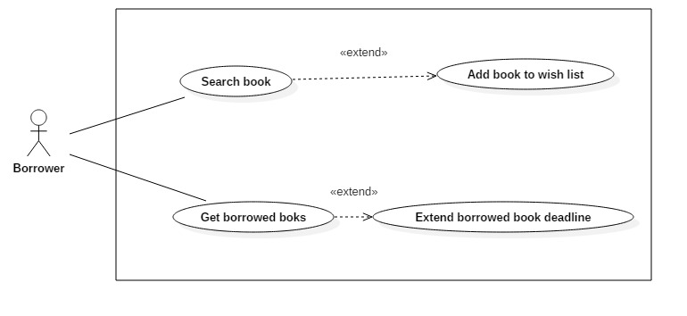

Figure : <Borrower> Overview Use Case

###### <Borrower> Search Book



Figure : <Borrower> Search Book

|  |  |  |  |
| --- | --- | --- | --- |
| **USE CASE – JWL17** | | | |
| **Use Case No.** | JWL17 | **Use Case Version** | 1.1 |
| **Use Case Name** | Search Book | | |
| **Author** | Dang Nhat Thien | | |
| **Date** | March 16, 2017 | **Priority** | Normal |
| **Actor:**   * Borrower   **Summary:**   * This use case allows Borrowers to search book. So that borrowers can view status of book, add book to wish list.   **Goal:**   * A list books that match input book’s name is displayed.   **Triggers:** Borrower send Search Command.  **Preconditions:**   * Actor logged in system with role Borrower.   **Post Conditions:**   * **Success:** List of matching books based on search term is showed. * **Fail:** A Dialog will be showed and display message: “Search fail. Please check your internet connection”.   **Main Success Scenario:**   |  |  |  | | --- | --- | --- | | Step | Actor Action | System Response | | 1 | Borrower inputs wanted book’s name.  Then send Search Command | System loads the result. Information for each account:   * Book Title * Position * Author * Is available   [Alternative 1]: There is no book that matches the search term.  [Exception 1]: Internet connection is lost. |   **Alternative Scenario:**   |  |  |  | | --- | --- | --- | | Step | Cause | System Response | | 1 | There is no book that matches the search term. | System shows message: “Không tìm thấy sách.” |   **Exceptions:**   |  |  |  | | --- | --- | --- | | No | Cause | System Response | | 1 | Internet connection is lost. | System show error message via Dialog. |   **Relationships:** Search successfully so Borrower can add book to wish list if Book is not available at that time.  **Business Rules:**   * Search return the most matched book with the search term. * Book Title: free text * Position: free text, get floor, shelf from position table. * Author: free text, get author name from author table. * Is available: Available if total book copies is more than number of borrowing books. If not, it’s not available. | | | |

Table : Borrower> Search Book

###### <Borrower> Add Book To Wish List

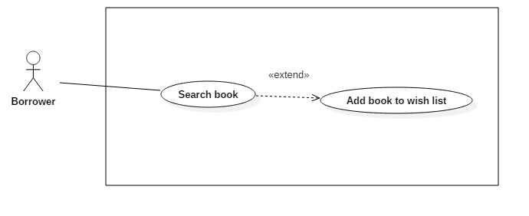

Figure : <Borrower> Add book to wish list

|  |  |  |  |
| --- | --- | --- | --- |
| **USE CASE – JWL18** | | | |
| **Use Case No.** | JWL18 | **Use Case Version** | 1.1 |
| **Use Case Name** | Add Book To Wish List | | |
| **Author** | Dang Nhat Thien | | |
| **Date** | March 16, 2017 | **Priority** | Normal |
| **Actor:**   * Borrower   **Summary:**   * Borrower Add Book To Wish List if a book is not available, so that when a book copy of that book is returned, Borrower will receive notification.   **Goal:**   * The book is saved as wish book of specific Borrower.   **Triggers:** Borrower send “Add Book To Wish List” command.  **Preconditions:**   * Actor logged in system with role Borrower. * Borrower find out the book. * Book is not available.   **Post Conditions:**   * **Success:** The system shows successful icon to the actor. * **Fail:** A dialog will be showed and display message: “Có lỗi xảy ra.”.   **Main Success Scenario:**   |  |  |  | | --- | --- | --- | | Step | Actor Action | System Response | | 1 | Borrower sends “Add To Wish List” command | * System save sto database and displays success message.   [Exception 1] Lost Internet Connection |   **Alternative Scenario:** N/A  **Exceptions:**   |  |  |  | | --- | --- | --- | | No | Cause | System Response | | 1 | Lost Internet Connection | System shows error message via Dialog. |   **Relationships:** Borrower must search book via Search book before.  **Business Rules:**   * Borrower can only add books which are currently not available to wish list. * Borrower id and book id is store in wish\_book table. * After adding book to wish list, borrower can receive notification when someone return this book. After sending notification, row has the borrower and book is deleted from wish\_book table. | | | |

Table : <Borrower> Add book to wish list

###### <Borrower> Get Borrowed Books



Figure : <Borrower> Get Borrowed Books

|  |  |  |  |
| --- | --- | --- | --- |
| **USE CASE – JWL19** | | | |
| **Use Case No.** | JWL19 | **Use Case Version** | 1.1 |
| **Use Case Name** | Get Borrowed Books | | |
| **Author** | Dang Nhat Thien | | |
| **Date** | March 16, 2017 | **Priority** | Normal |
| **Actor:**   * Borrower.   **Summary:**   * Borrower get list borrowed books to view their information, check deadline, and renew books.   **Goal:**   * List borrowed books is displayed.   **Triggers:** Borrower send “Get borrowed books” command.  **Preconditions:**   * Actor logged in system with role Borrower.   **Post Conditions:**   * **Success:** List borrowed books is displayed. * **Fail:** A dialog will be showed and display message: “Lỗi kết nối. Vui lòng kiểm tra internet”.   **Main Success Scenario:**   |  |  |  | | --- | --- | --- | | Step | Actor Action | System Response | | 1 | Borrower sends “Get borrowed books” command. | System shows list borrowed books.  [Exception 1] Lost Internet Connection. |   **Alternative Scenario:** N/A  **Exceptions:**   |  |  |  | | --- | --- | --- | | No | Cause | System Response | | 1 | Lost Internet Connection | System show error message via Dialog. |   **Relationships:** After Get Borrowed Books, Borrower can Extend Borrower Book Deadline.  **Business Rules:** N/A | | | |

Table : <Borrower> Get Borrowed Books

###### <Borrower> Extend Borrowed Book Deadline

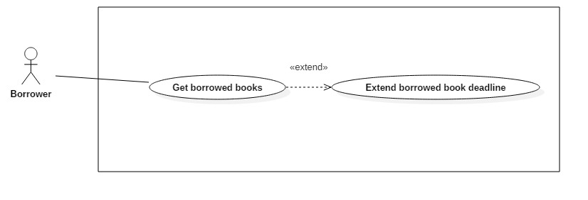

Figure : <Borrower> Extend Borrowed Book Deadline

|  |  |  |  |
| --- | --- | --- | --- |
| **USE CASE – JWL20** | | | |
| **Use Case No.** | JWL20 | **Use Case Version** | 1.1 |
| **Use Case Name** | Extend Borrowed Book Deadline | | |
| **Author** | Dang Nhat Thien | | |
| **Date** | March 16, 2017 | **Priority** | Normal |
| **Actor:**   * Borrower   **Summary:**   * Borrower wants to have more time reading a book, so he/she extend the book’s borrow time.   **Goal:**   * Book Deadline will be extended to a fixed number of days.   **Triggers:** N/A  **Preconditions:**   * Actor logged in system with role Borrower. * Book is not overdue the max number of late days of the library’s policy.   **Post Conditions:**   * **Success:** A dialog will be showed and display message: “Sách [tựa sách] đã được gia hạn đến ngày [ngày]!” * **Fail:** A dialog will be showed and display message: “Lỗi kết nối. Vui long kiểm tra lại internet!”.   **Main Success Scenario:**   |  |  |  | | --- | --- | --- | | Step | Actor Action | System Response | | 1 | After get list borrowed books, Borrower click on “Renew” button in Book detail. | System return new deadline and show success message.  [Exception 1] Lost Internet Connection. |   **Alternative Scenario:** N/A  **Exceptions:**   |  |  |  | | --- | --- | --- | | No | Cause | System Response | | 1 | Lost Internet Connection | System display error message. |   **Relationships:** Borrower can Extend Borrower Book Deadline after get Borrowed Booksvia [<Borrower> Get Borrowed Books](#_<Borrower>_Get_Borrowed)  **Business Rules:**  Book only can be extended when:   * Three or less days before deadline, or * After deadline, but book is not overdue the max number of late days in the library’s policy | | | |

Table : <Borrower> Extend Borrowed Book Deadline

##### Automatic Handler

###### <Automatic Handler> Overview Use Case

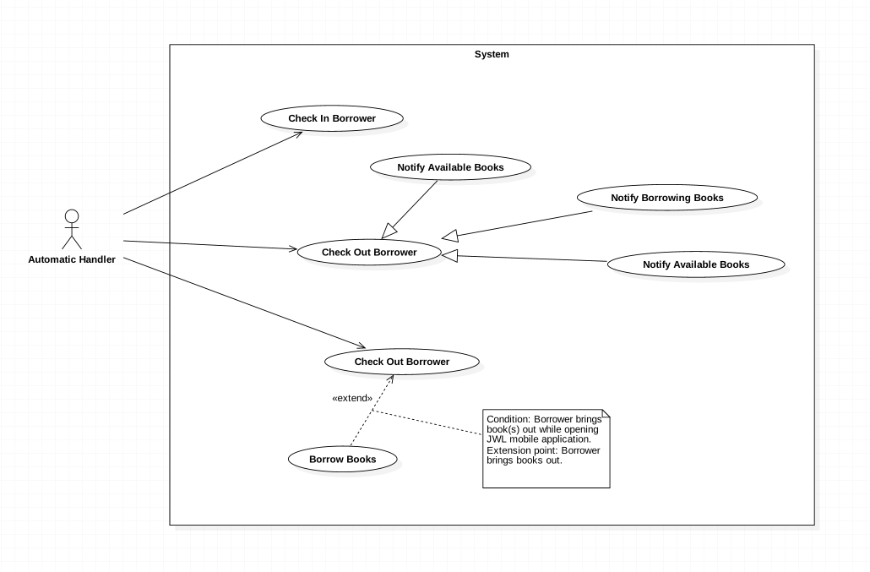

Figure : <Automatic Handler> Overview Use Case

###### <Automatic Handler> Check in Borrower



Figure : <Automatic Handler> Check in Borrower

|  |  |  |  |
| --- | --- | --- | --- |
| **USE CASE – JWL21** | | | |
| **Use Case No.** | JWL21 | **Use Case Version** | 2.0 |
| **Use Case Name** | Check in Borrower | | |
| **Author** | Vo Hong Ha | | |
| **Date** | February 13, 2017 | **Priority** | High |
| **Actor:**   * Automatic Handler   **Summary:**   * This use case allows Automatic Handler to check the attendance of those want to enter the library.   **Goal:**   * Authenticate the borrowers’ information.   **Triggers:**   * Automatic Handler checks the information of borrowers when they scan smartphone at the entrance.   **Preconditions:**   * Borrower scans NFC/QR code through the emulator.   **Post Conditions:**   * **Success:** The message will show on the application. * **Fail:** N/A   **Main Success Scenario:**   |  |  |  | | --- | --- | --- | | Step | Actor Action | System Response | | 1 | Automatic Handler check the information. | System response the message of result “Bạn đang ở trong thư viện.” |   **Alternative Scenario:** N/A  **Exceptions:** N/A  **Relationships:** N/A  **Business Rules:**   * Automatic Handler gets the information of NFC/QR code from the emulator then sends to the system. * Automatic Handler receives the response of the system, then plays sound and displays notification in comparable with that response. | | | |

Table : <Automatic Handler> Check in Borrower

###### <Automatic Handler> Notify return date



Figure : <Automatic Handler> Notify return date

|  |  |  |  |
| --- | --- | --- | --- |
| **USE CASE – JWL22** | | | |
| **Use Case No.** | JWL22 | **Use Case Version** | 1.0 |
| **Use Case Name** | Notify return date | | |
| **Author** | Vo Hong Ha | | |
| **Date** | February 13, 2017 | **Priority** | Normal |
| **Actor:**   * Automatic Handler   **Summary:**   * This use case allows Automatic Handler to send a notification to borrower about the return date of books   **Goal:**   * Borrowers are noticed 3 days prior to the return date.   **Triggers:**   * Automatic Handler send a notification to the borrower.   **Preconditions:**   * Borrower has borrowed books that have 3 days remaining.   **Post Conditions:**   * **Success:** Notification will be sent to the borrowers on the mobile application. * **Fail:** N/A   **Main Success Scenario:**   |  |  |  | | --- | --- | --- | | Step | Actor Action | System Response | | 1 | Automatic Handler send notification on noticed day. | System push a notification on the application of mobile phone:  “3 days remaining for [bookTitle]” |   **Alternative Scenario:** N/A  **Exceptions:** N/A  **Relationships:** N/A  **Business Rules:**   * The second notification will be sent on the return date in the case that the book was not returned until that date. | | | |

Table : <Automatic Handler> Notify return date

###### <Automatic Handler> Notify Borrowing Books



Figure : <Automatic Handler> Notify Borrowing Books

|  |  |  |  |
| --- | --- | --- | --- |
| **USE CASE – JWL23** | | | |
| **Use Case No.** | JWL23 | **Use Case Version** | 1.0 |
| **Use Case Name** | Notify Borrowing Books | | |
| **Author** | Vo Hong Ha | | |
| **Date** | February 13, 2017 | **Priority** | Normal |
| **Actor:**   * Automatic Handler   **Summary:**   * This use case allows Automatic Handler to send a notification to borrowers about the borrowed book after they borrow   **Goal:**   * Borrowers are noticed those books which they have borrowed   **Triggers:**   * Automatic Handler notices the list of borrowed book   **Preconditions:**   * Borrower borrow books and check out successfully.   **Post Conditions:**   * **Success:** Notification will be sent with a list of borrowed book * **Fail:** N/A   **Main Success Scenario:**   |  |  |  | | --- | --- | --- | | Step | Actor Action | System Response | | 1 | Automatic Handler send notification right after Borrower check out. | System push a notification on the application of mobile phone:  “You have check out successfully. The list of book is as follow.” |   **Alternative Scenario:** In the case the borrowers don’t check out with books, the notification will not be sent.  **Exceptions:** N/A  **Relationships:** N/A  **Business Rules:** N/A | | | |

Table : <Automatic Handler> Notify Borrowing Books

###### <Automatic Handler> Notify Available Books



Figure : <Automatic Handler> Notify Available Books

|  |  |  |  |
| --- | --- | --- | --- |
| **USE CASE – JWL24** | | | |
| **Use Case No.** | JWL24 | **Use Case Version** | 1.0 |
| **Use Case Name** | Notify Available Books | | |
| **Author** | Vo Hong Ha | | |
| **Date** | February 13, 2017 | **Priority** | Normal |
| **Actor:**   * Automatic Handler   **Summary:**   * This use case allows Automatic Handler to send a notification to borrowers about the available book according to borrower’s wish list.   **Goal:**   * Borrowers are noticed those books which are available in the library.   **Triggers:**   * Automatic Handler notices the available books.   **Preconditions:**   * Borrowers have add that books to their wish list and those books are available on the library.   **Post Conditions:**   * **Success:** Notification about the available books will be sent. * **Fail:** N/A   **Main Success Scenario:**   |  |  |  | | --- | --- | --- | | Step | Actor Action | System Response | | 1 | Automatic Handler send notification about available books. | System push a notification on the application of mobile phone:  “Some books of your wish list have available” |   **Alternative Scenario:** N/A  **Exceptions:** N/A  **Relationships:** N/A  **Business Rules:** N/A | | | |

Table : <Automatic Handler> Notify Available Books

###### <Automatic Handler> Check out Borrower



Figure : <Automatic Handler> Check out Borrower

|  |  |  |  |
| --- | --- | --- | --- |
| **USE CASE – JWL25** | | | |
| **Use Case No.** | JWL25 | **Use Case Version** | 1.0 |
| **Use Case Name** | Check out Borrower | | |
| **Author** | Vo Hong Ha | | |
| **Date** | February 13, 2017 | **Priority** | High |
| **Actor:**   * Automatic Handler   **Summary:**   * This use case allows Automatic Handler to check out the borrower.   **Goal:**   * Check the borrowers who get out of the library.   **Triggers:**   * N/A.   **Preconditions:**   * N/A.   **Post Conditions:**   * **Success:** N/A. * **Fail:** N/A   **Main Success Scenario:**   |  |  |  | | --- | --- | --- | | Step | Actor Action | System Response | | 1 | Automatic Handler check the borrower with RFID reader. | N/A |   **Alternative Scenario:** N/A  **Exceptions:** N/A  **Relationships:** N/A  **Business Rules:** N/A | | | |

Table : <Automatic Handler> Check out Borrower

###### <Automatic Handler> Check out Borrow Books



Figure : <Automatic Handler> Check out Borrow Books

|  |  |  |  |
| --- | --- | --- | --- |
| **USE CASE – JWL26** | | | |
| **Use Case No.** | JWL26 | **Use Case Version** | 1.0 |
| **Use Case Name** | Check out Borrow Books | | |
| **Author** | Vo Hong Ha | | |
| **Date** | February 13, 2017 | **Priority** | High |
| **Actor:**   * Automatic Handler   **Summary:**   * This use case allows Automatic Handler to check out the borrower’s books.   **Goal:**   * Check out the borrower whether they get out with books.   **Triggers:**   * RFID Reader scan the books of the Borrower.   **Preconditions:**   * The books have RFID tag.   **Post Conditions:**   * **Success:** N/A. * **Fail:** N/A   **Main Success Scenario:**   |  |  |  | | --- | --- | --- | | Step | Actor Action | System Response | | 1 | Automatic Handler scan the books with RFID reader. | Add the books to the borrowed list. |   **Alternative Scenario:** N/A  **Exceptions:** N/A  **Relationships:** N/A  **Business Rules:** N/A | | | |

Table : <Automatic Handler> Check out Borrow Books

## Software System Attribute



### Usability

* The Android application for emulator requires 10 minutes training for staff.
* The Android application for passenger will take 15-20 minutes to get used to the mobile system completely.

### Reliability

* The number of sending notification failure is 1 time per 1000 notifications.
* Timer tasks run at configured time with 100% execution rate.

### Availability

* System is available 24 hours per day and 7 days per week.
* System should take at most 5 hours per month for backup or repairing.

### Security

* Privacy: Each role of user has a specific permission to interact with system.
* System always checks authorization and authenticated before doing anything.
* Only admin can grant permission to other roles.

### Maintenanability

* The system is divided into separated modules.
* The code is easy to maintain and upgrade.

### Portability

* The web application is running on Heroku environment.
* Mobile application for passenger and emulator runs on Android API greater than 4.1.
* Providing easy installation.

### Performance

* Web appication handles the task within 5 seconds.

### Conceptual Diagram

**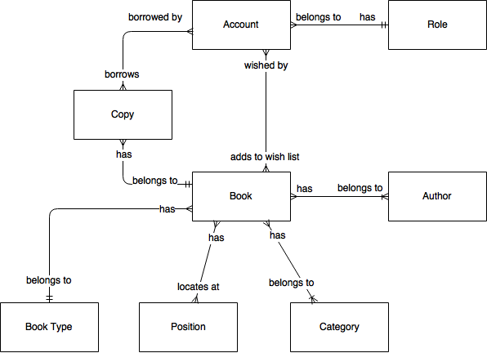**

Figure : Conceptual Diagram

**Data Dictionary:**

|  |  |
| --- | --- |
| Entity Name | Description |
| Account | Contains all information of users in the system. |
| Role | The system role of an account. |
| Book | Contains all information of books in the system. |
| Copy | Contains all information of copies of books. |
| Author | Contains all information of authors of books in the system. |
| Category | Contains all information of book’s categories, for example, Math, Literature, Physics, Software Engineering, … |
| Book Type | Contains all information of book’s types, for example, text book or reference book. |
| Position | Contains all information of physical positions of books in the system. |

Table : Conceptual Diagram Data Dictionary

# Report No. 4 Software Design Description

## Design Overview

* The architectural design describes the overall architecture of the system and the architecture of each main component and subsystem.
* The detailed design describes static and dynamic structure for each component and functions. It includes class diagrams, class explanations and sequence diagrams for each use cases.
* The database design describes the relationships between entities and details of each entity.
* Document overview:
* Section 1: gives an overall description of the system architecture design.
* Section 2: gives component diagrams that describe the connection and integration of the system.
* Section 3: gives the detail design description, which includes class diagram, class explanation, and sequence diagram to details the application functions.
* Section 4: gives the interface design description, which includes component interface, web application interface and mobile application design.
* Section 5: describe a fully attributed Entity Relationship Diagram.
* Section 6: describe the algorithms that apply to the system.

## System Architecture Design

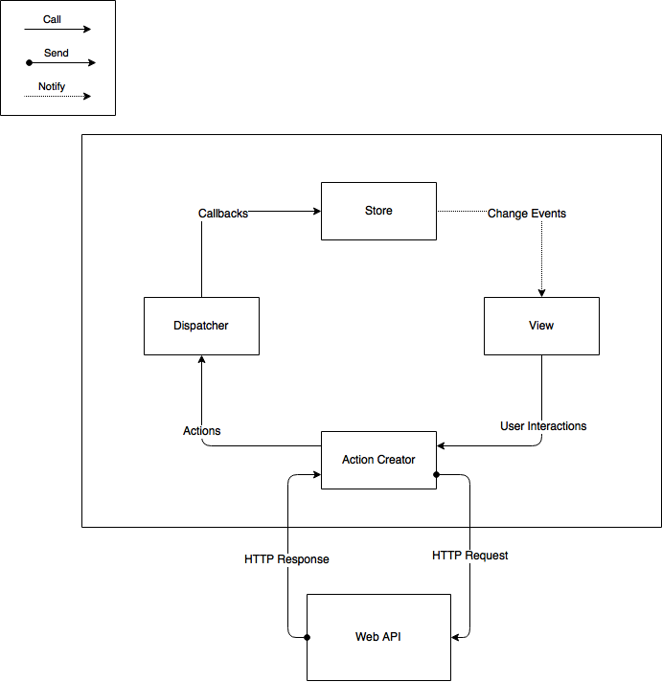

Figure : Web Application Architecture

The web application uses React (<https://facebook.github.io/react/)> with Flux (<https://facebook.github.io/flux/>) as its architecture. Flux creates a unidirectional data flow for web applications built with React. We choose this architecture for a couple of reasons:

* Performance: The web application’s render performance is dramatically improved thanks to React. React renders the web application with the help of its virtual DOM. Each React view component has a render method, which will update the virtual DOM. React then compares the updated virtual DOM with a virtual DOM snapshot that was taken right before the update. By doing so, React figures out exactly which virtual DOM objects have change, and only updates those different objects on the real DOM.
* Simplicity: the whole web application is simple to develop and maintain, because the data always flows in one direction. There is no need to handle event listener for each web component like in MVC application. This architecture also separates frontend from backend, so developers are able to work independently.
* Reusability and Testability: The architecture divides the application into components. This increases reusability and testability.

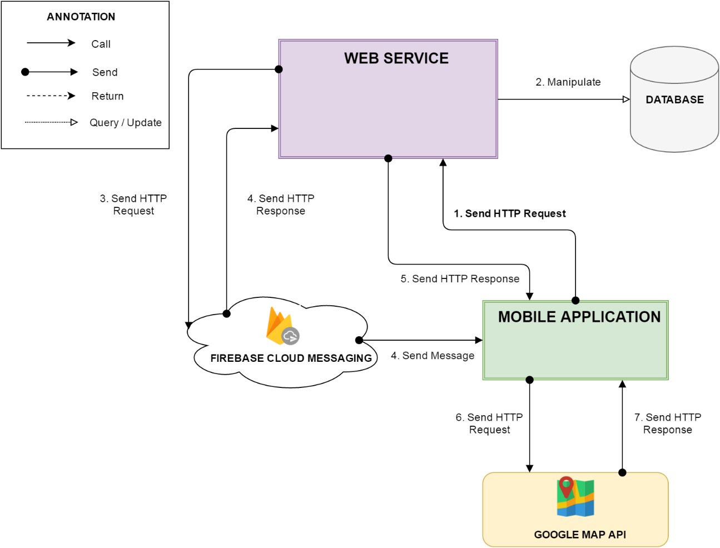

Figure : Mobile Application Architecture

### Web Application Architecture Description

In Web Application, the system is developed under MVC architecture style. We choose this architecture for Web application because of following advantages:

* Web application contains Web services with MVC architecture, we can separate business code with Controller and View. So we can use the business code in web service without repeat the code.
* We can organize the code better for maintainability, extensibility, reusability so we can expand the scope to other kind of illnesses such as flu, fever…
* In scope of 3-members team, MVC architecture makes it easier to split the big project into small modules and make it easier to assign each module for members in our team.

### Android Application Architecture Description

In our Android application, the application is developed under MVC architecture style. We choose this architecture for Android application because of following advantages:

* We can organize the code better for maintainability, extensibility and reusability.

## Component Diagram



Figure : Component Diagram

|  |  |
| --- | --- |
| Component Dictionary: Describes components | |
| Mobile application | Mobile application package |
| Web service | Provide API for mobile application to interact with the system. |
| Service | Common component is used to handle system’s business operations. |
| Admin Component | Component to handler admin activities in the system |
| Passenger Component | Component to handler passenger activities in the system |
| Staff Component | Component to handler staff activities in the system |
| Manager Component | Component to handler manager activities in the system |
| Repository | Component is used to handle interaction between the system and database. |
| Auto Handler Component | Component is used to handle scheduler in the system |
| Model | Entity framework |
| Google Firebase Service | Handle push notification with Google Firebase Message |

Table : Component Dictionary

## Detailed Description



### Class Diagram



Figure : Class Diagram

|  |  |  |
| --- | --- | --- |
| **Class Dictionary: Describe Classes** | | |
| **Class name** | **Mapping column with conceptual diagram** | **Description** |
| Subscription | Subscription | Contains the information of subscription. |
| User Subscription | Subscription | Contain the subscription information of user who subscribe an offer. |
| User | User | Contains the information of user. |
| Card | Card | Contains the information of card. |
| Ticket | Ticket | Contains the information of ticket. |
| Ticket Type | Ticket Type | Contains the information of ticket type. |
| Bus Route | Bus Route | Contains the information of bus route. |
| Credit Plan | Credit Plan | Contain the the information of credit plan which is used to add credit to card in the system. |
| Payment Transaction | N/A | Contains transaction history of card. |
| Promotion | Promotion | Contains the information of promotion. |
| Scratch Card | Scratch Card | Contains the information of scratch card. |

Table 46: Describe class

### Class diagram explanation

* + 1. Ticket Type

**Attributes**

|  |  |  |  |
| --- | --- | --- | --- |
| **Attribute** | **Type** | **Visibility** | **Description** |
| Id | Integer | Private | Unique identifier of a ticket type |
| Name | String | Private | Name of the ticket type |
| Price | Integer | Private | Price of the ticket type |
| Description | String | Private | Description of the ticket type |
| Status | Integer | Private | Status of the ticket type |

Table 47: Ticket Type Attributes

**Methods**

|  |  |  |  |
| --- | --- | --- | --- |
| **Method** | **Return type** | **Visibility** | **Description** |
| Getter | Attribute type | Public | Get attribute value |
| Setter | Void | Public | Set value of attribute |

Table 48: Ticket Type Methods

* + 1. Ticket

**Attributes**

|  |  |  |  |
| --- | --- | --- | --- |
| **Attribute** | **Type** | **Visibility** | **Description** |
| Id | Integer | Private | Unique identifier of a ticket ticket |
| CardID | Integer | Private | Unique identififer of the NFC card |
| TicketTypeId | Integer | Private | Unique identifier of the ticket type |
| BusRouteId | Integer | Private | Unique identifier of the bus route |
| Total | Integer | Private | The ticket price |
| BoughtDated | DateTime | Private | The date time that ticket is bought |
| IsNoCard | Boolean | Private | Ticket is bought by card or cash |

Table 49: Ticket Attributes

**Methods**

|  |  |  |  |
| --- | --- | --- | --- |
| **Method** | **Return type** | **Visibility** | **Description** |
| Getter | Attribute type | Public | Get attribute value |
| Setter | Void | Public | Set value of attribute |

Table 50: Ticket Methods

1. Bus Route

**Attributes**

|  |  |  |  |
| --- | --- | --- | --- |
| **Attribute** | **Type** | **Visibility** | **Description** |
| Id | Integer | Private | Unique identifier of a bus route |
| Code | String | Private | Unique code of the bus route |
| Name | String | Private | Name of the bus route |

Table 51: Bus Routes Attributes

**Methods**

|  |  |  |  |
| --- | --- | --- | --- |
| **Method** | **Return type** | **Visibility** | **Description** |
| Getter | Attribute type | Public | Get attribute value |
| Setter | Void | Public | Set value of attribute |

Table 52: Bus Routes Methods

1. Card

**Attributes**

|  |  |  |  |
| --- | --- | --- | --- |
| **Attribute** | **Type** | **Visibility** | **Description** |
| Id | Integer | Private | Unique identifier of an card |
| UniqueIdentifier | String | Private | Manufacture UID NFC card |
| CardName | String | Private | Name of the NFC card |
| RegistrationDate | DateTime | Private | Date of registration of the NFC card |
| Balance | Double | Private | Balance of the NFC card |
| Status | Integer | Private | Status of the NFC card |
| UserId | Integer | Private | Indentifier of the NFC’card holder |
| DataVersion | Long | Private | The version of data on card |

Table 53: Card Attributes

**Methods**

|  |  |  |  |
| --- | --- | --- | --- |
| **Method** | **Return type** | **Visibility** | **Description** |
| Getter | Attribute type | Public | Get attribute value |
| Setter | Void | Public | Set value of attribute |

Table 54: Card Methods

1. Payment Transaction

**Attributes**

|  |  |  |  |
| --- | --- | --- | --- |
| **Attribute** | **Type** | **Visibility** | **Description** |
| Id | Integer | Private | Unique identifier of a payment transaction |
| CardId | Integer | Private | Identifier of the NFC card |
| CreditPlanId | Date | Private | Identifier of the credit plan |
| TransactionId | String | Private | Identifier of the payment transaction |
| Total | Double | Private | Total cost of the payment transaction |
| PaymentDate | DateTime | Private | Date of payment |

Table 55: Payment Transaction Attribute

**Methods**

|  |  |  |  |
| --- | --- | --- | --- |
| **Method** | **Return type** | **Visibility** | **Description** |
| Getter | Attribute type | Public | Get attribute value |
| Setter | Void | Public | Set value of attribute |

Table 56: Payment Transaction Methods

1. User

**Attributes**

|  |  |  |  |
| --- | --- | --- | --- |
| **Attribute** | **Type** | **Visibility** | **Description** |
| Id | Integer | Private | Unique identifier of a user |
| PhoneNumber | String | Private | User’s phone number |
| Password | String | Private | User account’s password |
| Fullname | String | Private | User’s fullname |
| Status | Integer | Private | User’s statatus |
| RoleId | Integer | Private | User’s role identifier |
| DeviceToken | String | Private | Firebase notification token of a passenger’s mobile. |
| MinBalance | Integer | Private | Minimum balance of passenger’s cards that the system will notify them. |

Table 57: User Attributes

**Methods**

|  |  |  |  |
| --- | --- | --- | --- |
| **Method** | **Return type** | **Visibility** | **Description** |
| Getter | Attribute type | Public | Get attribute value |
| Setter | Void | Public | Set value of attribute |

Table 58: User Methods

1. Promotion

**Attributes**

|  |  |  |  |
| --- | --- | --- | --- |
| **Attribute** | **Type** | **Visibility** | **Description** |
| Id | Integer | Private | Unique identifier of a promotion |
| Name | String | Private | Name of the promotion |
| Description | String | Private | Description of the promotion |
| Status | Integer | Private | Status of the promotion |
| CreatedDate | DateTime | Private | Date of creation |
| ExpiredDate | DateTime | Private | Date of expiration |

Table 59: Promotion Attributes

**Methods**

|  |  |  |  |
| --- | --- | --- | --- |
| **Method** | **Return type** | **Visibility** | **Description** |
| Getter | Attribute type | Public | Get attribute value |
| Setter | Void | Public | Set value of attribute |

Table 60: Methods Methods

1. Credit Plan

**Attributes**

|  |  |  |  |
| --- | --- | --- | --- |
| **Attribute** | **Type** | **Visibility** | **Description** |
| Id | Integer | Private | Unique identifier of a credit plan |
| Name | String | Private | Name of the credit plan |
| Price | Integer | Private | Price of the credit plan |
| Status | Integer | Private | Status of the credit plan |

Table 61: Credit Plan Attributes

**Methods**

|  |  |  |  |
| --- | --- | --- | --- |
| **Method** | **Return type** | **Visibility** | **Description** |
| Getter | Attribute type | Public | Get attribute value |
| Setter | Void | Public | Set value of attribute |

Table 62: Credit Plan Methods

1. Role

**Attributes**

|  |  |  |  |
| --- | --- | --- | --- |
| **Attribute** | **Type** | **Visibility** | **Description** |
| Id | Integer | Private | Unique identifier of a role |
| Name | String | Private | Name of the role |

Table 63: Role Attributes

**Methods**

|  |  |  |  |
| --- | --- | --- | --- |
| **Method** | **Return type** | **Visibility** | **Description** |
| Getter | Attribute type | Public | Get attribute value |
| Setter | Void | Public | Set value of attribute |

Table 64: Role Methods

1. Scratch Card

**Attributes**

|  |  |  |  |
| --- | --- | --- | --- |
| **Attribute** | **Type** | **Visibility** | **Description** |
| Id | Integer | Private | Unique identifier of a scratch card |
| Code | String | Private | Code of a scratch card |
| Price | Integer | Private | Price of of a scratch card |
| Status | Integer | Private | Status of a scratch card |
| ExpiredDate | DateTime | Private | Date of expiration |

Table 65: Scratch Card Attributes

**Methods**

|  |  |  |  |
| --- | --- | --- | --- |
| **Method** | **Return type** | **Visibility** | **Description** |
| Getter | Attribute type | Public | Get attribute value |
| Setter | Void | Public | Set value of attribute |

Table 66: Scratch Card Methods

1. Offer Subscription

**Attributes**

|  |  |  |  |
| --- | --- | --- | --- |
| **Attribute** | **Type** | **Visibility** | **Description** |
| Id | Integer | Private | Unique identifier of an offer subscription |
| Name | String | Private | Name of an offer subscription |
| Code | String | Private | Code of an offer subscription |
| Price | Integer | Private | Price of an offer subscription |
| DiscountPercent | Integer | Private | Percentage of discount on each ticket of an offer subscription |
| TicketNumber | Integer | Private | Number discounted ticket of an offer subscription |
| Status | Integer | Private | Status of an offer subscription |

Table 67: Offer Subscription Attributes

**Methods**

|  |  |  |  |
| --- | --- | --- | --- |
| **Method** | **Return type** | **Visibility** | **Description** |
| Getter | Attribute type | Public | Get attribute value |
| Setter | Void | Public | Set value of attribute |

Table 68: Offer Subscription Methods

1. User Subscription

**Attributes**

|  |  |  |  |
| --- | --- | --- | --- |
| **Attribute** | **Type** | **Visibility** | **Description** |
| Id | Integer | Private | Unique identifier of a user subscription |
| UserId | Integer | Private | Identifier of the user |
| SubscriptionId | Integer | Private | Identifier of the offer subscription |
| ExpiredDate | DateTime | Private | Date of expiration |
| IsActive | Boolean | Private | Auto extend the subscription or not |
| TicketRemaining | Integer | Private | Number discounted ticket remaining. |

Table 69: User Subscription Attributes

**Methods**

|  |  |  |  |
| --- | --- | --- | --- |
| **Method** | **Return type** | **Visibility** | **Description** |
| Getter | Attribute type | Public | Get attribute value |
| Setter | Void | Public | Set value of attribute |

Table 70: User Subscription Methods

### Interactive Diagram

* + 1. **Passenger**
       1. Add credit

Summary: This diagram shows process of passenger toping-up his/her card.

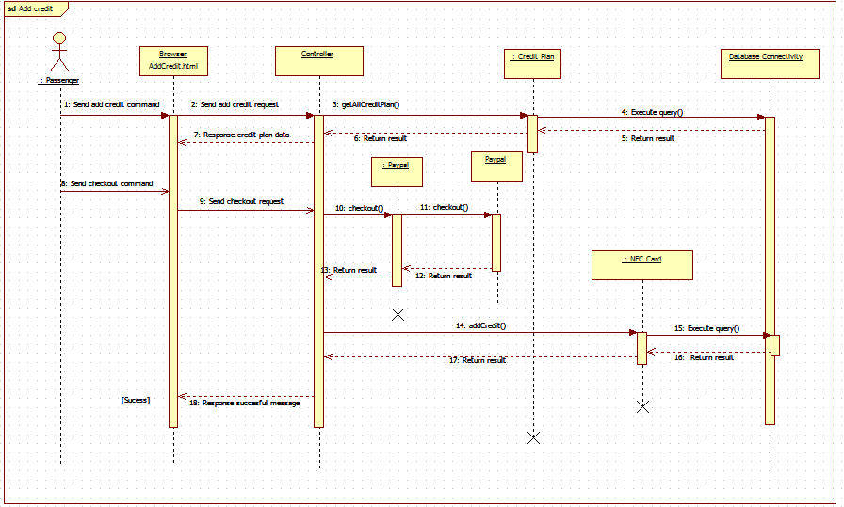

Figure : <Sequence Diagram> Add Credit

* + - 1. Get Cards

Summary: This diagram shows process of passenger getting his/her card information.

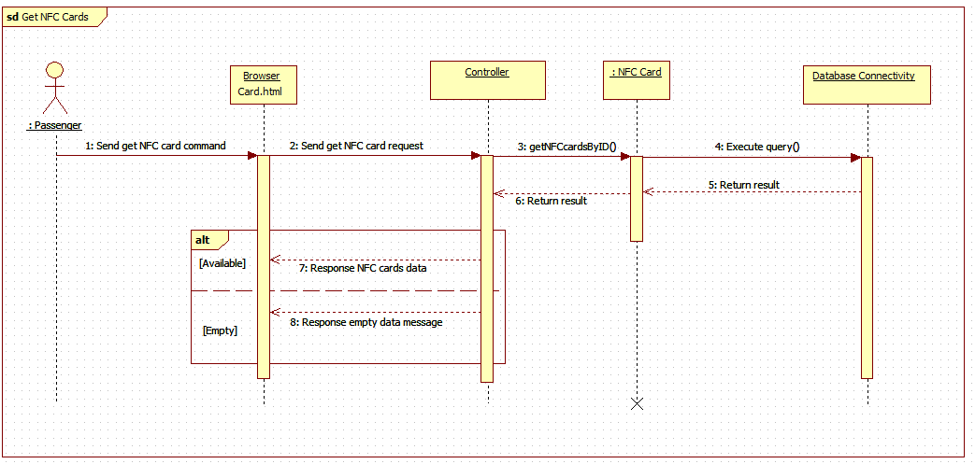

Figure : <Sequence Diagram> Get Cards

* + - 1. Find bus

Summary: This diagram shows process of passenger finding a bus’s information

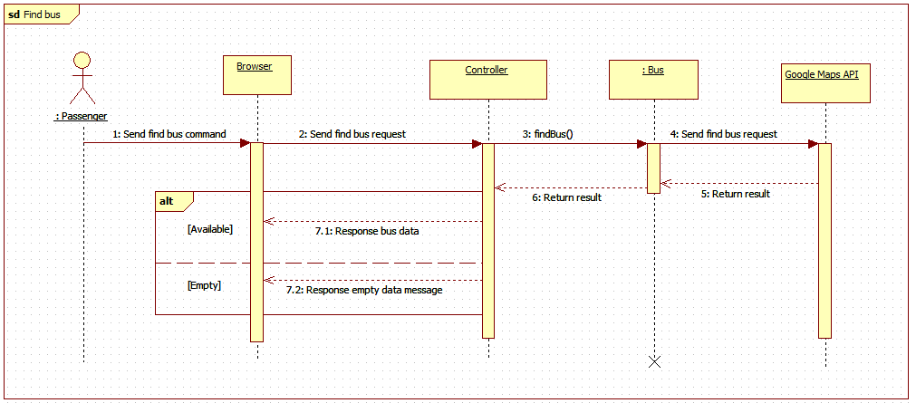

Figure 49: <Sequence Diagram> Find bus

* + - 1. Get outcome report

Summary: This diagram shows process of passenger getting his/her outcome report.

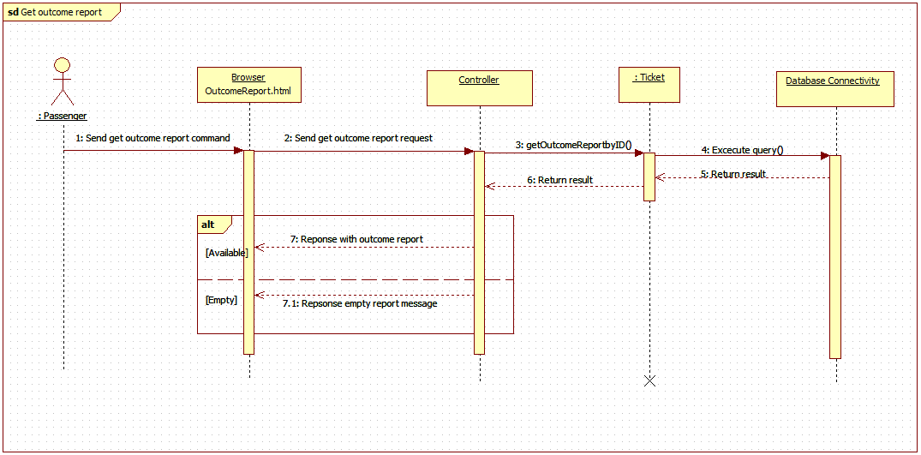

Figure 49: <Sequence Diagram> Get Income Report

* + 1. **Staff**

1. Edit Passenger

Summary: This diagram shows process of staff editing passenger information.

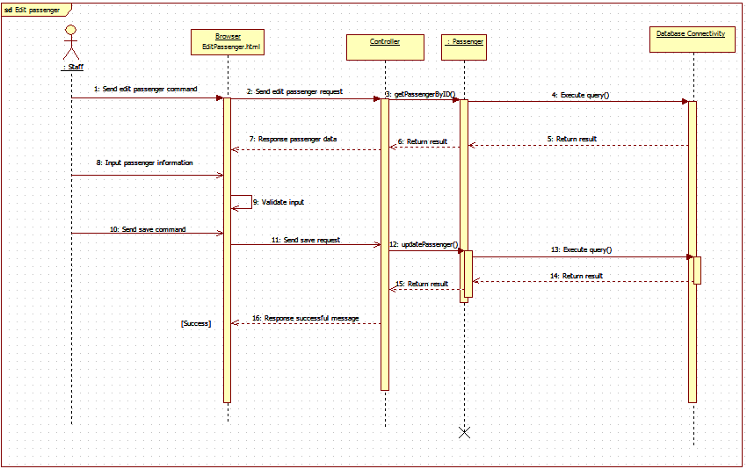

Figure 50: <Sequence Diagram> Edit Passenger

1. Activate/Deactivate Card

Summary: This diagram shows process of staff activating or deactivating passenger’s card

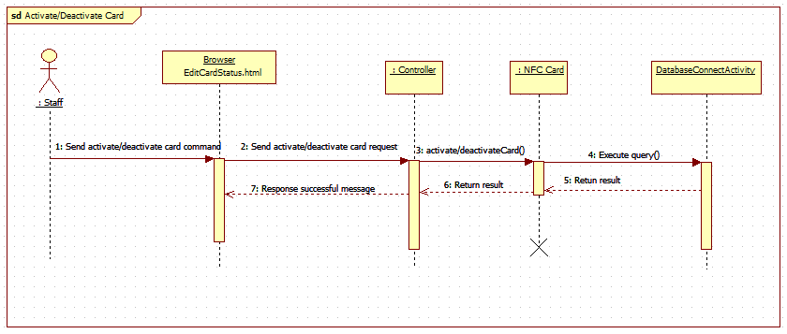

Figure 51: <Sequence Diagram> Activate/Deactivate Card

1. Add Card

Summary: This diagram shows process of staff adding new card

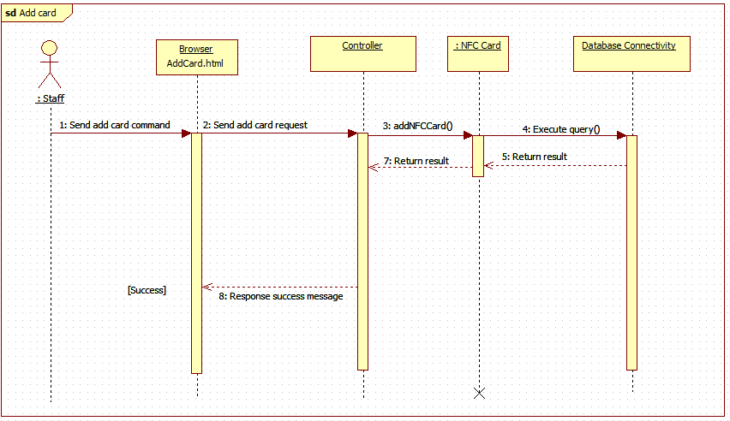

Figure 52: <Sequence Diagram>Add Card

* + 1. Manager

1. Get Income Report

Summary: This diagram shows process of manager getting income report

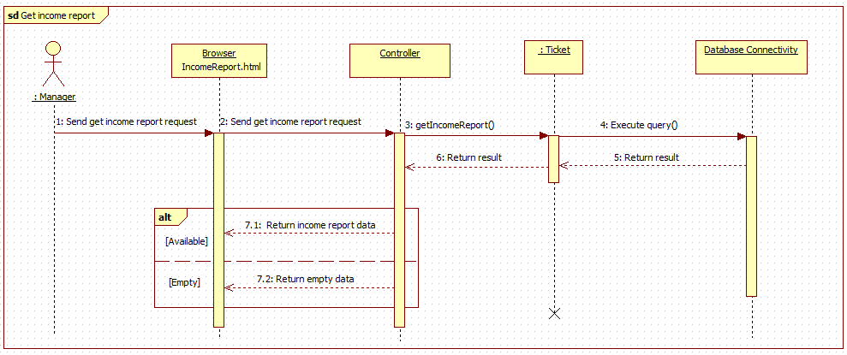

Figure 53: <Sequence Diagram>Get Outcome Report

1. Create promotion

Summary: This diagram shows process of manger creating a promotion

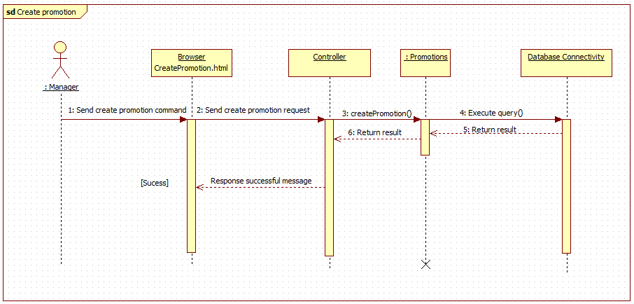

Figure 54: <Sequence Diagram>Create Promotion

1. **Mobile Application**
   * + 1. Add credit

Summary: This diagram shows process of passenger toping-up his/her card via mobile application.

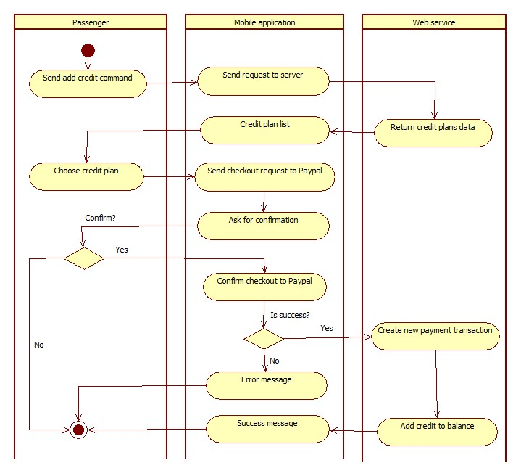

Figure 55: <Activity Diagram> Add Credit

* + - 1. Find Bus

Summary: This diagram shows process of passenger finding a bus route information via mobile application.

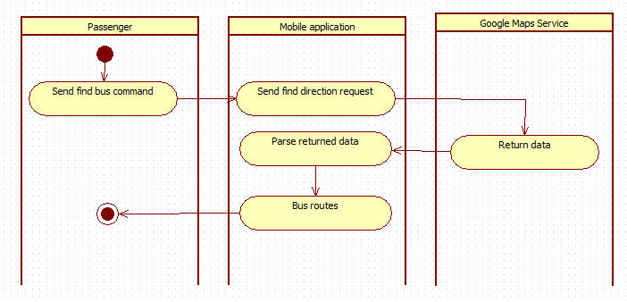

Figure 56: <Activity Diagram>Find Bus

* + - 1. Get Outcome Report

Summary: This diagram shows process of passenger getting his/her outcome report via mobile application.

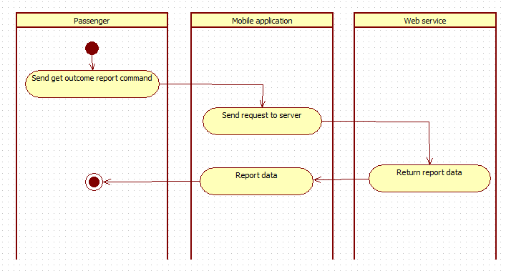

Figure 57: <Activity Diagram> Get Outcome Report

1. Send Notification

Summary: This diagram shows process of sending notification from system to passenger’s mobile phone.



Figure 58: <Activity Diagram> Send Notification

## User Interface

### Component Interface

|  |  |  |  |  |  |
| --- | --- | --- | --- | --- | --- |
| Signature | Description | Input | Output | Output format | Exception |
| /Api/PushOfflineData | Push offline ticket from emulator to server after connection lost. | key: string  cardId: string  ticketTypeId: int  routeCode: string  boughtDate: string | Json string of message object | Json | JsonException |
| /Api/GetBusStop | Get all bus stops of a bus route. | key: string  routeCode: string | Json string of message object | Json | JsonException |
| /Api/AddCard | Add new NFC card to the system | key: string  cardId: string | Json string of medical record object | Json | JsonException |
| /Api/ChangeCardName | Change name of a card | key: string  cardId: string  name: string | Json string of message object | Json | JsonException |
| /Api/Topup | Add credit to card by scratch card | key: string  cardId: string  code: string | Json string of pet object | Json | JsonException |
| /Api/GetCardInfo | Get information of a card | key: string  cardId: string | Json string of pet object | Json | JsonException |
| /Api/AddCardBalance | Add credit to card by Paypal | key: string  cardId: string  creditPlanId: int  transactionId: string | Json string of pet object | Json | JsonException |
| /Api/GetProfile | Get profile of an account | key: string  phone: string | Json string of pet object | Json | JsonException |
| /Api/GetAllCreditPlan | Get all credit plans information | key: string | Json string of pet object | Json | JsonException |
| /Api/GetAllTicketType | Get all ticket type information | key: string | Json string of pet object | Json | JsonException |
| /Api/ GetBusRouteByCode | Get a bus route details information by route code | key: string  routeCode: string | Json string of pet object | Json | JsonException |
| /Api/ GetAllBusRoutes | Get all bus routes information | key: string | Json string of pet object | Json | JsonException |
| /Api/ SellTicket | Sell ticket to emulator by card | key: string  cardId: string  ticketTypeId: int  routeCode: string  currentBalance: long  dataVersion: long | Json string of pet object | Json | JsonException |
| /Api/ RequestSellTicketToken | Get current server token | key: string | Json string of pet object | Json | JsonException |
| /Api/ SellTicketWithToken | Sell ticket to emulator by phone, server token is required | key: string  cardId: string  ticketTypeId: int  routeCode: string  currentBalance: long  dataVersion: long  token: string | Json string of pet object | Json | JsonException |
| /Api/ Login | Login to the system | key: string  phone: string  password: string | Json string of pet object | Json | JsonException |
| /Api/ UpdateProfile | Update account profile | key: string  phone: string  password: string  fullname: string  minBalance: int | Json string of pet object | Json | JsonException |
| /Api/ ActivateAccountByApp | Activate account by mobile application | key: string  phone: string  cardId: string | Json string of pet object | Json | JsonException |
| /Api/ GetAllCard | Get card list of an account | key: string  phone: string | Json string of pet object | Json | JsonException |
| /Api/ GetReport | Get outcome report | key: string  phone: string  beginDate: string  endDate: string | Json string of pet object | Json | JsonException |
| /Api/ RegisterNotificationToken | Register device token to get notification | key: string  phone: string  token: string | Json string of pet object | Json | JsonException |
| /Api/ GetPromotion | Get current available promotions | key: string | Json string of pet object | Json | JsonException |

Table 71: Component Interface

### 5.2 Web Application Design

5.2.1 Unauthorized User

5.2.1.1 Login

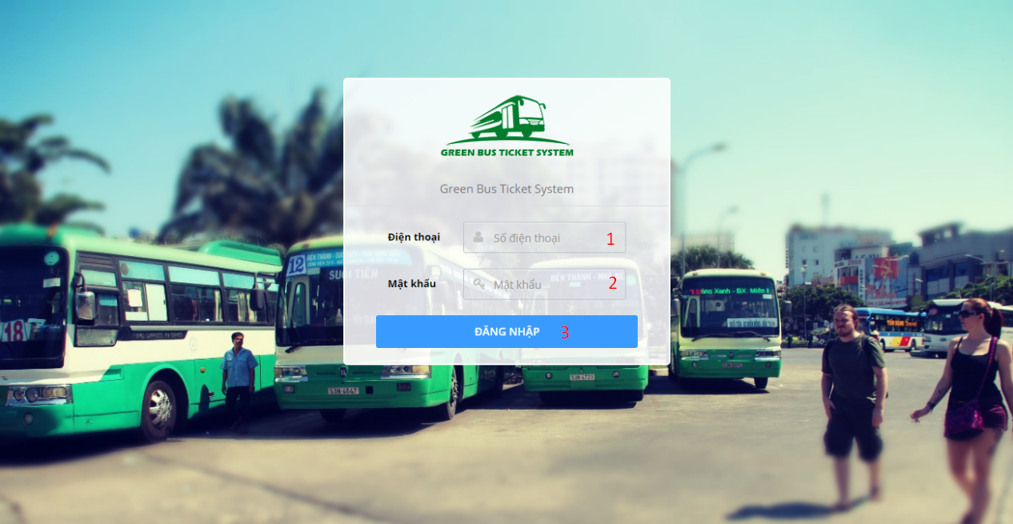

**Fields**

|  |  |  |  |  |  |  |  |
| --- | --- | --- | --- | --- | --- | --- | --- |
| No | Field Name | Description | Read only | Mandatory | Control type | Data type | Length |
| 1 | Phone | Account phone number | No | Yes | Textbox | String | 9-13 characters |
| 2 | Password | Account password | No | Yes | Textbox | String | 6-50 characters |

**Button/Hyperlinks**

|  |  |  |  |  |
| --- | --- | --- | --- | --- |
| No | Function | Description | Validation | Outcome |
| 3 | Login | Send login command | Validate PhoneNumber and Password | Open specific page with specific account |

5.2.2 Authorized User

5.2.2.1 Update profile

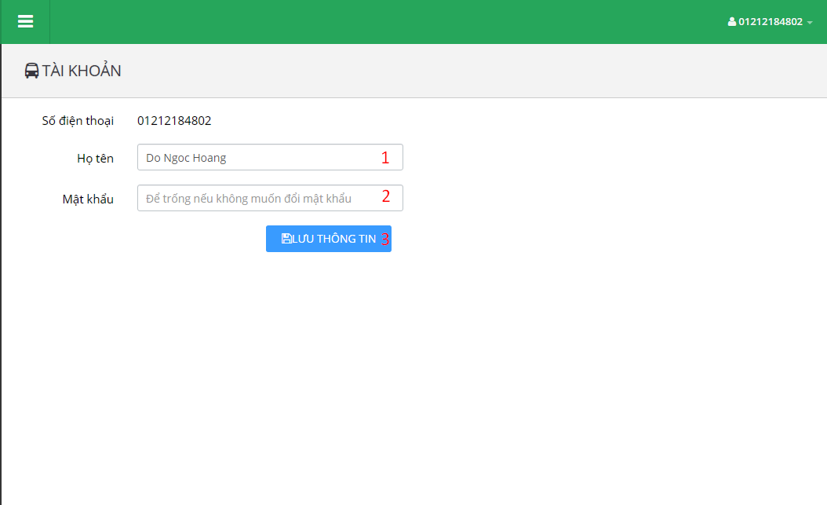

**Fields**

|  |  |  |  |  |  |  |  |
| --- | --- | --- | --- | --- | --- | --- | --- |
| No | Field Name | Description | Read only | Mandatory | Control type | Data type | Length |
| 1 | Fullname | Account full name | No | No | Textbox | String | 0-250 characters |
| 2 | Password | Account password | No | No | Textbox | String | 6-50 characters |

**Button/Hyperlinks**

|  |  |  |  |  |
| --- | --- | --- | --- | --- |
| No | Function | Description | Validation | Outcome |
| 3 | UpdateProfile | Send update profile command | Validate Fullname and Password | Display success message. |

5.2.3 Passenger

5.2.3.1 Dashboard

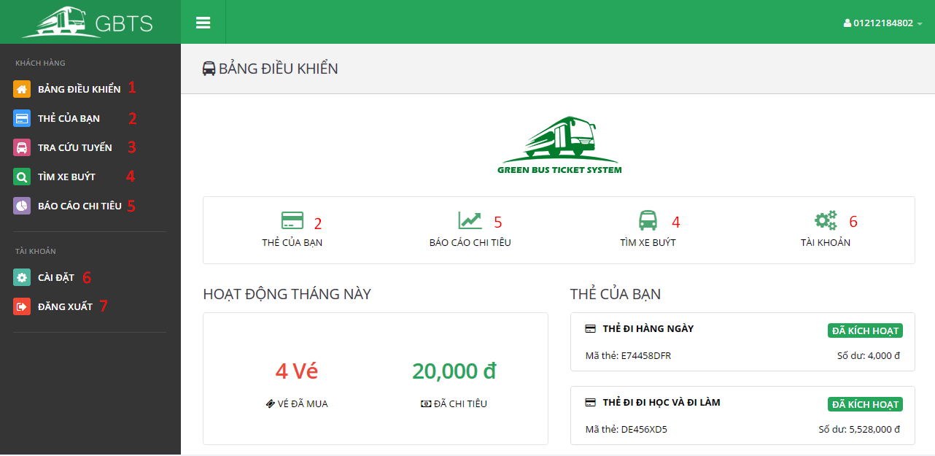

**Button/Hyperlinks**

|  |  |  |  |  |
| --- | --- | --- | --- | --- |
| No | Function | Description | Validation | Outcome |
| 1 | ViewDashboard | View dashboard page | N/A | Open dashboard page |
| 2 | GetCards | Send get cards command | N/A | Open card list page |
| 3 | ViewLookupBusRoutePage | View lookup bus route page | N/A | Open lookup bus route page |
| 4 | ViewFindBusPage | View find bus page | N/A | Open find bus page |
| 5 | ViewOutcomeReportPage | View outcome report page | N/A | Open get outcome report page |
| 6 | ViewProfile | View profile page | N/A | Open profile page |
| 7 | Logout | Send logout command | N/A | Destroy current session and redirect to login page. |

5.2.3.2 Get cards

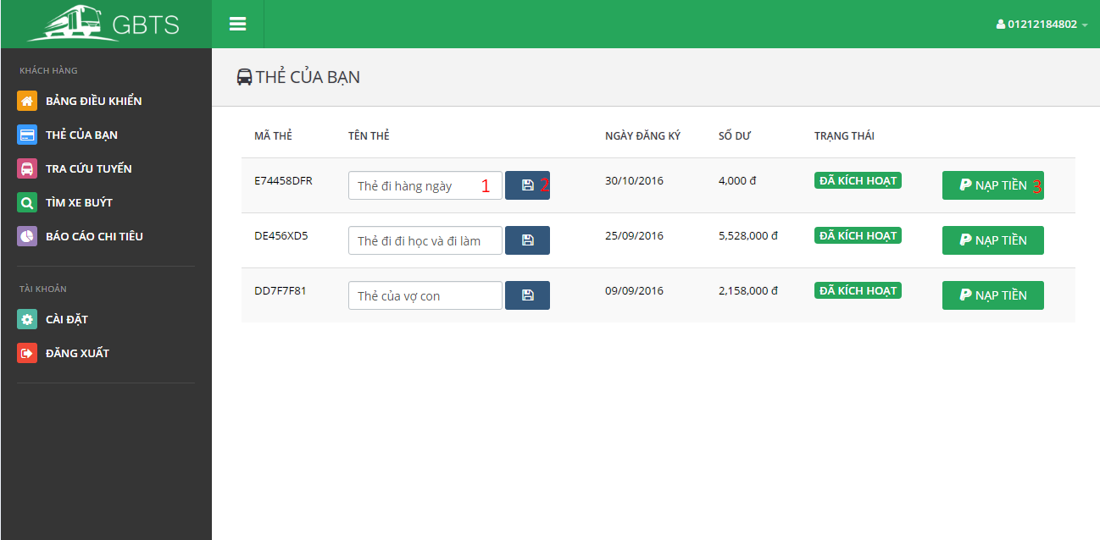

**Fields**

|  |  |  |  |  |  |  |  |
| --- | --- | --- | --- | --- | --- | --- | --- |
| No | Field Name | Description | Read only | Mandatory | Control type | Data type | Length |
| 1 | CardName | Card name | No | No | Textbox | String | 0-250 characters |

**Button/Hyperlinks**

|  |  |  |  |  |
| --- | --- | --- | --- | --- |
| No | Function | Description | Validation | Outcome |
| 2 | UpdateCardName | Send update card name command | Validate CardName | Display success message. |
| 3 | AddCredit | Send add credit command | Validate card’s status. Disable button if card is deactivated. | Show add credit plan view. |

5.2.3.3 Lookup bus route

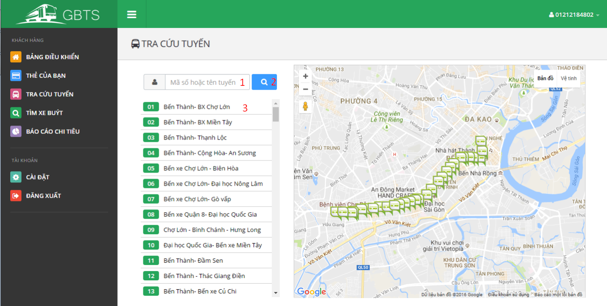

**Fields**

|  |  |  |  |  |  |  |  |
| --- | --- | --- | --- | --- | --- | --- | --- |
| No | Field Name | Description | Read only | Mandatory | Control type | Data type | Length |
| 1 | Term | Route code or route name | No | No | Textbox | String | 0-250 characters |

**Button/Hyperlinks**

|  |  |  |  |  |
| --- | --- | --- | --- | --- |
| No | Function | Description | Validation | Outcome |
| 2 | Lookup | Send lookup bus route command | N/A | Display bus routes match searching term |
| 3 | ViewBusStop | Send view bus stop command | N/A | Display bus stops belong to selected term on map view. |

5.2.3.4 Find bus

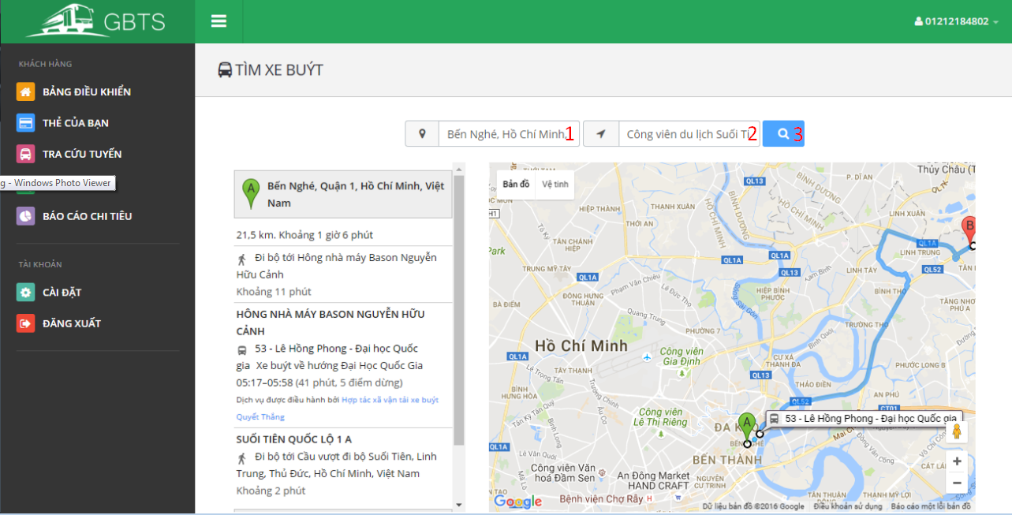

**Fields**

|  |  |  |  |  |  |  |  |
| --- | --- | --- | --- | --- | --- | --- | --- |
| No | Field Name | Description | Read only | Mandatory | Control type | Data type | Length |
| 1 | StartingAddress | Starting address | No | No | Textbox | String | N/A |
| 2 | DestinationAddress | Destination address | No | No | Textbox | String | N/A |

**Button/Hyperlinks**

|  |  |  |  |  |
| --- | --- | --- | --- | --- |
| No | Function | Description | Validation | Outcome |
| 3 | GetRoute | Send get route command | N/A | Display bus routes match starting address and destination address on map view. |

5.2.3.4 Find bus

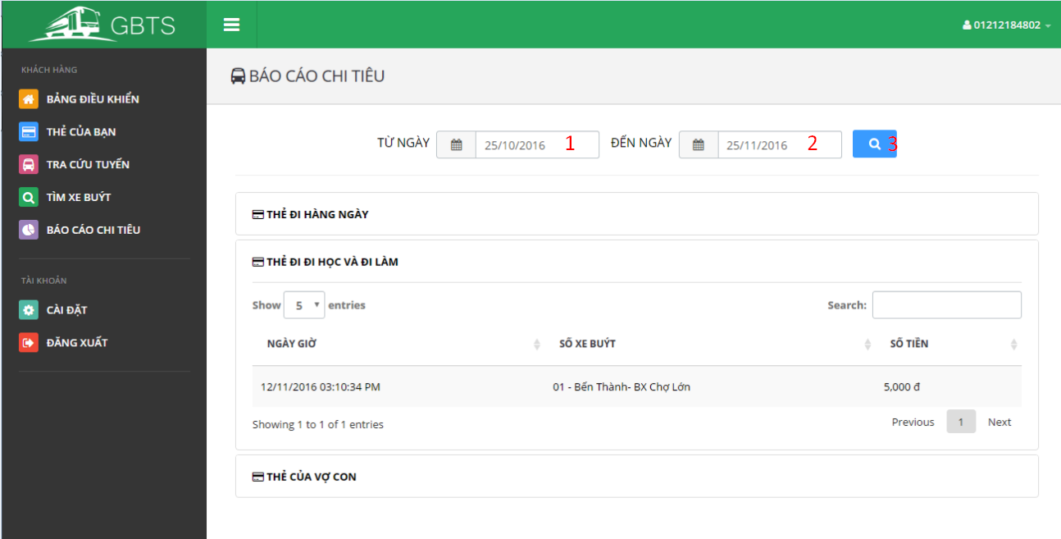

**Fields**

|  |  |  |  |  |  |  |  |
| --- | --- | --- | --- | --- | --- | --- | --- |
| No | Field Name | Description | Read only | Mandatory | Control type | Data type | Length |
| 1 | BeginDate | Begin date | No | No | Date select box | String | N/A |
| 2 | EndDate | End date | No | No | Date select box | String | N/A |

**Button/Hyperlinks**

|  |  |  |  |  |
| --- | --- | --- | --- | --- |
| No | Function | Description | Validation | Outcome |
| 3 | GetOutcomeReport | Send get outcome report command | N/A | Display outcome report according to selected begin date and end date. |

5.2.4 Staff

5.2.4.1 Dashboard

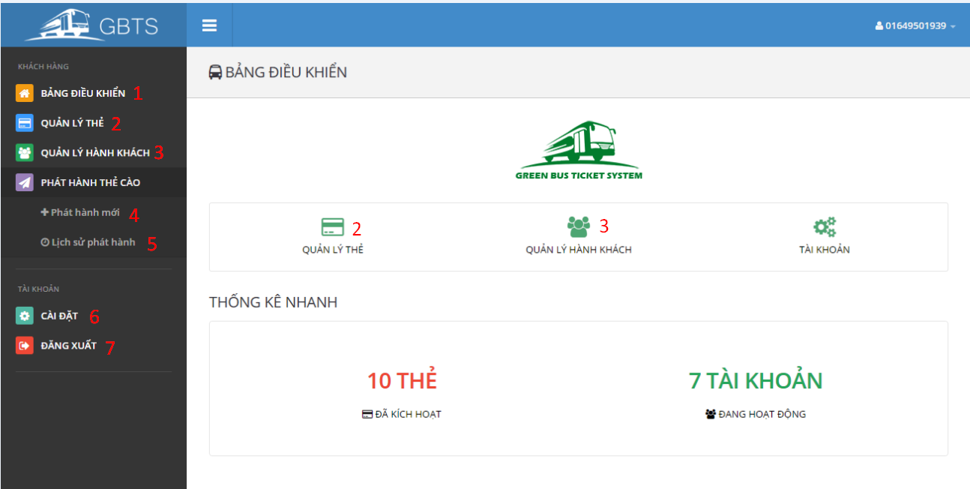

**Button/Hyperlinks**

|  |  |  |  |  |
| --- | --- | --- | --- | --- |
| No | Function | Description | Validation | Outcome |
| 1 | ViewDashboard | View dashboard page | N/A | Open dashboard page |
| 2 | ManageCards | View manage cards page | N/A | Open manage card page |
| 3 | ManagePassengers | View manage passengers page | N/A | Open manage passengers page |
| 4 | PublishScratchCard | Send publish scratch card command | N/A | Publish scratch card view is showed. |
| 5 | PublishHistory | Send publish history command | N/A | Publish history view is showed. |
| 6 | ViewProfile | View profile page | N/A | Open profile page |
| 7 | Logout | Send logout command | N/A | Destroy current session and redirect to login page. |

5.2.4.2 Manage Cards

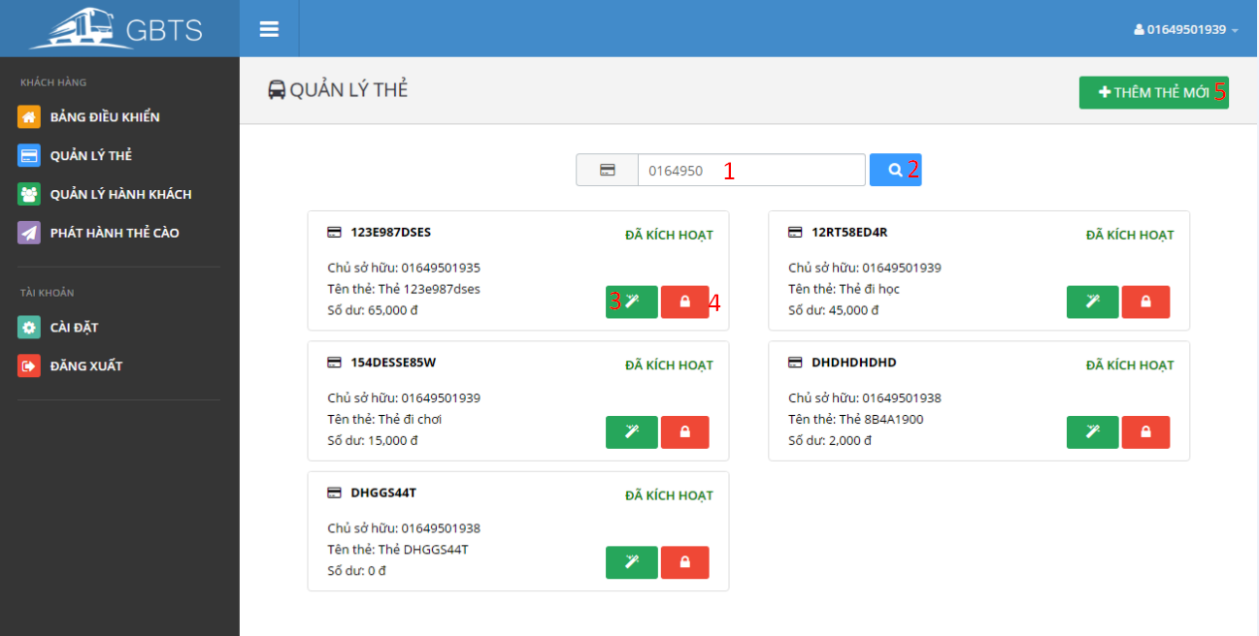

**Fields**

|  |  |  |  |  |  |  |  |
| --- | --- | --- | --- | --- | --- | --- | --- |
| No | Field Name | Description | Read only | Mandatory | Control type | Data type | Length |
| 1 | Term | Owner phone number or card UID | No | No | Textbox | String | N/A |

**Button/Hyperlinks**

|  |  |  |  |  |
| --- | --- | --- | --- | --- |
| No | Function | Description | Validation | Outcome |
| 2 | SearchCard | Send search card command | N/A | Display cards match searching term. |
| 3 | TransferCard | Send transfer card command | N/A | Transfer card view is showed. |
| 4 | Activate/DeactivateCard | Send activate/deactivate card command | N/A | Selected card is activated/deactivated |
| 5 | Add card | Send add card command | N/A | Add card view is showed. |

5.2.4.3 Manage Passengers

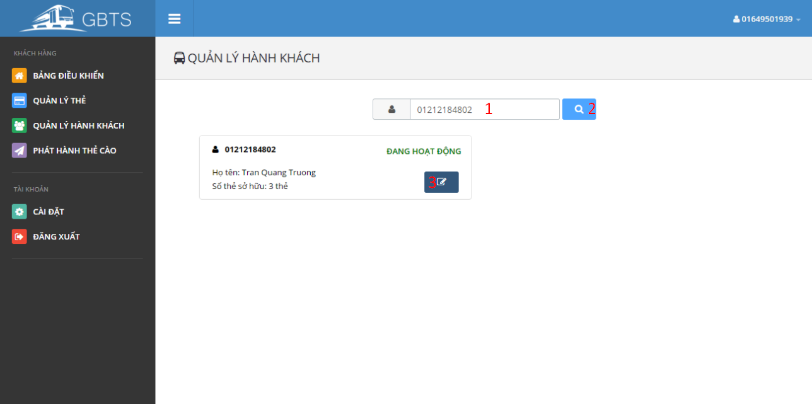

**Fields**

|  |  |  |  |  |  |  |  |
| --- | --- | --- | --- | --- | --- | --- | --- |
| No | Field Name | Description | Read only | Mandatory | Control type | Data type | Length |
| 1 | Term | Passenger phone number or full name | No | No | Textbox | String | N/A |

**Button/Hyperlinks**

|  |  |  |  |  |
| --- | --- | --- | --- | --- |
| No | Function | Description | Validation | Outcome |
| 2 | SearchPassenger | Send search passenger command | N/A | Display passengers match searching term. |
| 3 | EditPassenger | Send edit passenger command | N/A | Edit passenger view is showed. |

5.2.4.4 Publish scratch card

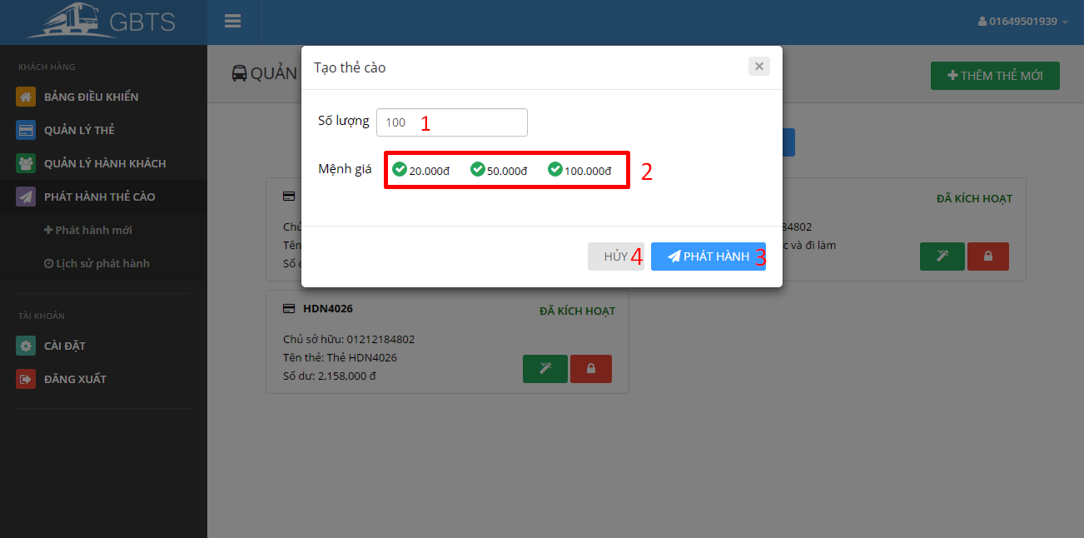

**Fields**

|  |  |  |  |  |  |  |  |
| --- | --- | --- | --- | --- | --- | --- | --- |
| No | Field Name | Description | Read only | Mandatory | Control type | Data type | Length |
| 1 | Quantity | Scratch card quantity. | No | No | Textbox | Number | N/A |
| 2 | ScratchCardType | Type of scratch card | No | No | Checkbox | Number | N/A |

**Button/Hyperlinks**

|  |  |  |  |  |
| --- | --- | --- | --- | --- |
| No | Function | Description | Validation | Outcome |
| 3 | Publish | Send publish scratch card command | N/A | Open published scratch card list on a new page. |
| 4 | Cancel | Close publish scratch card view | N/A | Publish scratch card view is closed. |

5.2.4.5 Publish history

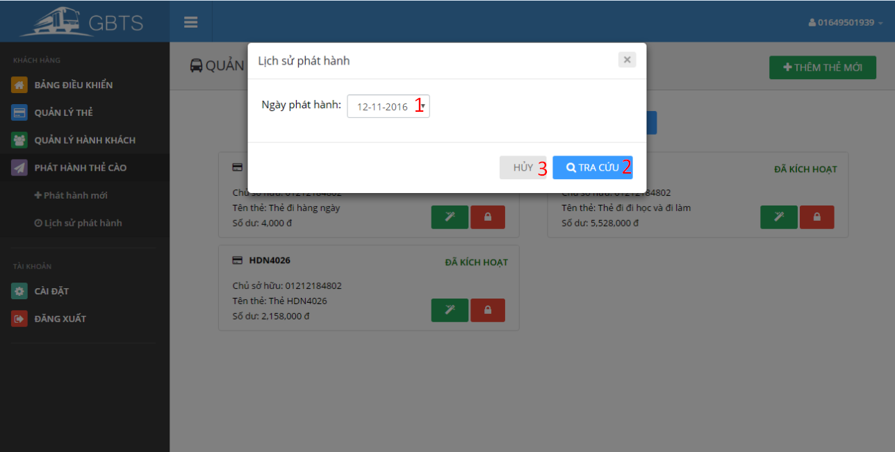

**Fields**

|  |  |  |  |  |  |  |  |
| --- | --- | --- | --- | --- | --- | --- | --- |
| No | Field Name | Description | Read only | Mandatory | Control type | Data type | Length |
| 1 | PublishedDate | Scratch card published dated | No | No | Selectbox | String | N/A |

**Button/Hyperlinks**

|  |  |  |  |  |
| --- | --- | --- | --- | --- |
| No | Function | Description | Validation | Outcome |
| 3 | GetPublishedHistory | Send get published history command | N/A | Open published scratch card list of selected published date on a new page. |
| 4 | Cancel | Close publish history view | N/A | Publish history view is closed. |

5.2.5 Manager

5.2.5.1 Dashboard

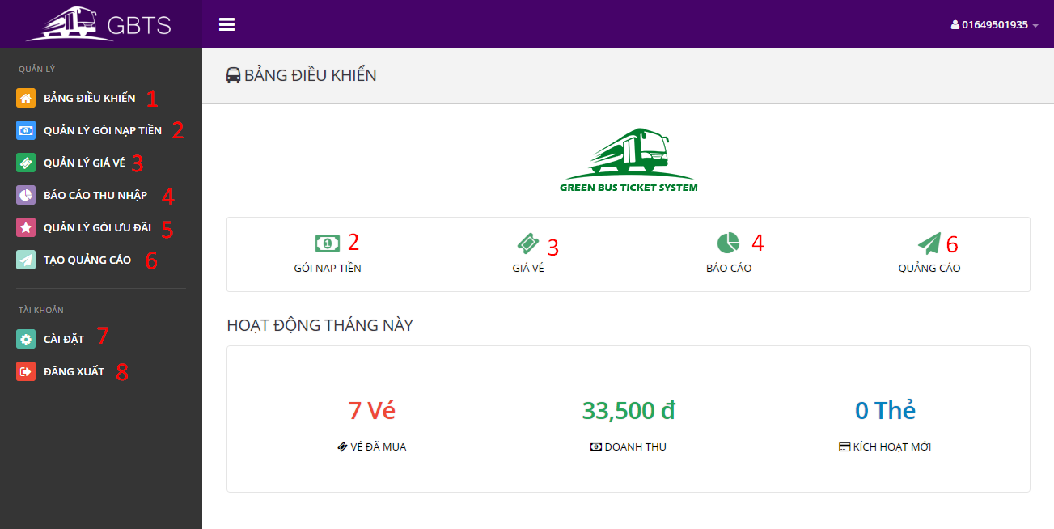

**Button/Hyperlinks**

|  |  |  |  |  |
| --- | --- | --- | --- | --- |
| No | Function | Description | Validation | Outcome |
| 1 | ViewDashboard | View dashboard page | N/A | Open dashboard page |
| 2 | ManageCreditPlans | View manage credit plans page | N/A | Open manage credit plans page |
| 3 | ManageTicketTypes | View manage ticket types page | N/A | Open manage ticket types page |
| 4 | ViewIncomeReportPage | View income report page | N/A | Open income report page |
| 5 | ManageSubscriptions | View manage subscriptions page | N/A | Open manage subscriptions page |
| 6 | CreatePromotionPage | View create promotion page | N/A | Open create promotion page |
| 7 | ViewProfile | View profile page | N/A | Open profile page |
| 8 | Logout | Send logout command | N/A | Destroy current session and redirect to login page. |

5.2.5.2 Manage Credit Plans

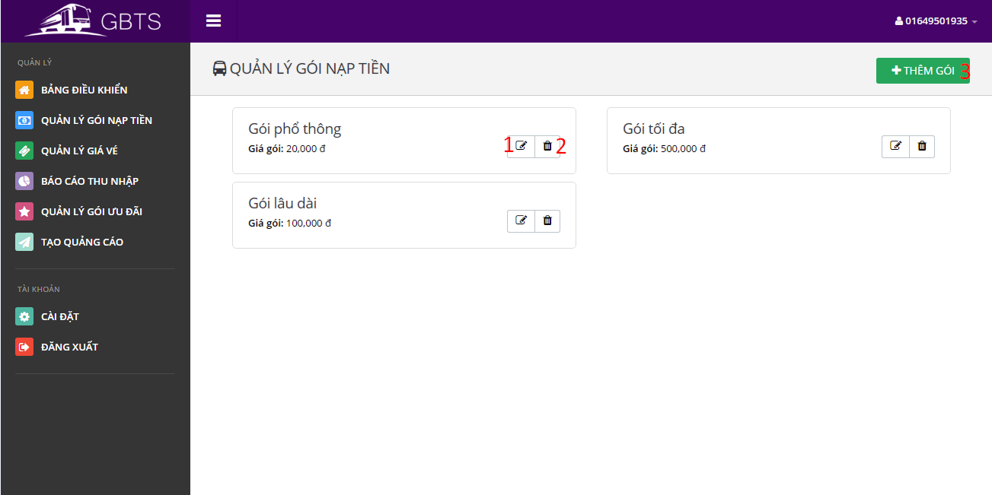

**Button/Hyperlinks**

|  |  |  |  |  |
| --- | --- | --- | --- | --- |
| No | Function | Description | Validation | Outcome |
| 1 | EditCreditPlan | Send edit credit plan command | N/A | Edit credit plan view is showed. |
| 2 | DeleteCreditPlan | Send delete credit plan command | N/A | A delete confirmation is show. |
| 3 | AddCreditPlan | Send add credit plan command | N/A | Add credit plan view is showed. |

5.2.5.3 Manage Ticket Type

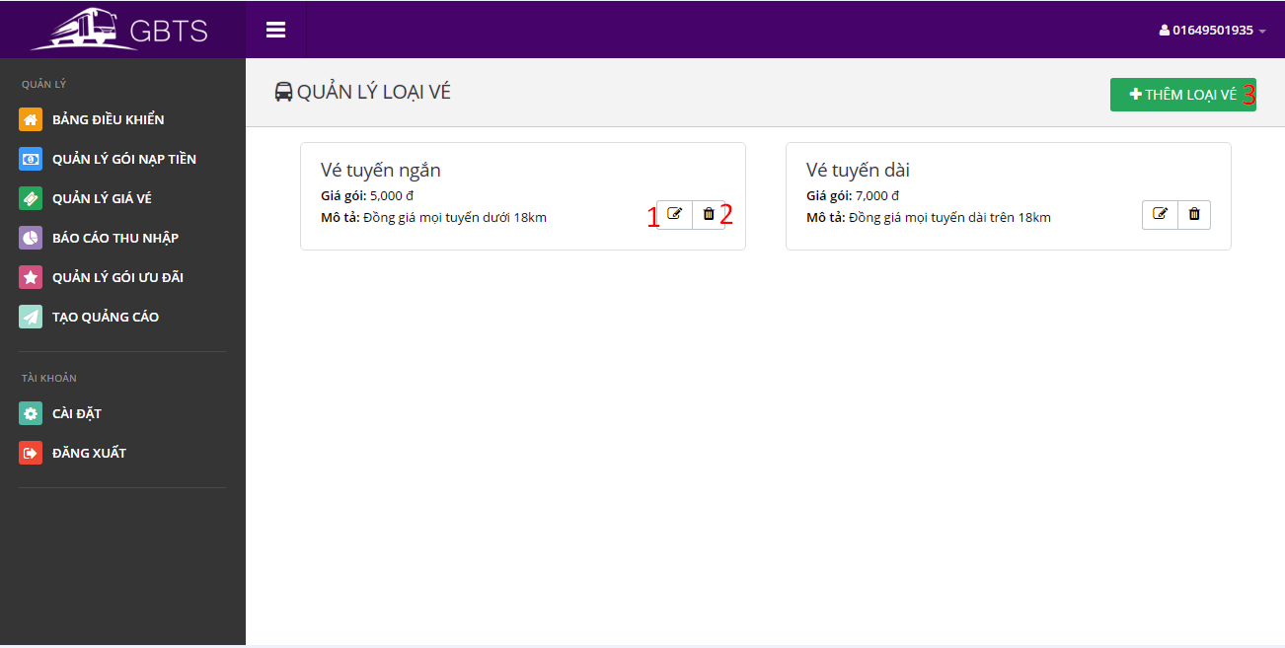

**Button/Hyperlinks**

|  |  |  |  |  |
| --- | --- | --- | --- | --- |
| No | Function | Description | Validation | Outcome |
| 1 | EditTicketType | Send edit ticket type command | N/A | Edit ticket type view is showed. |
| 2 | DeleteTicketType | Send delete ticket type command | N/A | A delete confirmation is show. |
| 3 | AddTicketType | Send add ticket type command | N/A | Add ticket type view is showed. |

5.2.5.4 Get income report

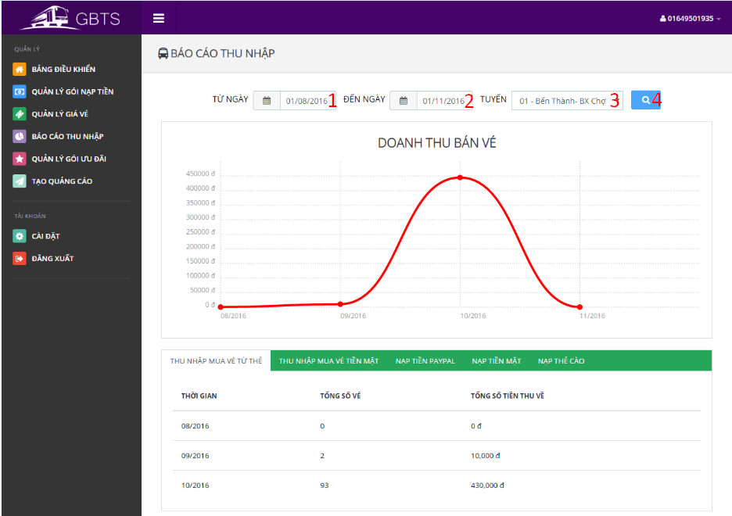

**Fields**

|  |  |  |  |  |  |  |  |
| --- | --- | --- | --- | --- | --- | --- | --- |
| No | Field Name | Description | Read only | Mandatory | Control type | Data type | Length |
| 1 | BeginDate | Begin date | No | No | Date selection box | String | N/A |
| 2 | EndDate | End date | No | No | Date selection box | String | N/A |
| 3 | BusRoute | Bus route | No | Yes | Selectbox | String | N/A |

**Button/Hyperlinks**

|  |  |  |  |  |
| --- | --- | --- | --- | --- |
| No | Function | Description | Validation | Outcome |
| 4 | GetOutComeReport | Send get outcome report command | N/A | Report according to begin date and end date is showed. |

5.2.5.5 Manage Subscriptions

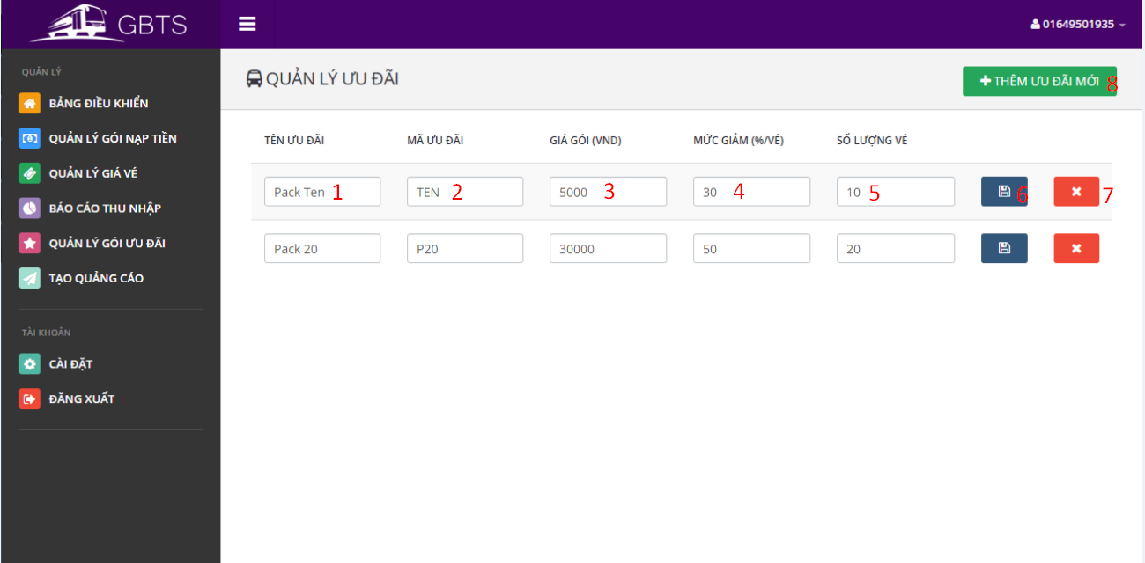

**Fields**

|  |  |  |  |  |  |  |  |
| --- | --- | --- | --- | --- | --- | --- | --- |
| No | Field Name | Description | Read only | Mandatory | Control type | Data type | Length |
| 1 | SubscriptionName | Subscription name | No | Yes | Textbox | String | 3-250 characters |
| 2 | SubscriptionCode | Subscription code | No | Yes | Textbox | String | 3-6 characters |
| 3 | SubscriptionPrice | Subscription price | No | Yes | Textbox | Number | N/A |
| 4 | DiscountPercent | Subscription discount percent per ticket | No | Yes | Textbox | Number | N/A |
| 5 | TicketNumber | Number of applied ticket. | No | Yes | Textbox | Number | N/A |

**Button/Hyperlinks**

|  |  |  |  |  |
| --- | --- | --- | --- | --- |
| No | Function | Description | Validation | Outcome |
| 6 | SaveSubscription | Send save subscription command | All fields are required. | Success message is showed |
| 7 | DeleteSubscription | Send delete subscription command | N/A | A confirmation box is showed. |
| 8 | AddSubscription | Send add subscription command | N/A | New blank subscription is added to subscription list. |

5.2.5.6 Create promotion

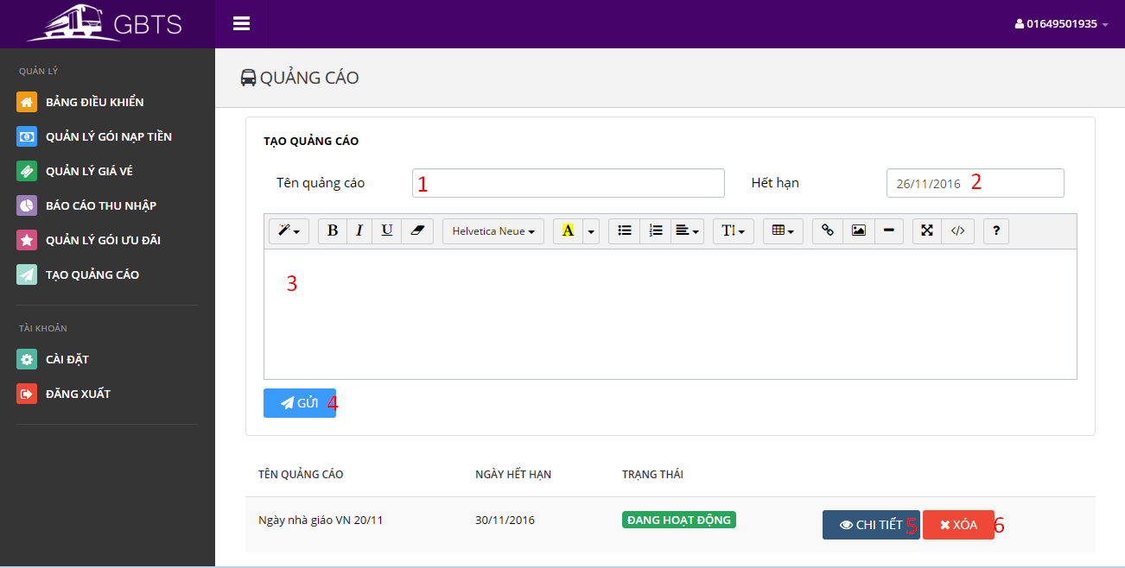

**Fields**

|  |  |  |  |  |  |  |  |
| --- | --- | --- | --- | --- | --- | --- | --- |
| No | Field Name | Description | Read only | Mandatory | Control type | Data type | Length |
| 1 | PromotionName | Promotion name | No | Yes | Textbox | String | 3-250 characters |
| 2 | ExpiredDate | Promotion expired date | No | Yes | Date selection box | String | N/A |
| 3 | PromotionContent | Promotion content | No | Yes | Text area | String | At least 20 characters |

**Button/Hyperlinks**

|  |  |  |  |  |
| --- | --- | --- | --- | --- |
| No | Function | Description | Validation | Outcome |
| 4 | CreatePromotion | Send create promotion command | All fields are required. | Success message is showed. New promotion is added to promotion list. |
| 5 | ViewPromotion | Send view promotion command | N/A | Promotion content is showed. |
| 6 | DeletePromotion | Send delete promotion command | N/A | A confirmation box is showed. |

5.2.6 Admin

5.2.6.1 Dashboard

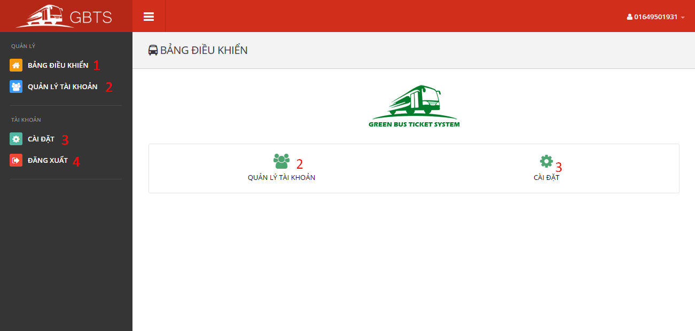

**Button/Hyperlinks**

|  |  |  |  |  |
| --- | --- | --- | --- | --- |
| No | Function | Description | Validation | Outcome |
| 1 | ViewDashboard | View dashboard page | N/A | Open dashboard page |
| 2 | ManageAccounts | View manage accounts page | N/A | Open manage accounts page |
| 3 | ViewProfile | View profile page | N/A | Open profile page |
| 4 | Logout | Send logout command | N/A | Destroy current session and redirect to login page. |

5.2.6.2 Manage Accounts

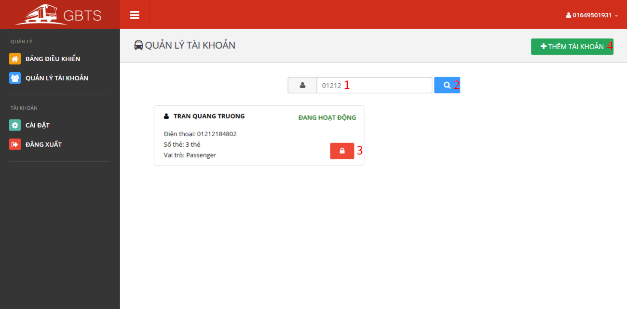

**Fields**

|  |  |  |  |  |  |  |  |
| --- | --- | --- | --- | --- | --- | --- | --- |
| No | Field Name | Description | Read only | Mandatory | Control type | Data type | Length |
| 1 | Term | Account phone number or full name | No | No | Textbox | String | 3-250 characters |

**Button/Hyperlinks**

|  |  |  |  |  |
| --- | --- | --- | --- | --- |
| No | Function | Description | Validation | Outcome |
| 2 | Search account | Send search account command | N/A | Accounts match searching term is showed. |
| 3 | Activated/Deactivated account | Send activated/deactivated account command | N/A | Account is activated/deactivated |
| 4 | AddAccount | Send add account command | N/A | Add account view is showed. |

### 5.2 Mobile Application Design

#### 5.2.1 Login

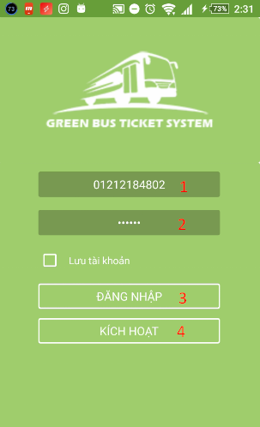

|  |  |  |  |  |  |  |
| --- | --- | --- | --- | --- | --- | --- |
| No | Field Name | Description | Read only | Mandatory | Control type | Data type |
| 1 | Phone number | Allow user to input their registered phone number. | No | Yes | Number input | String |
| 2 | Password | Allow user to input their registered password | No | Yes | Text input | String |

**Fields**

**Button/Hyperlinks**

|  |  |  |  |  |
| --- | --- | --- | --- | --- |
| No | Function | Description | Validation | Outcome |
| 3 | Login | Perform login function | Yes | Open view main screen or display error messages |
| 4 | Activate | Allow user active account by phone number. | Yes | Open view active screen |

#### 5.3.2 Active Card

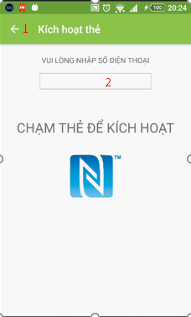

**Fileds**

|  |  |  |  |  |  |  |
| --- | --- | --- | --- | --- | --- | --- |
| No | Field Name | Description | Read only | Mandatory | Control type | Data type |
| 1 | Phone number | Allow user to input their registered phone number. | No | Yes | Text input | String |

|  |  |  |  |  |
| --- | --- | --- | --- | --- |
| No | Function | Description | Validation | Outcome |
| 1 | Back | Navigate back 1 screen | No | Open previous screen in the activity stack |

**Button/Hyperlinks**

‘

#### 5.3.3 Main screen

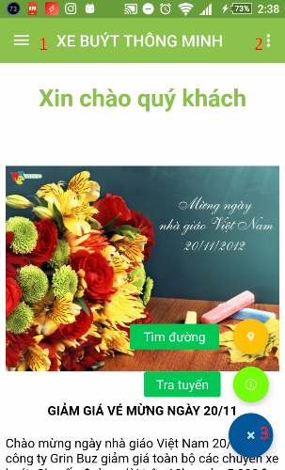

**Button/Hyperlinks**

|  |  |  |  |  |
| --- | --- | --- | --- | --- |
| No | Function | Description | Validation | Outcome |
| 1 | Navigation Drawer | Navigation Drawer | No | Open/Close Navigation Drawer |
| 2 | Menu item | Let user choose a function | No | Open fast function |
| 3 | Search | Open search screen | No | Open search screen |

#### 5.3.4 View Report

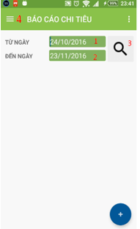

|  |  |  |  |  |  |  |
| --- | --- | --- | --- | --- | --- | --- |
| No | Field Name | Description | Read only | Mandatory | Control type | Data type |
| 1 | Date Start | Allow user to input date start. | No | Yes | Text input | Datetime |
| 2 | Date End | Allow user to input date end. | No | Yes | Text input | Datetime |

**Fileds**

**Button/Hyperlinks**

|  |  |  |  |  |
| --- | --- | --- | --- | --- |
| No | Function | Description | Validation | Outcome |
| 3 | View report | View report of card | No | Open/Close Navigation Drawer |
| 4 | Navigation Drawer | Navigation Drawer | No | Open/Close Navigation Drawer |

#### 5.3.5 Manage Account

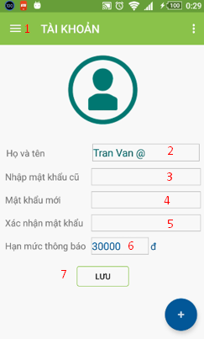

|  |  |  |  |  |  |  |
| --- | --- | --- | --- | --- | --- | --- |
| No | Field Name | Description | Read only | Mandatory | Control type | Data type |
| 2 | Full Name | Allow user input name. | No | Yes | Text Input | String |
| 3 | Old password | Allow user input password. | No | Yes | Text | String |
| 4 | New password | Allow user input password | No | Yes | Text | String |
| 5 | Confirm password | Allow user input password | No | Yes | Text | String |
| 6 | Notification | Allow user min balance to get notification. | No | Yes | Text | Number |

**Fields**

**Button/Hyperlinks**

|  |  |  |  |  |
| --- | --- | --- | --- | --- |
| No | Function | Description | Validation | Outcome |
| 1 | Navigation Drawer | Navigation Drawer | No | Open/Close Navigation Drawer |
| 7 | Save | Send request to server | No | Change data on this screen |

## Database design

### 6.1 Entity Relationship Diagram

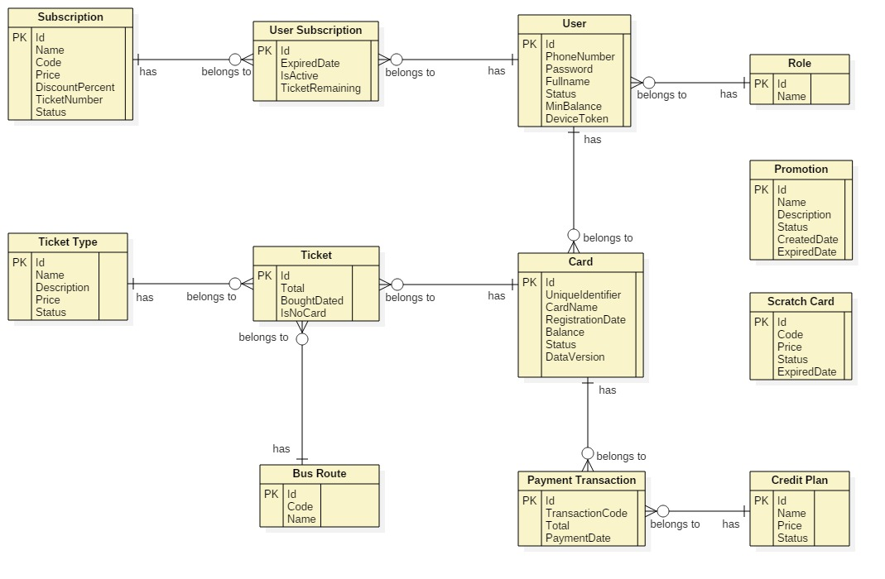

Figure 59: <Database design> Entity Relation Diagram

### 6.2 Entity Dictionary

|  |  |
| --- | --- |
| Entity Name | Description |
| User | Contains all properties about user. |
| Passenger | Contains all properties about passenger info. |
| Admin | Contains all properties about admin info. |
| Staff | Contains all properties about staff info. |
| Manager | Contains all properties about manager info. |
| Card | Contains all properties about NFC card. |
| Ticket Type | Contains all properties about ticket type for based on bus route, each ticket type has diffirent price. |
| Bus Route | Contains all properties about bus route in Ho Chi Minh City. |
| Ticket | Contains all properties about ticket to specify which card buy ticket belongs to which ticket type on which bus route. |
| Credit Plan | Contains all info about credit plan which will be chosen while adding credit to card. |
| Payment Transaction | Contains all info about transaction when adding credit to card via cash, credit plan or scratch card. |
| Promotion | Contains all info about promotion. |
| Scratch Card | Contains all info about scratch card. |
| Subscription | Contains all info about offer subscription. |
| User Subscription | Contains all info about user subscription to specify who subscribe which offer subscription. |

Table 72: Entity Dictionary

## Algorithms

### 7.1 AES Encryption

#### 7.1.1 Definition

AES (acronym of Advanced Encryption Standard) is a symmetric encryption algorithm. The algorithm was developed by two Belgian cryptographer Joan Daemen and Vincent Rijmen. AES was designed to be efficient in both hardware and software, and supports a block length of 128 bits and key lengths of 128, 192, and 256 bits.

#### 7.1.2 Define Problem

For convevient purposes of allowing passenger to buy ticket in case of no internet connection from emulator to server, we save card’s balance and data version to NFC card. We need to encrypt these information to make sure no one can change the original information.

#### 7.1.3 Solution

In order to secure these informations, we use AES Encryption Algorithm to encrypt informations before saving to NFC card.

Algorithm reference: <http://howtodoinjava.com/security/java-aes-encryption-example/>

### 7.2 Token Authentication

#### 7.2.1 Definition

Token authentication is a technique to prove that the passengers is who they claim to be. Requests which have the right token will be processed.

#### 7.2.2 Define problem

When the passengers use mobile application to buy ticket instead of their cards. Mobile application sends some informations to emulator for verification, we have to make sure that these informations only valid in a specific time for buying ticket, anyone who can capture these informations will not be able to use it and buy ticket later.

#### 7.2.3 Solution

Token we use in this solution is a GUID. GUIDs are stored as 128-bit values, and are displayed as 32 hexadecimal digits with groups separated by hyphens.

GUID Reference: <https://en.wikipedia.org/wiki/Globally_unique_identifier>

To solve this problem, we should follow these steps:

* Server creates a token if there is no token on the server.
* Server change the token frequently (every 30 minutes).
* When mobile application is used to buy ticket, it asks the token from server.
* Then mobile application sends a request along with this token to emulator.
* Emulator sends to server. Server verifies the received token, if it matchs current server token, request will be processed.

1. Complexity: O(n)
2. Flowchart

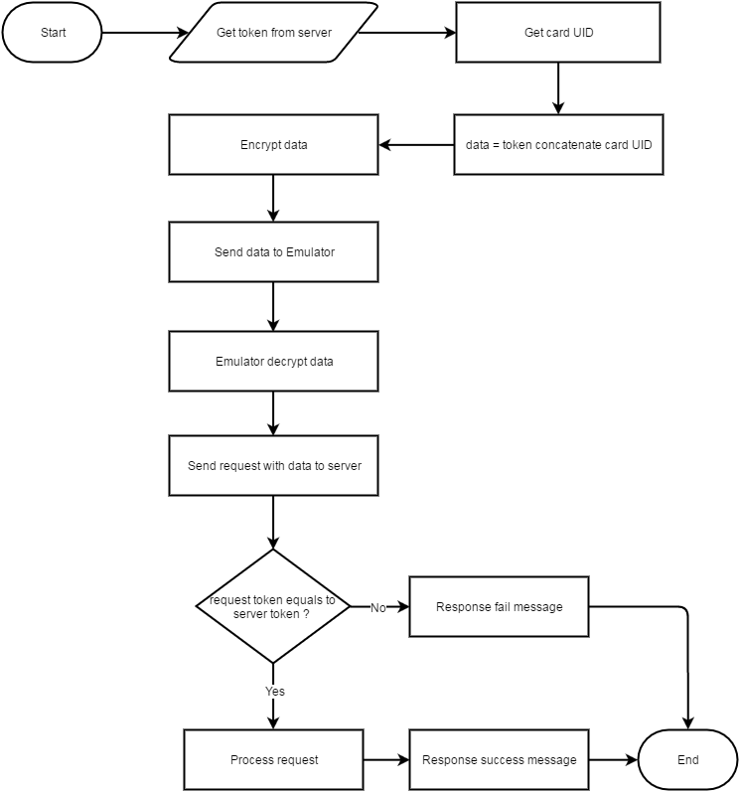

Figure 60: <Algorithms> Entity Relation Diagram

1. **Daily Usage Prediction**
2. Definition

Daily Usage Prediction is the way to predict how much a passenger need to spend for buying ticket in the next day base on the average bought tickets in the past.

1. Define Problem

Passenger sometimes forget to add credit to their cards. Each passenger has a diffirent travel demand. We should notify them in the morning if the remaining balance in their card is not enough for spending in the next day.

1. Solution

To solve this problem, we should follow these steps:

* Everyday, at a specific time, Auto Handler will filter the current passenger list to get passengers who have already installed mobile application, bought at least 30 tickets before and the last bought ticket must not exceed 7 days from the current date.
* Calculate the average spending for each customer and on each card of them:

**Average spending** = $\frac{Total Spending}{Number of dates }$

**Total Spending**: Total money spent on a card in last 30 days.

**Number of dates**: Number of distinct dates which have at least one ticket was bought in last 30 days.

* If the current card’s balance less than the average spending above, a notification will be send to passenger’s mobile for reminding them.

1. Complexity: O(n2)
2. Flowchart

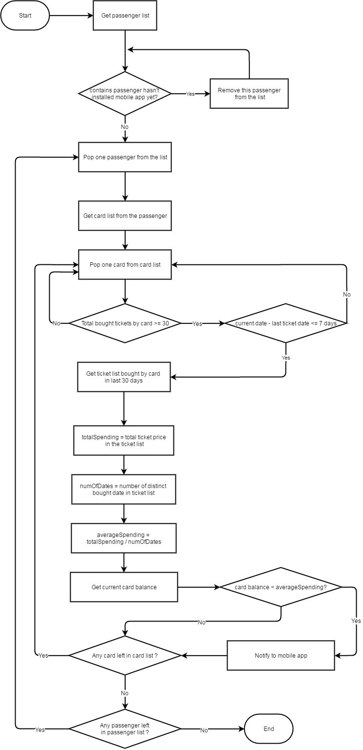

Figure 61: <Algorithms> Daily Usage Prediction

# Report No. 5 System Implementation & Test

## Introduction

### Overview

This section describes the approach and methodologies used by group to plan, organize and manage the testing of GBTS system. It provides in the detail all necessary information about the implementation and testing procedure of the system included test plans, test cases, test result, test environments, pass/fail criteria and risks estimations as well as a checklist to cover all possible cases.

### Test Approach

* Goal: Test all features in the whole GBTS system based on the core flow.
* Method: black-box testing
* Technique: check list

The testing for this project will consists of Integration System test level. Testing the program which was integrated and as a complete system to ensure that the software requirements have been met.

* Integration testing would be performed by all member of team and approved by team leader.

System testing is focused on assessing the system’s reliability. This process is concerned with finding errors that result from unanticipated interactions between components and component interface problems.

## Database Relationship Diagram

### Physical Diagram



### Data Dictionary

Figure 62: <Database Relation Diagram> Physical Diagram

|  |  |  |
| --- | --- | --- |
| Data dictionary: describe content of all tables | | |
| Table Name | **Mapping column with Conceptual diagram** | **Description** |
| User | User | Contain the user information. |
| Role | N/A | Contain the role information. |
| BusRoute | BusRoute | Contain the bus route information |
| Card | Card | Contain the card information |
| Credit Plan | Credit Plan | Contain the credit plan which is used to add credit to card in the system. |
| Offer Subscription | Subscription | Contain the offer subscription information. |
| Payment Transaction | Payment Transaction | Contain the payment transaction information. |
| Promotion | Promotion | Contain the promotion information. |
| ScratchCard | ScratchCard | Contain the scratch card information. |
| Ticket | Ticket | Contain the bought ticket information for a card on a bus route or via cash. |
| Ticket Type | Ticket Type | Contain the type of ticket information |
| Token | N/A | Contain the server token information for verifying ticket bought by phone. |
| UserSubscription | Subscription | Contain the subscription information of user who subscribe an offer. |

|  |  |  |  |  |
| --- | --- | --- | --- | --- |
| Table Name | Attributes | Description | Domain | Null |
| BusRoute | ID{PK} | Unique identifier of a bus route | Integer | No |
| Code | Unique code for each bus route | String | No |
| Name | Name of a bus route | String | No |
| Card | Id{PK} | Unique identifier of a card | Integer | No |
| UniqueIdentifier | Manufacturer ID of a card | String | No |
| CardName | Name of a card | String | Yes |
| RegistrationDate | Registration date of a card | Date Time | No |
| Balance | Balance of a card | Float | No |
| Status | Status of a card | String | No |
| UserId | Unique identifier of an user | Integer | Yes |
| DataVersion | Data version of a card | Big integer | Yes |
| CreditPlan | Id{PK} | Unique identifier of a credit plan | Integer | No |
| Name | Name of a credit plan | String | No |
| Price | Price of a credit plan | Integer | No |
| Status | Status of a credit plan | Integer | No |
| PaymentTransaction | Id{PK} | Unique identifier of a payment transaction | Integer | No |
| CardId | Unique identifier of a card | Integer | No |
| CreditPlanId | Unique identifier of a credit plan | Integer | No |
| TransactionCode | Unique code of a transaction | String | No |
| Total | Total payment amount of a transaction | Integer | No |
| PaymentDate | Date and time of a transaction | Date Time | No |
| Promotion | Id{PK} | Unique identifier of a promotion | Integer | No |
| Name | Name of a promotion | String | No |
| Status | Status of a description | Integer | No |
| CreateDate | Created date of a promotion | Date Time | No |
| ExpireDate | Expired date of a promotion | Date Time | No |
| Role | Id{PK} | Unique identifier of a role | Integer | No |
| Name | Name of a role | String | No |
| ScratchCards | Id{PK} | Unique identifier of a scratch card | Integer | No |
| Code | Code of a scratch card | String | No |
| Price | Price of a scratch card | Integer | No |
| Status | Status of a scratch card | Integer | No |
| ExpiredDate | Expired date of a scratch card | Date Time | No |
| Subscription | Id | Unique identifier of a subscription | Integer | No |
| Name | Name of a subscription | String | No |
| Code | Code of a subscription | String | No |
| Price | Price of a subscription | Integer | No |
| DiscountPercent | Discount percent to ticket price of a subscription | Float | No |
| TicketNumber | Number of ticket can be use in a subscription | Integer | No |
| Status | Status of a subscription | Integer | No |
| Ticket | Id{PK} | Unique identifier of a ticket | Integer | No |
| CardId | Unique identifier of a card | Integer | No |
| BusRouteId | Unique identifier of a bus route | Integer | No |
| Total | Total payment amount for a ticket | Integer | No |
| BoughtDated | Date of ticket bought | Date Time | No |
| IsNoCard | Bought ticket using phone | Boolean | No |
| TicketType | Id{PK} | Unique identifier of a ticket | Integer | No |
| Name | Name of a ticket type | String | No |
| Description | Description of a ticket type | String | Yes |
| Price | Price of a ticket type | Integer | No |
| Status | Status of a ticket type | Integer | No |
| User | UserId{PK} | Unique identifier of a user | Integer | No |
| PhoneNumber | Phone number of a user’s account | String | No |
| Password | Password for a user’s account | String | No |
| Fullname | Fullname of a user | String | Yes |
| Status | Status of a user | Integer | No |
| RoleId | Unique identifier of a user’s role | Integer | No |
| DeviceToken | Device token of user’s device | String | Yes |
| MinBalance | Minimum balance to get notification | Integer | Yes |
| UserSubScription | Id | Unique identifier of a user subscription | Integer | No |
| UserId | Unique identifier of a user | Integer | No |
| SubscriptionId | Unique identifier of a subscription | Integer | No |
| ExpiredDate | Expired date of user subscription | Date Time | No |
| IsActive | Activity of user subscription | Boolean | No |
| TicketRemaining | Number of ticket remain of user subscription | Integer | No |

Table 73: Data dictionary: Describe content of all tables

## Performance Measures

### 3.1 Web Application Loading Speed

* + 1. Definition

This section tests the speed of loading some page of the web application.

* + 1. Test Environment
    - Server: Shared Windows Hosting on server:
      * Operating System: Windows Server 2012 R2
      * Network: 100 Mbps
    1. Test Cases

|  |  |  |
| --- | --- | --- |
| Test case | Role | Page |
| 1 | Unauthorize User | * Login |
| 2 | Passenger | * Get card list |
| 3 | Passenger | * Get outcome report |
| 4 | Staff | * Publish scratch card |
| 5 | Manager | * Get income report |

* + 1. Test Results

The test is run 100 times. Each time we run all the listed test cases and record the average time of web services responding.

|  |  |
| --- | --- |
| Test case | Average Loading Time (second) |
| 1 | 1.15 |
| 2 | 1.38 |
| 3 | 1.96 |
| 4 | 2.16 |
| 5 | 2.23 |

Test report: <https://github.com/dnhoang/GBTS/blob/master/Documents/Test_Report/GBTS_Performance_Test_Report.xlsx>

### Mobile API Speed

1. Definition

This section shows the testing speed results of some mobile application functions when connection to server through API

1. Test Environment
   * + Server: Shared Windows Hosting on server:
       - Operating System: Windows Server 2012 R2
       - Network: 100 Mbps
2. Test Cases

|  |  |  |
| --- | --- | --- |
| Test case | Role | Function |
| 1 | Unauthorize User | * Login |
| 2 | Passenger | * Get card list |
| 3 | Passenger | * Get outcome report |
| 4 | Passenger | * Topup card |

1. Test Results

The test is run 100 times. Each time we run all the listed test cases and record the average time of web services responding.

|  |  |
| --- | --- |
| Test case | Average Response Time (second) |
| 1 | 1.44 |
| 2 | 1.95 |
| 3 | 2.05 |
| 4 | 1.34 |

Test report: <https://github.com/dnhoang/GBTS/blob/master/Documents/Test_Report/GBTS_Performance_Test_Report.xlsx>

## Test Plans

### Features to be tested

* 1. **Manager**:
     + Add/update credit plans
     + Add/update ticket types
     + Add/update promotion packages
     + Add/delete promotions
  2. **Staff**:
     + Add/update passengers’ cards
     + Update passengers’ information
     + Publish scratch cards
  3. **Passenger**:
     + Top up card
     + Update card’s name
  4. **Admin**:
     + Insert account
     + Activate/deactivate account
  5. **Auto handler**:
     + Predict usage
     + Generate token
     + Crawl bus route data
     + Auto extend subcription
  6. Login, logout, update profile
  7. **Mobile application**:
     + Login, logout
     + Top up card
     + Add credit
     + Activate card
     + Update passenger’s profile
  8. **Emulator application**:
     + Verify ticket
     + Top up card
     + Publish card

### Features not to be tested

1. **Manager**:

* View income report

1. **Passenger**:

* View cards’ information
* Search bus routes by bus code
* Find buses by lacations

1. **Mobile** **application**

* View cards’ information
* View outcome report

## System Testing Test Case

### Communication Diagram



Figure 63: <Testcase> System Test



### System Test Cases

#### Web Application Test Cases

* + - 1. <Unauthorized User> Login

|  |  |  |  |  |  |  |
| --- | --- | --- | --- | --- | --- | --- |
| ID | Test Case Description | Test case procedure | Expected output | Inter-test case dependence | Result | Test Date |
| LG01 | Login with valid phone number and password | 1. Go to login page 2. Input valid phone and password 3. Press “Đăng nhập” button | Show target main page. |  | Pass | From 20/9/16  To 12/12/16 |
| LG02 | Login with invalid phone number or password | 1. Go to login page 2. Input invalid phone and password 3. Press “Đăng nhập” button | Show message “Sai số điện thoại hoặc mật khẩu” |  | Pass | From 20/9/16  To 12/12/16 |
| LG03 | Login with blocked account | 1. Go to login page 2. Input blocked account phone number and password 3. Press “Đăng nhập” button | Show message “Tài khoản đã bị khóa” |  | Pass | From 20/9/16  To 12/12/16 |

Table 75: <Unauthorized> Login

* + - 1. <Manager> Add card

|  |  |  |  |  |  |  |
| --- | --- | --- | --- | --- | --- | --- |
| ID | Test Case Description | Test case procedure | Expected output | Inter-test case dependence | Result | Test Date |
| AC01 | Add card successful | 1. Go to card page 2. Press “Thêm thẻ mới” button 3. Tap new card on the emulator 4. Input initial card balance 5. Press “Lưu” button | Updated card page with new promotion added |  | Pass | From 1/10/16  To 12/12/16 |

Table 76: <Manager> Add Card

* + - 1. <Staff> Activate/Deactivate card

|  |  |  |  |  |  |  |
| --- | --- | --- | --- | --- | --- | --- |
| ID | Test Case Description | Test case procedure | Expected output | Inter-test case dependence | Result | Test Date |
| AD01 | Activate card successful | 1. Go to card page 2. Press “Mở khóa thẻ” button | “Mở khóa thẻ” button change to “Khóa thẻ” button |  | Pass | From 1/10/16  To 12/12/16 |
| AC02 | Deactivate card successful | 1. Go to card page 2. Press “Mở khóa thẻ” button | “Khóa thẻ” button change to “Mở khóa thẻ” button |  | Pass | From 1/10/16  To 12/12/16 |

Table 77: <Staff> Add Card

* + - 1. <Passenger> Add credit

|  |  |  |  |  |  |  |
| --- | --- | --- | --- | --- | --- | --- |
| ID | Test Case Description | Test case procedure | Expected output | Inter-test case dependence | Result | Test Date |
| CR01 | Add credit successfully | 1. Go to card page 2. Press “Nạp tiền” button 3. Select a credit plan 4. Input valid PayPal account 5. Press “Continue” button | Updated “Thẻ của bạn” panel with updated balance |  | Pass | From 25/9/16  To 12/12/16 |
| CR02 | Add credit using invalid PayPal account | 1. Go to card page 2. Press “Nạp tiền” button 3. Select a credit plan 4. Input invalid PayPal account 5. Press “Continue” button | Show error message “Check your email address and password and try again.” |  | Pass | From 25/9/16  To 12/12/16 |

Table 78: <Passenger> Add Credit

#### Mobile Application Test Cases

* + - 1. <Passenger> Login

|  |  |  |  |  |  |  |
| --- | --- | --- | --- | --- | --- | --- |
| ID | Test Case Description | Test case procedure | Expected output | Inter-test case dependence | Result | Test Date |
| LI01 | Login successfully | 1. Open “GBTS” application 2. Input valid phone number and password 3. Press “Login” button | Show main screen |  | Pass | From 1/10/16  To 12/12/16 |
| LI02 | Login with invalid phone number or password | 1. Open “GBTS” application 2. Input invalid phone number and password 3. Press “Login” button | Show message “Sai điện thoại hoặc mật khẩu” |  | Pass | From 1/10/16  To 12/12/16 |
| LI03 | Login with blocked account | 1. Open “GBTS” application 2. Input with blocked account 3. Press “Login” button | Show message “Tài khoản đã bị khóa” |  | Pass | From 1/10/16  To 12/12/16 |

Table 79: <Passenger> Login

* + - 1. <Passenger> Add credit

|  |  |  |  |  |  |  |
| --- | --- | --- | --- | --- | --- | --- |
| ID | Test Case Description | Test case procedure | Expected output | Inter-test case dependence | Result | Test Date |
| CR01 | Add credit successful | 1. Open “GBTS” application 2. Input valid phone number and password 3. Press “Login” button 4. Select card panel 5. Choose a card 6. Press “Nạp tiền” button 7. Select credit package 8. Press “Thanh toán” button 9. Press “Pay with” PayPal” button 10. Input valid email and password 11. Press “Login” button 12. Press “Pay with PayPal” button 13. Press “Pay” button | Updated “Thẻ của bạn” panel with updated balance |  | Pass | From 5/10/16  To 12/12/16 |
|  | Add credit using wrong PayPal account | 1. Open “GBTS” application 2. Input valid phone number and password 3. Press “Login” button 4. Select card panel 5. Choose a card 6. Press “Nạp tiền” button 7. Select credit package 8. Press “Thanh toán” button 9. Press “Pay with” PayPal” button 10. Input invalid account 11. Press “Login” button 12. Press “Pay with PayPal” button 13. Press “Pay” button | Show error message “Check your email address and password and try again.” |  | Pass | From 5/10/16  To 12/12/16 |

Table 80: <Passenger> Add Credit

* + - 1. <Passenger> Buy ticket by phone

|  |  |  |  |  |  |  |
| --- | --- | --- | --- | --- | --- | --- |
| ID | Test Case Description | Test case procedure | Expected output | Inter-test case dependence | Result | Test Date |
| PT01 | Buy ticket by phone successfully | 1. Open “GBTS” application 2. Input valid phone number and password 3. Press “Login” button 4. Tap phone on the emulator | Show successful message |  | Pass | From 7/11/16  To 12/12/16 |

Table 81: <Passenger> Buy ticket by phone

* + - 1. <Passenger> Top up card

|  |  |  |  |  |  |  |
| --- | --- | --- | --- | --- | --- | --- |
| ID | Test Case Description | Test case procedure | Expected output | Inter-test case dependence | Result | Test Date |
| TU01 | Top up card successfully | 1. Open “GBTS” application 2. Input valid phone number and password 3. Press “Login” button 4. Select card panel 5. Choose a card 6. Press “Nạp tiền” button 7. Press “Nạp tiền bằng thẻ cào” button 8. Input valid scratch card’s code 9. Press “Nạp” button | Show main screen |  | Pass | From 10/10/16  To 12/12/16 |
| TU02 | Top up card using wrong code | 1. Open “GBTS” application 2. Input valid phone number and password 3. Press “Login” button 4. Select card panel 5. Choose a card 6. Press “Nạp tiền” button 7. Press “Nạp tiền bằng thẻ cào” button 8. Input valid scratch card’s code 9. Press “Nạp” button | Show message “Mã nạp tiền không hợp lệ hoặc hết hạn” |  | Pass | From 10/10/16  To 12/12/16 |
| TU03 | Top up card without a code | 1. Open “GBTS” application 2. Input valid phone number and password 3. Press “Login” button 4. Select card panel 5. Choose a card 6. Press “Nạp tiền” button 7. Press “Nạp tiền bằng thẻ cào” button 8. Leave scratch card’s code space blank 9. Press “Nạp” button | Show message “Mã nạp tiền không hợp lệ hoặc hết hạn” |  | Pass | From 10/10/16  To 12/12/16 |

Table 82: <Passenger> Top up card

* + - 1. <Emulator> Verify ticket

|  |  |  |  |  |  |  |
| --- | --- | --- | --- | --- | --- | --- |
| ID | Test Case Description | Test case procedure | Expected output | Inter-test case dependence | Result | Test Date |
| TU01 | Verify ticket successfully | 1. Tap GBTS card on the emulator | Show success screen |  | Pass | From 20/9/16  To 12/12/16 |

Table 82: <Emulator> Verify ticket

* + - 1. <Emulator> Verify mobile ticket

|  |  |  |  |  |  |  |
| --- | --- | --- | --- | --- | --- | --- |
| ID | Test Case Description | Test case procedure | Expected output | Inter-test case dependence | Result | Test Date |
| TU01 | Verify ticket with token successfully | 1. Open GBTS application on passenger’s phone 2. Tap passenger’s phone on the emulator to confirm | Show success screen |  | Pass | From 1/10/16  To 12/12/16 |

Table 83: <Emulator> Verify mobile ticket

# Software User’s Manual

## Installation Guide

### Setting up environment at server side

#### Hardware Requirement

|  |  |
| --- | --- |
| Hardware Specification | |
| Internet Connection | 100 Mbps |
| Server type | Shared Windows Hosting on Window Server |

#### Software Requirement

|  |  |
| --- | --- |
| Software | Application name/version |
| Operating System | Windows Server 2012 R2 |
| Visual Studio | 2013 or 2015 |
| Web Server | IIS 8.1 |
| Database | Microsoft SQL Server 2012 R2 |
| Control Panel | Plesk 11 |

### Deployment at server side

#### Prepare deployment package

* + Publish web application.
  + Step by step:

1. Click right into web package. Click to “Publish”



1. Publish web with steps bellows:









#### Deploy web application on server

* Step 1 : Go to Plesk Control Panel and login
* Step 2 : Click “File Manager” feature



* Step 3: Upload all published files from Visual Studio to httpdocs folder



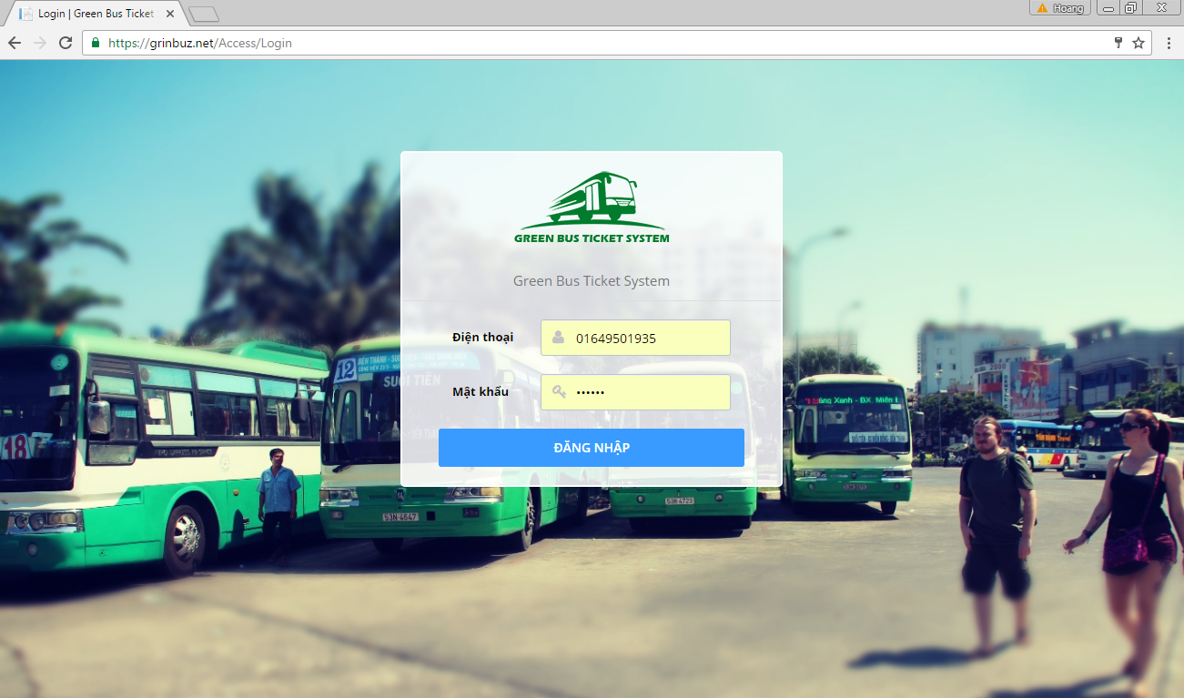

### Deployment at Client Side

* On mobile device, install one of the application from the GBTS package application apk from our attachment on the CD.

*For Bus Emulator:*

* + Install “GBTS Emulator”

*For Customer:*

* + Install “GBTS”

*For Staff:*

* + Install “Máy nạp tiền”
  + Install “CardPublisherStaff” for staff use
  + Install “GBTS Card Publisher” for web use

## User Guide

### Web application

* + 1. <Unauthorized user>Login



|  |  |
| --- | --- |
| Step | Description |
| 1 | Click “ĐĂNG NHẬP” button |

* + 1. <Passenger> Get NFC cards

|  |  |
| --- | --- |
| **Step** | **Description** |
| **1** | Click “Thẻ của bạn” button |

* + 1. <Passenger> Edit card name

|  |  |
| --- | --- |
| Step | Description |
| 1 | Click “Thẻ của bạn” button |
| 2 | Input new card name |
| 3 | Click save button |

<Passenger> Add credit



|  |  |
| --- | --- |
| Step | Description |
| 1 | Click “Thẻ của bạn” button |
| 2 | Click “Nạp tiền” button |
| 3 | Select a credit plan |
| 4 | Click “Thanh toán” button |
| 5 | Confirm the payment by clicking “Continue” |

* + 1. <Passenger> Get outcome report

|  |  |
| --- | --- |
| Step | Description |
| 1 | Click “Báo cáo chi tiêu” button |

* + 1. <Passenger> Look up bus route



|  |  |
| --- | --- |
| Step | Description |
| 1 | Click “Tìm xe buýt” button |
| 2 | Input “Nơi khởi hành” and “Nơi đến” |
| 3 | Click search button |

* + 1. <Passenger> Find bus

|  |  |
| --- | --- |
| Step | Description |
| 1 | Click “Tra cứu tuyến” button |
| 2 | Choose a bus route in a list or input bus route name or code into “Mã số tuyến hoặc tên tuyến” |

* + 1. <Administrator> Search account



|  |  |
| --- | --- |
| Step | Description |
| 1 | Click “Quản lý tài khoản” button |
| 2 | Input a phone number |
| 3 | Click search button |

* + 1. <Administrator> Add account





|  |  |
| --- | --- |
| Step | Description |
| 1 | Click “Quản lý tài khoản” button |
| 2 | Click Thêm tài khoản” button |
| 3 | Input phone number and select one of the roles |
| 4 | Click “Lưu” button |

* + 1. <Administrator> Activate/Deactivate account





|  |  |
| --- | --- |
| Step | Description |
| 1 | Click “Quản lý tài khoản” button |
| 2 | Input a phone number |
| 3 | Click “Khóa tài khoản” or “Mở khóa tài khoản” button |

* + 1. <Staff> Publish scratch cards



|  |  |
| --- | --- |
| Step | Description |
| 1 | Click “Phát hành thẻ cào” button |
| 2 | Click “Phát hành mới” button |
| 3 | Input all information |
| 4 | Click “Phát hành” button |

* + 1. <Staff> Search card



|  |  |
| --- | --- |
| Step | Description |
| 1 | Click “Quản lý thẻ” button |
| 2 | Input card ID |
| 4 | Click search button |

* + 1. <Staff> Add card





|  |  |
| --- | --- |
| Step | Description |
| 1 | Click “Quản lý thẻ” button |
| 2 | Click “Thêm thẻ mới” button |
| 3 | Tap new NFC card on the NFC reader or enter card ID by hand |
| 4 | Input initial balance |
| 5 | Click “Lưu” button |

* + 1. <Staff> Activate/Deactivate card





|  |  |
| --- | --- |
| Step | Description |
| 1 | Click “Quản lý thẻ” button |
| 2 | Input card ID or a phone number |
| 3 | Click “Khóa thẻ” button or “Mở khóa thẻ” button |

* + 1. <Staff> Search passenger



|  |  |
| --- | --- |
| Step | Description |
| 1 | Click “Quản lý hành khác” button |
| 2 | Input phone number or name |
| 3 | Click search button |

* + 1. <Manager> Add ticket type





|  |  |
| --- | --- |
| Step | Description |
| 1 | Click “Quản lý giá vé” button |
| 2 | Input phone number or name |
| 3 | Click “Lưu” button |

* + 1. <Manager> Edit ticket type





|  |  |
| --- | --- |
| Step | Description |
| 1 | Click “Quản lý giá vé” button |
| 2 | Click edit button on a ticket type |
| 3 | Click “Lưu” button |

* + 1. <Manager> Delete ticket type





|  |  |
| --- | --- |
| Step | Description |
| 1 | Click “Quản lý giá vé” button |
| 2 | Click delete button on a ticket type |
| 3 | Confirm by clicking “Xóa” button |

* + 1. <Manager> Add credit plan





|  |  |
| --- | --- |
| Step | Description |
| 1 | Click “Quản lý gói nạp tiền” button |
| 2 | Click “Thêm gói” button |
| 3 | Input new credit plan information |
| 4 | Click “Lưu” button |

* + 1. <Manager> Edit credit plan





|  |  |
| --- | --- |
| Step | Description |
| 1 | Click “Quản lý gói nạp tiền” button |
| 2 | Click edit button on a credit plan |
| 3 | Edit credit plan information |
| 4 | Click “Lưu” button |

* + 1. <Manager> Delete credit plan





|  |  |
| --- | --- |
| Step | Description |
| 1 | Click “Quản lý gói nạp tiền” button |
| 2 | Click delete button on a credit plan |
| 3 | Confirm by clicking “Xóa” button |

* + 1. <Manager> Add subscription





|  |  |
| --- | --- |
| Step | Description |
| 1 | Click “Quản lý gói ưu đãi” button |
| 2 | Click “Thêm ưu đãi mới” button |
| 3 | Enter new promotion package information |
| 4 | Click save button |

* + 1. <Manager> Edit subscription



|  |  |
| --- | --- |
| Step | Description |
| 1 | Click “Quản lý gói ưu đãi” button |
| 3 | Edit promotion package information |
| 4 | Click save button |

* + 1. <Manager> Delete subscription





|  |  |
| --- | --- |
| Step | Description |
| 1 | Click “Quản lý gói ưu đãi” button |
| 3 | Click delete button on a promotion package |
| 4 | Confirm by click “Xóa” button |

* + 1. <Manager> Get income report



|  |  |
| --- | --- |
| Step | Description |
| 1 | Click “Báo cáo thu nhập” button |
| 3 | Input query information |
| 4 | Click search button |

* + 1. <Manager> Create promotion



|  |  |
| --- | --- |
| Step | Description |
| 1 | Click “Tạo quảng cáo” button |
| 3 | Input new advertisement information |
| 4 | Click “Gửi” button |

### Mobile application

* + 1. <Passenger> View Login



|  |  |
| --- | --- |
| Step | Description |
| 1 | Tab “ĐĂNG NHẬP” |
| 2 | Tap “KÍCH HOẠT “ |

* + 1. <Passenger> View Active Card

|  |  |
| --- | --- |
| Step | Description |
| 1 | Input your phone number, tap and hold to Active Card |

#### <Passenger> Function Overview



|  |  |
| --- | --- |
| Step | Description |
| 1 | Tap “THẺ CỦA TÔI”. |
| 2 | Tap “BÁO CÁO CHI TIÊU” |
| 3 | Tap “TRA CỨU TUYẾN” |
| 4 | Tap “TÌM XE BUÝT” |
| 5 | Tap “TÀI KHOẢN” |
| 6 | Tap “LIÊN HỆ “ |

#### <Passenger> THẺ CỦA TÔI





|  |  |
| --- | --- |
| Step | Description |
| 1 | Click one item of list card on fragment to view details and purchase. |
| 2 | Tap “ICON” to edit Name card. |
| 3 | Tap “NẠP THẺ TRỰC TUYẾN” purchase to recharge. |
| 4 | Tap “NẠP BẰNG THẺ CÀO”. |
| 5 | Click one item of list credit plan on fragment to recharge. |
| 6 | Tap “NẠP” to recharge. |

#### <Passenger> BÁO CÁO CHI TIÊU





|  |  |
| --- | --- |
| Step | Description |
| 1 | Click “TỪ NGÀY” to choose date. |
| 2 | Click “ĐẾN NGÀY” to choose date. |
| 3 | Click “ICON SEARCH” to get report. |

#### <Passenger> TRA CỨU TUYẾN



|  |  |
| --- | --- |
| Step | Description |
| 1 | Filler to fine bus routes |
| 2 | Click one item of list bus routes to find direction and bus routes. |

#### <Passenger> TÌM XE BUÝT



|  |  |
| --- | --- |
| Step | Description |
| 1 | Choose origin direction |
| 2 | Choose destination direction |
| 3 | Tap “TÌM KIẾM” to find bus routes |

#### <Passenger > TÀI KHOẢN



|  |  |
| --- | --- |
| Step | Description |
| 1 | Click “LƯU” to change profile. |

### Emulator application

#### Verify ticket



|  |  |
| --- | --- |
| Step | Description |
| 1 | Open Bus Emulator application |
| 2 | Tap and hold NFC card or NFC-enabled phone on the NFC reader |

#### Configure emulator



|  |  |
| --- | --- |
| Step | Description |
| 1 | Open Bus Emulator application |
| 2 | Tap driver’s NFC card on the NFC reader |
| 3 | Press on Bus floating button |
| 4 | Input a bus code and select a ticket type |
| 5 | Press “Lưu cài đặt” button |

#### C:\Users\Duc\AppData\Local\Microsoft\Windows\Temporary Internet Files\Content.Word\Screenshot_20161120-212352.pngSell cash ticket

|  |  |
| --- | --- |
| Step | Description |
| 1 | Open Bus Emulator application |
| 2 | Tap driver’s NFC card on the NFC reader |
| 3 | Press on Cash floating button |

#### Publish card

|  |  |
| --- | --- |
| Step | Description |
| 1 | Open Card Publisher application |
| 2 | Open publish card panel on the web application |
| 3 | Tap and hold new NFC card on the NFC reader |



#### C:\Users\Duc\AppData\Local\Microsoft\Windows\Temporary Internet Files\Content.Word\Screenshot_20161120-212801.pngPublish card (Immediately publish a card without using the web application)

|  |  |
| --- | --- |
| Step | Description |
| 1 | Open Card Publisher application |
| 2 | Tap and hold new NFC card on the NFC reader |

# Appendix

1. UML Documentation of IBM <http://www.ibm.com/developerworks/rational/library/769.html?ca=drs->
2. AES encryption

[http://](http://www.ibm.com/developerworks/rational/library/769.html?ca=drs-)www.java2s.com/Code/Java/Security/EncryptionanddecryptionwithAESECBPKCS7Padding.htm

1. Android Developer Guide – Application Fundamentals

<https://developer.android.com/guide/components/fundamentals.html>

1. FPT Vietnamese Accentizer

[http://doc.openfpt.vn/services/vnaccent/documentation.html#/README](http://doc.openfpt.vn/services/vnaccent/documentation.html%23/README)

1. Google Firebase Api

<https://firebase.google.com/docs/reference/>